Don Paterson: Poetry and Change
Celebrate National Poetry Day's 2018 theme of 'Change' using a Don Paterson poem as your starting point
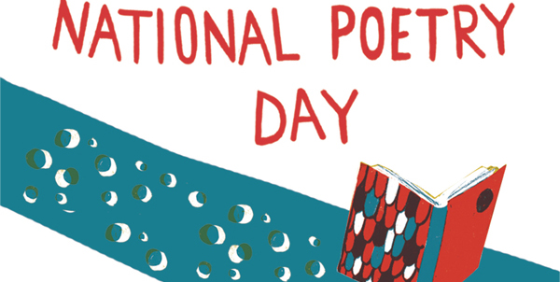

This resource is great for:
Encouraging new approaches to reading and writing poetry, considering ‘change’ and translation as both a subject for poetry and a tool in creating your own poems.
Summary:
A selection of Scottish and international poems to read, and some activities to encourage creative thinking and writing.

Introduction:
This year’s National Poetry Day theme is ‘Change’, and it’s a perfect choice: change is central to a great deal of poetry, whether the subject of the writing or embedded in the form of a poem itself.
Looking at a few examples of poems and poets featured in the Scottish curriculum, this resource will help get pupils thinking about how poets approach change and encourages them to get creative by ‘changing’ poems themselves.

Activities
Part One – Poetic License
Read Scottish poet Don Paterson’s poem ‘Being’ at the link below. It’s not the easiest poem, so don’t worry if you’re not sure what it means:
www.scottishpoetrylibrary.org.uk/poetry/poems/being
The poem, which itself talks about ‘transformations’, is the final piece in a collection called Orpheus, in which every poem is a reworking of an original by European poet Rainer Maria Rilke, who wrote his collection Sonnets to Orpheus nearly 100 years ago in German. Paterson’s poem isn’t a straightforward German-to-English translation however; he calls it a ‘version’. In his own words:
Versions are trying to be poems in their own right; while they have the original to serve as detailed ground-plan and elevation, they are trying to build themselves a robust home in a new country, in its vernacular architecture, with local words for its brick and local music for its mortar.
In other words, Paterson has taken the meaning or the sense of the original poems, but made them relevant to him, his experiences and opinions.
You can read a more literal translation of Rilke’s original poem here: https://onbeing.org/blog/let-this-darkness-be-a-bell-tower/
- Consider the similarities and differences between the two versions. Does reading one help you understand the other? Which is easier to understand, and which do you consider a more interesting poem?

- What do you think Paterson thought about when he made his ‘version’? How would you go about deciding what should stay similar and what should be changed? How would you then implement that?
- The sonnet form has change at its heart, as most sonnets have a turn or twist, where the tone or the meaning changes. This is called a volta. Can you see where it might be in these poems?

Part Two – Making a Change
Poetry can seem scary (or boring!) even to lovers of reading, and often that’s because young readers don’t see poems that reflect themselves, their interests or sense of humour. Even if you found the above poems hard to understand, you might enjoy the sound of them, or even just a word or a phrase that you like. Or maybe you hate them! Hopefully what you can see is that even the most important poems and poets aren’t sacred, and you are entitled to make them your own.
One famous – and short! – poem which is often reworked in funny and interesting ways is ‘This Is Just To Say’ by the American poet William Carlos Williams. You can read his poem here: https://www.poets.org/poetsorg/poem/just-say
The poem reads like a simple note left for someone to find, and so almost anyone in the world can imagine their own version (and many people on the internet have done just that). One great example is Scottish poet Tom Leonard’s version, called ‘Jist Ti Let Yi No’, which is written in Glaswegian dialect. You can read that poem here: http://www.wildhoneypress.com/voices/Williams.htm
- Try writing your own version of William’s poem. You can change what the note is about and the language it uses to make it feel like something you might say, or something a character you like or invent might write. It can be funny, serious, sad, silly – whatever you want!
- Tom Leonard starts his version with ‘From the American of Carlos Williams’, which is unusual as Williams wrote in English. What do you think Leonard might be suggesting by this, and what point might he be making by writing it in a Glaswegian voice? What do you think about this? Which version do you like better, and why?

Part Three – Try it Yourself
Try to create your own ‘version’ of a poem by choosing an existing one and changing it. You could alter the setting, characters, dialect or language so they reflect you and your world. You can even change the images, tone and atmosphere so the new poem feels especially true or honest to you (even if it’s completely made up!) It could be similar but subtly different like Don Paterson’s poem, or look and sound radically changed like Tom Leonard’s. You could write a modern update to a Robert Burns poem, take a famous First World War poem and change its setting, or look for a new angle in a poem you’ve been studying in class.
- Find a poem you think is interesting and which you can see things that could be changed in. Ask your teacher for help if you’re struggling.
- Think about what the meaning or the message of the original poem might be, and what you would want your version to convey. Write down anything that would have to change for this to happen.
- Get creative! Whether your eventual poem ends up completely, unrecognisably different from the original because you’ve made so many changes or is quite similar but says something new – that’s fine! Either way you’ve written a poem.
- You could ask a classmate or a teacher to read your version and the original, then tell you why they think you’ve made your changes and what your new poem is trying to communicate.

Further information:
Find out all about National Poetry Day and this year’s theme of ‘Change’ by visiting the website: https://nationalpoetryday.co.uk/
The Scottish Poetry Library’s website has lots of poems you can read for free as well as resources to help you think about poetry: http://www.scottishpoetrylibrary.org.uk/
Check out more of our poetry resources, featuring some of Scotland’s best contemporary poets:
https://learning.edbookfest.co.uk/resources/liz-lochhead-poetry-and-place/
https://learning.edbookfest.co.uk/resources/an-interview-with-carol-ann-duffy/
https://learning.edbookfest.co.uk/resources/edwin-morgan-a-taste-of-poetry/

