Around the World in Books
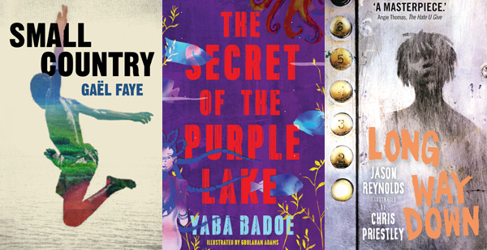
An international reading list from the Edinburgh International Book Festival Baillie Gifford Schools Programme 2018

This resource is great for:
Discovering new books written by authors from across the globe.
Summary:
An international reading list for all ages, followed by some accompanying activities.

Introduction
Sometimes pupils (and teachers…) can get stuck in a reading rut. Why not broaden your horizons – literally – with our international reading list for all ages, featuring some of the amazing authors from around the world who are appearing in our 2018 Baillie Gifford Schools Programme.
Reading books by international authors (including books in translation) can give pupils a broader perspective on the world and encourage them to think about the lifestyles of people in cultures different to their own. This is important when

building knowledge of other countries and cultures and developing compassion for others.
Explore our reading list below, featuring a range of international authors, and then try out some of our accompanying activities.

Reading List and Activities
Books for Primary Pupils
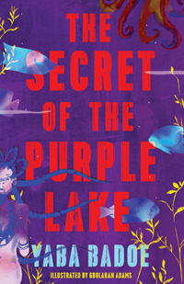
- The Secret of the Purple Lake by Yaba Badoe

Recommended age: P3 – P5
Travel the world with Ghanaian-British author Yaba Badoe and her beautiful tale, The Secret of the Purple Lake, which takes you from Ghana to Orkney, from Spain to Thailand, interweaving a collection of magical characters.

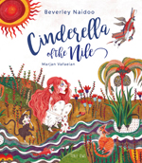
- Cinderella of the Nile by Beverley Naidoo, illustrated by Marjan Vafaeian

Recommended age: P4 – P5
This South African author and Iranian illustrator have teamed up to create a vibrant new retelling of the 2000 year old classic Cinderella story.

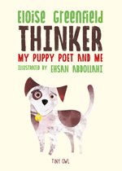
- Thinker: My Puppy Poet and Me by Eloise Greenfield, illustrated by Ehsan Abdollahi

Recommended age: P2 – P4
The first of multi award-winning African American poet Eloise Greenfield’s books to be published in the UK, Thinker: My Puppy Poet and Me is beautifully illustrated with Iranian Ehsan Abdollahi’s stunning collage pictures. It’s the story of 7 year old Jace and his pet puppy, Thinker, who turn everything they do into verse!

Books for Secondary Pupils
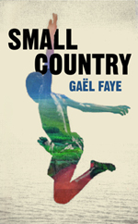
- Small Country by Gaël Faye

Recommended age: S4 – S6
Gaël Faye is an author, composer and hip-hop artist born in Burundi to a Rwandan mother and French father. Small Country is his autobiographical coming-of-age story, set in his war-torn home country at the time of the genocide.

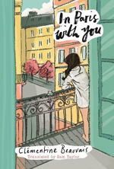
- In Paris With You by Clémentine Beauvais

Recommended age: S1 – S3
Translated from its original French, this delicious verse novel gives an insight into life and love in France’s capital. Clémentine has a gift for writing quirky characters.
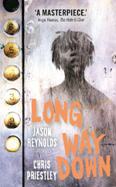
- Long Way Down by Jason Reynolds, illustrated by Chris Priestley

Recommended age: S2 – S4
A wonderful lyrical verse novel by American author Jason Reynolds gives a human insight into US gang culture and the mindsets which support it.

Extra Activities
Why not ask your pupils for suggestions of other international authors they know? Their answers may surprise you! Or they may be inspired to dip into some of the books above.
Challenge your class to write a story set in a different country. It might be somewhere they’ve been on holiday, somewhere they’ve always dreamed of going or somewhere they used to live. Ask them to do some research and then describe

what life is like in their chosen country. How is life there different from life in the UK?

