Children’s Authors Share their Writing Top Tips
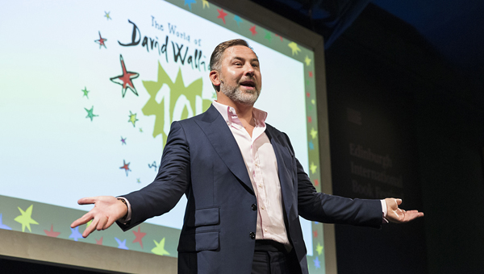
Get top tips from fantastic authors and be inspired to pick up a pen
and get writing

This resource is great for:
Hearing first hand from big name children’s authors sharing their top tips for doing your own writing.
Summary:
Interviews with authors recorded at the 2018 Edinburgh International Book Festival and related activities.

Introduction
During the Book Festival this year, BBC’s The L.A.B. invited local schoolchildren to interview some of our fabulous authors. Listen to the audio interviews, then follow the authors’ advice and start writing stories inspired by your own experiences.

Interviews and Activities
Part One – David Walliams
Listen here: https://www.bbc.co.uk/programmes/p06jt689
Sometimes I’m inspired by people I’ve met, sometimes it’s stories people have told me.
In his interview with children from The Royal Blind School, Britain’s biggest selling author David Walliams tells us where he gets his ideas from. Think about all of the people you know. Do any of them have big, over-the-top personalities like David’s sister who was always trying to get other people in trouble? Think about what funny stories you could create using those characters. Once you’ve thought about some interesting plots and the hilarious escapades your characters could get up to, put pen to paper and start writing your story!

Part Two – Elizabeth Laird
Listen here: https://www.bbc.co.uk/programmes/p06jt62p
In her interview with pupils from Craigour Park Primary School, award-winning children’s writer Elizabeth Laird advises young writers to keep a diary and write down their experiences. She uses lots of her own life experiences in her writing, including being charged by a rhino and bitten by a snake! Even if your diary isn’t quite as exciting and exotic as Elizabeth’s, try to find at least one interesting thing to write about each day. Add detail and your own thoughts about what happened. Could any of your experiences lead to a story?

Part Three – Julia Green
Listen here: https://www.bbc.co.uk/programmes/p06jxz02
To the Edge of the World and The Wilderness War author Julia Green tells the children from Craigour Park Primary School how she used to make little books of her own stories, inspired by the books which she loved to read. Why not take one

of your stories and turn it into your own mini book? You can get some ideas on how to make a little book online – it doesn’t need to be complicated. Remember to use your best handwriting and to add lots of pictures. Your book will also need a description (called a blurb) on the back and a wonderful cover illustration – make sure you add your name in big letters so people know it’s your story!

Part Four – What would you ask?
If you were given the opportunity to meet your favourite author, what questions would you ask?
Why not write to your chosen author and ask them your questions. Or you can save them for your next author visit or trip to the Edinburgh International Book Festival!

Further Information:
Watch this space for more author interviews from Edinburgh International Book Festival 2018 coming very soon…
BBC’s The L.A.B Scotland is an outreach project designed to develop digital media literacy within Scotland, working with a diverse range of groups to create their own content.

