Colouring the Book Festival with Eilidh Muldoon
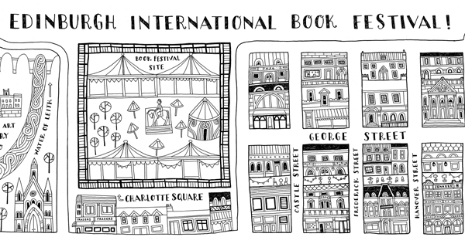
Get excited about your visit to the Book Festival with beautiful colouring sheets created by illustrator Eilidh Muldoon

This resource is great for:
Getting creative while you prepare for your visit to the Book Festival.
Summary:
Colouring sheets designed by illustrator Eilidh Muldoon.

Introduction
Illustrator Eilidh Muldoon’s stunning, ornate illustrations are perfect for colouring in and we’re lucky enough that she’s created a whole series of images of the Book Festival for you to get creative with.

Activity – Adding colour to the Book Festival
Part One
Download the colouring sheets below. Then get creative with your colouring pens, pencils or crayons.
Colouring Sheet – Charlotte Square & Princes Street Gardens
Colouring Sheet – Book Festival Site
Colouring Sheet – Edinburgh Map
Colouring Sheet – Book Festival Charlotte Square
Part Two
Why not add yourself, your family, friends or class into the Book Festival Site colouring sheet, and then make sure you draw your favourite authors or events in the marquees.
Part Three
Once you’ve finished colouring in all of Eilidh’s images, why not try your hand at creating your own illustration of the Book Festival?

