Creepy Tales with Helena Duggan & Christopher Edge
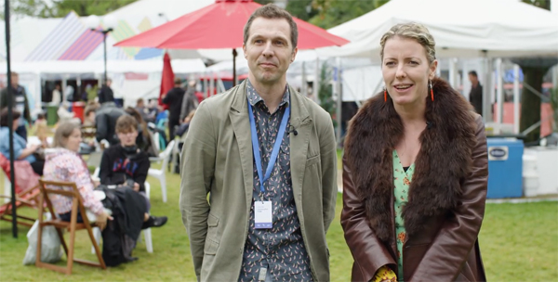
Get telling your own scary stories inspired by two wonderful authors' creepy tales

This resource is great for:
Getting to grips with telling scary stories
Summary:
Watch a filmed interview with authors of creepy tales, Helena Duggan and Christopher Edge. Then use the activities below to create your own thrilling stories.

Introduction
Helena Duggan and Christopher Edge are the authors of some seriously creepy books. In Helena’s A Place Called Perfect series, Violet discovers that her town is being controlled by the mysterious glasses that everybody wears, while Christopher’s most recent book, The Infinite Lives of Maisie Day, starts with Maisie opening her front door to discover… a void.
Our Year of Young People 2018 young programmers, Bruce and Martyna, got the chance to interview the authors during the Book Festival to find out all about the

inspiration behind their latest books and hear about their favourite creepy stories. Watch the interview at the following link before working your way through the related activities: https://www.youtube.com/watch?v=BdD5WFlkgcQ&t=2s
This is the first in a series of videos featuring the young programmers interviewing some of the wonderful authors they chose for their strand of events which explored the theme of Freedom in all its different forms.

Activities
Part One – Object Inspiration
In the interview, Helena tells us that her book A Place Called Perfect was inspired by an old pair of glasses that she found in an antiques shop in Australia. The glasses got her thinking about the person who owned them before and the things which they had seen and done. It wasn’t long before she got carried away in her own imagination and she started to think that if she got rid of the glasses, she would also get rid of the previous owner’s memories.
Do some searching and find an old object which you think is really interesting. You could look in your own house, your grandparents’ or another relative’s house, or in charity or antiques shops. Once you’ve found an object, imagine the person who might have owned it before.
Write a sentence or short paragraph about the following:
- Who owned the object
- Why they owned the object
- How they came to own the object
- What they used it for
- If they discovered something unexpected about the object
- What might have happened next
- How the object came to be where you found it
Do you think you might have the beginnings of your own short story?

Part Two – Scary Storytelling
“You’ve got to be able to scare yourself to scare other people.”
Christopher Edge
What scares you? In your class share stories of times you’ve been really scared (or scary stories you’ve read or been told which really creeped you out).
This is also a good opportunity to practise your storytelling techniques. Think about the atmosphere you’re creating. Can you dim the lights? Think about creating tension, maybe using different voices, sound effects and dramatic pauses. We’re big fans of sitting around at sleepovers telling scary stories. Why not channel that atmosphere and get your torches out?
Part Three – Recommended Reads
Helena and Christopher mention a couple of authors of great creepy books which they would recommend – Roald Dahl and Neil Gaiman. Have you read anything by either of these authors? What other authors of wonderfully spooky stories would YOU recommend? Chat with your classmates and see if you can find some new must-reads.

Further Information:
You can find out more about our Year of Young People 2018 young programmers and the amazing events they programmed at the 2018 Book Festival here: https://learning.edbookfest.co.uk/news/year-of-young-people-meet-our-young-programmers/

