Draw Along with Tom Morgan-Jones
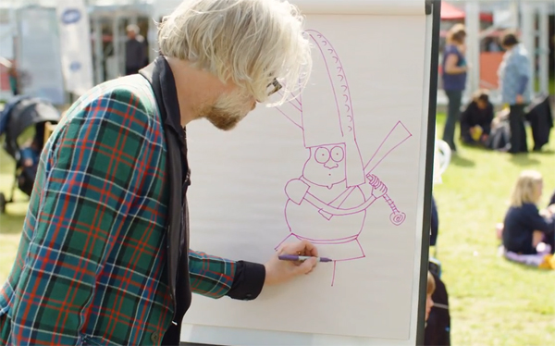
Top illustrator and author Tom Morgan-Jones shows you how to draw his comical character, Norman the Norman, from Philip Ardagh's book series

This resource is great for:
Giving pupils the skills and confidence to draw characters.
Summary:
Tom Morgan-Jones, the illustrator of Philip Ardagh’s Norman the Norman from Normandy and Norman the Norman and the Very Small Duchess, shows you how to draw young Norman in a step-by-step video.

Introduction:
While visiting the 2018 Book Festival, illustrator Tom Morgan-Jones gave up some time to lead pupils in a quick draw-along. Watch the video at the following link and draw along to create your very own Norman the Norman from Normandy!: www.youtube.com/watch?v=XsxTUQPBjqg

Activities
Part One – Customising your character
When drawing Norman’s mouth, Tom wonders if Norman is smiling, or worried, or confused, before deciding on a simple little spot for his mouth to show confusion. How do you think Norman should be feeling, and how would his mouth look if he was? Try different mouths on your drawing. What difference does it make? You could even draw his mouth on a separate piece of paper and hold it over your drawing to try different mouths before deciding on one for your picture.
Try customising different parts of Norman. Could he be holding something different, wearing a different hat, or doing a different action? Be as creative as you can!
Part Two – Special effects
Tom rubs a crayon over a cheese grater to get the texture of Norman’s chainmail. You might not have a cheese grater handy but have a look around your classroom or playground – what else could you use? Try out lots of different rubbings on paper to see which one has the best effect.

Further information:
Tom Morgan-Jones is an award-winning illustrator based in Edinburgh. His work is widely and internationally published, from children’s books and magazines to satirical board games. You can find out more about him here: www.inkymess.com
The Norman the Norman from Normandy series is written by Philip Ardagh, who regularly appears at the Book Festival. Find out more about the series here: www.barringtonstoke.co.uk/books/norman-norman-normandy/

