Dystopian Dramas with Julie Bertagna & William Sutcliffe
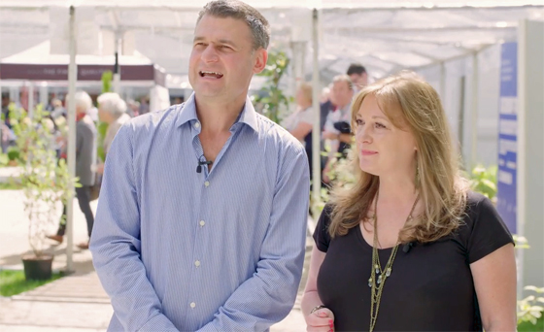
Authors Julie Bertagna and William Sutcliffe get to grips with the issues in their YA dystopian novels

This resource is great for:
Getting your class to discuss some meaty issues, using YA dystopian fiction as a prompt.
Summary:
Watch a filmed interview with authors Julia Bertagna and William Sutcliffe and hear them get to grips with some of the issues in their YA dystopian novels. Then use some of the discussion points below to discuss the issues raised.

Introduction
In their novels, these two top writers for teens offer visions of our near future that are uncomfortably recognisable. In Exodus, Julie Bertagna depicts a world drowned by rising sea waters and a migrant Scottish population searching for new

homes. While William Sutcliffe’s Concentr8 is a dark tale of kidnap, corruption and manipulation in a society where the unruly are kept constantly medicated.
During the 2017 Edinburgh International Book Festival, our young reporters Abbie and Megan got the chance to speak to the authors. Watch the interview at the following link and then use the discussion prompts below: www.youtube.com/watch?v=9CN1BwLsO40&t=1s

Discussion Points
Part One
Julie Bertagna’s novel is an example of Cli-Fi, or climate fiction, meaning it deals with climate change and global warming. Julie states that when she wrote Exodus the idea of a flooded earth seemed far-fetched and futuristic, though we know that sea levels are rising and, if something isn’t done to halt them, will start infringing on towns, farmland and animals’ habitats.
How much do your class know about climate change and global warming? What steps can we take now to help slow or reverse the problems caused by climate change?
Now imagine what extreme measures civilisation might be driven to if we don’t stop these problems. In Exodus sea levels have risen and the population who are rich enough to do so live in sky-cities. Do you think any of your ideas are realistic?
Part Two
Concentr8 is set in a reimagined London, where young people are given powerful drugs which change their behaviour, making it more convenient for adults. William Sutcliffe describes it as a satire on ADHD and Ritalin.
What do you think of medications being prescribed to young people to help them concentrate? What moral issues do you think are involved? Can you see any arguments for prescribing these drugs, maybe from the point of view of parents, teachers or the police? Now, rethink your answers but imagine you live in the UK

of Concentr8, where mass riots are taking place throughout London, and a large percentage of teenagers are being prescribed a controversial drug which makes them docile and obedient.
Part Three
How do you find your own path through life when you’re made to live in a structure where it’s dictated to you a lot of the time what you want to do? How do you find your path against rules which can seem a bit dictatorial?
William points out that a lot of YA fiction is set in quite rigid societies but feature a protagonist who breaks out and disobeys these rules.
Can you think of any examples of YA fiction like this? Do you think this kind of story is attractive to teenagers, and if so why? Are there any rules in our society which you think are overly strict for young people (whether imposed by the government, parents or schools)?
Part Four
They challenge the stuff that adults just accept.
William states that middle aged people accept bad things that are going on, while teenagers ask why, and what they can do to make things better. Do you think that’s true? What examples can you give of teenagers taking a stand on issues they believe in? These could be recent or historical.
Have you taken any action against things that you disagree with? Are there any issues which you do feel strongly about which you might like to take action? Discuss the issue and what action would be most appropriate – maybe joining a protest march, writing a letter to your local councillor or volunteering for a charity. Why not get involved and make a stand for something you feel passionately about?

Part Five
Take something from this world which terrifies you, which upsets you, which fascinates you, that you’re obsessed with… and take it to an extreme. You exaggerate it.
Do any of your discussions lead to potential story ideas? If so, then get them down on paper! Remember Julie and William’s advice on creating a real character in a surreal situation. Then, as Julie says, see where your imagination takes you!

Further Information
Young reporters Abbie and Megan are part of What’s Your Story?, Scottish Book Trust’s development programme for teenage writers and illustrators. Find out more at www.thestoryis.co.uk

