Fantastical Fiction with Ade Adepitan and Gill Arbuthnott
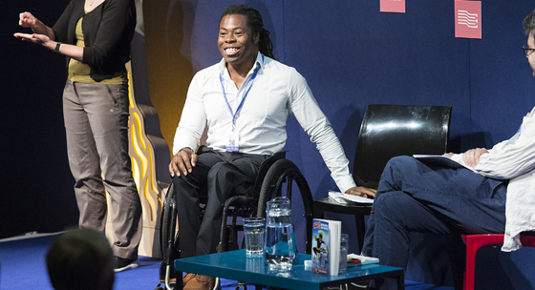
Learn how to write wacky, fantastical stories based in reality with top tips from two brilliant children's authors

This resource is great for:
Getting inspiration for writing fantastical stories based in reality.
Summary:
Interviews with authors recorded at the 2018 Edinburgh International Book Festival and related activities.

Introduction
During the Book Festival this year, BBC’s The L.A.B. invited local schoolchildren to interview some of our fabulous authors. Listen to the audio interviews, then follow the authors’ advice and start writing fantastical and wacky stories.

Interviews and Activities
Part One – Ade Adepitan
Listen here: https://www.bbc.co.uk/programmes/p06l4fl1
Writing’s all about your life and the stuff that influences you, the things that you see, the things that come into your head and your imagination.
In his interview with children from Juniper Green Primary School, Paralympian, TV presenter and author Ade Adepitan tells us that his hilarious new series, Ade’s Amazing Ade-ventures, is based on his life but with lots of wacky, made-up ideas thrown in.
Think about your life story. Where do you come from? What do you like to do in your spare time? Who are your friends? Have you ever found yourself in a new or unusual situation? Does it seem like you have a story? Perhaps you feel that your life isn’t interesting enough to write a story about…
But now let your imagination run wild! What would make your story much more interesting? Add in things that you enjoy reading about in stories – maybe superpowers, talking animals, magic spells… Now how does your story look?
Books are about ideas. However wacky, however crazy or intense the idea is that you have, write it down or record it and just make notes and put it together. Don’t be afraid to put your ideas down on paper. Just absorb everything you see.

Part Two – Gill Arbuthnott
Listen here: https://www.bbc.co.uk/programmes/p06l4fqr
In her interview with Broomhouse Primary School, author of fiction and non-fiction, Gill Arbuthnott, tells us that she usually likes to set her main story in the present day and grounded in reality, but then chooses to weave in folk tales and legends – such as using the myth of the Kelpies, or Nykur, in her mysterious book Beneath.

Think of any fascinating folk tales you know – from the Loch Ness Monster to werewolves and Selkies – or research some. Then think about what present day situations they could appear in – perhaps the Loch Ness Monster appears in a school swimming lesson! Sounds like the start of a story to us…

Further Information:
Watch this space for more author interviews from Edinburgh International Book Festival 2018 coming very soon…
BBC’s The L.A.B Scotland is an outreach project designed to develop digital media literacy within Scotland, working with a diverse range of groups to create their own content.

