Graphic Novel Draw-Off with
Alexis Deacon & Joe Todd-Stanton
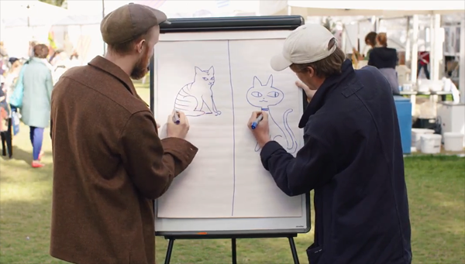
Two awesome graphic novelists take part in an illustration battle

This resource is great for:
Budding illustrators who want to learn from some inspirational graphic novelists
Summary:
Watch a video interview with graphic novelists Alexis Deacon and Joe Todd-Stanton, find out the inspiration for their storylines and art styles. Then watch as they have an illustration battle.

Introduction
The video interview below is part of a series of videos featuring our Year of Young People young programmers interviewing some of the wonderful authors they chose for their 2018 strand of events exploring the theme of Freedom in all its different forms.

Young programmers Joe, Laurence and Martyna loved the illustrations and strong storylines of Alexis Deacon’s Geis series and Joe Todd-Stanton’s Marcy and the Riddle of the Sphinx.
“The art styles in the books really intrigued me” – Joe
Watch them interview the graphic novelists at the following link and then have your pens at the ready to get drawing yourself: https://www.youtube.com/watch?v=QdVncVuTo1E&t=3s

Activity – Illustration Battle
At the end of the interview, Alexis and Joe have an illustration battle to draw cats – which end up looking quite different!
Why not have an illustration battle in your class? Let two pupils step up to the board. The rest of the class can choose what they draw. The object isn’t to decide who is the ‘better’ illustrator but to see how different your styles are, and what different choices you make when drawing (to make it more interesting try not to look at what the other person is drawing). We didn’t put a time limit on Alexis and Joe’s drawing – but you could. You could also have one person choose what to draw, but only tell the two people drawing. The rest of the class have to guess what they’re drawing.

Further information
You can find out more about our young programmers and the events they programmed as part of their 2018 strand here: https://learning.edbookfest.co.uk/news/year-of-young-people-meet-our-young-programmers/

