Inspiring Stories with Meg Rosoff
Award-winning author Meg Rosoff shares her top tips for writing your own emotive tales
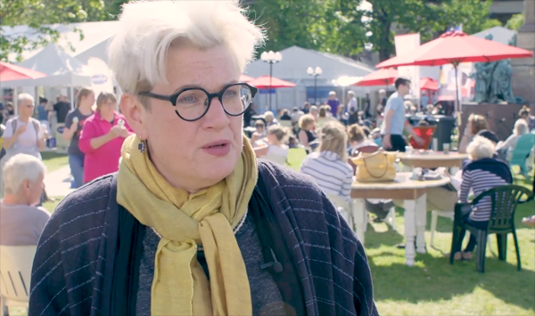
This resource is great for:
Getting an inside look into the writing process from an acclaimed author.
Summary:
Watch a filmed interview with renowned Young Adult fiction author Meg Rosoff which explores emotive writing, friendship and the importance of having a good moral in a Young Adult novel. Then, put Meg’s advice into practise using our writing prompts and discussion points.

Introduction
Meg Rosoff’s first novel, How I Live Now, sold over a million copies in 36 territories. It won the Guardian Children’s Prize and the Printz Award in the US, and was later made into a film. Her subsequent six novels have all been awarded or shortlisted for, among other prizes, the Carnegie Medal and the National Book Award. Her most recent book, Beck, the moving story of an orphan boy in search of belonging,

was a continuation of the work of the author Mal Peet, who passed away before completing the story.
During the 2017 Edinburgh International Book Festival, our young reporter Sheena got the chance to speak to Meg. Watch the interview at the link below and then read on for related activities: https://www.youtube.com/watch?v=HaK5F4Sc1cc&t=15s

Activities
Part One – Swapping Stories
In the interview, Meg explains how Beck was a continuation of the work of her friend, author Mal Peet, who sadly developed cancer and passed away before he could complete it. Meg says she enjoyed the process of finishing the book, working from Mal’s plot and redrafting his work.
Briefly write the plot outline for a short story. It could be one you already have an idea for, or you could brainstorm a completely new plot. Then swap plotlines with another person in your class. Without communicating with them, write a short story based on your classmate’s plot. Then swap and read each other’s stories. How easy do you find it writing from someone else’s idea? How closely does your classmate’s story resemble your original concept? How does it differ? Are you able to make the story ‘your own’ when working from someone else’s brief?
Part Two
A lot of the time when you get a strong sense of emotion from a book or from characters, it’s because the writer him or herself has a very strong sense of connection with their unconscious.
In the interview, Sheena asks Meg how she achieves such emotion in her writing. Meg states that a book can feel dead when a writer is paying more attention to the words and sentences and less to how a character makes you feel. She also talks about the importance of putting yourself in the situation of your character, to accurately discover how they would feel.

Try to write a short paragraph describing a character experiencing a certain emotion which you feel familiar with. Don’t worry too much about sentence structure, word choice and spelling, only on accurately portraying the emotion. As you write try to take a step back and imagine how that emotion makes you feel, and try to clearly express that on paper. When you’ve finished, talk with your class about how you found the exercise. Was it difficult? How accurately do you think you’ve expressed the emotion?
Part Three
I think the most important thing I’ve learned as a writer is how the job of being human is to understand as much of our place in the world as we possibly can… just to be the best human being you can possibly be.
In 2016, Meg Rosoff received the Astrid Lindgren Memorial Award, an international prize awarded to a YA or children’s author whose work champions humanistic values and is of the highest quality. The prize has the UN convention of rights of the child as its foundation.
Discussion points:
From your knowledge of Meg’s work, why do you think she was awarded the prize?
Do you think it’s important that YA or children’s writing embodies humanistic values? Should writers be considering this aspect when writing, or is there something else more important?
If you were one of the judges of the award who would you give it to this year?

Further information:
Find our more about Meg and her books, watch videos, read short stories and blog posts on her website: www.megrosoff.co.uk
Find out more about the Astrid Lindgren Memorial Award at: astridlindgrenmemorialaward.wordpress.com

Young reporter Sheena is part of What’s Your Story?, Scottish Book Trust’s development programme for teenage writers and illustrators. Find out more at www.thestoryis.co.uk

