Reach for the Stars: Non-Fiction Poetry with James Carter
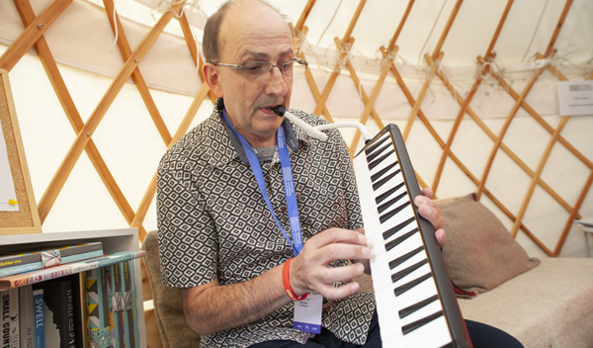
Children's poet James Carter gets you thinking about how to incorporate non-fiction poetry into science and nature topics

This resource is great for:
Getting tips from James Carter, whose poetry books are on subjects including the solar system and water cycle, on how to incorporate poetry and creative writing into your classroom topics.
Summary:
An interview with poet James Carter and associated activities designed to help you incorporate poetry into different topics.

Introduction:
During the 2018 Edinburgh International Book Festival, we took the opportunity to ask poet James Carter some questions about his wonderful non-fiction poetry books Once Upon a Sun and Once Upon a Raindrop. Click this link to read the interview and then work through the activities below.

Activities
Part One – Cross-curricular creative writing
Why not try to incorporate creative writing into your class’s science or nature topic?
Take James’ advice and start by gathering facts which you find interesting on the subject you’re studying. Once armed with all of the knowledge, challenge pupils to find a story within the facts.
Writing a story or poem using facts will help pupils to see the subject in a new way. They can even enjoy illustrating their stories or poems before reading them aloud to the class. And remember: poems don’t have to rhyme!
Part Two – Sensory storytelling
For some of his events at the Book Festival, James worked with experts from PAMIS to create a sensory version of Once Upon a Star.
Whether your class includes pupils with additional support needs or not, creating a sensory telling of one of James’ books (or another non-fiction book you enjoy) can be fun and help everyone to understand the topic covered.
Together, read the story page by page and think how you could bring it to life. Particularly think about what props you could use. At the Festival, we used a black umbrella with fairy lights stuck inside to represent the night sky and stars. You could also create a big sun out of shiny and bright materials. We even had an indoor confetti cannon to represent the Big Bang!
Once you have an action or prop to represent each page, you just need to read – and perform! – your story. Bonus points if you can incorporate sound effects and costumes too…

Further information:
James Carter makes regular visits to schools and libraries across the UK. You can find out more about him on his website: www.jamescarterpoet.co.uk

