Planning the Perfect Book Festival Event
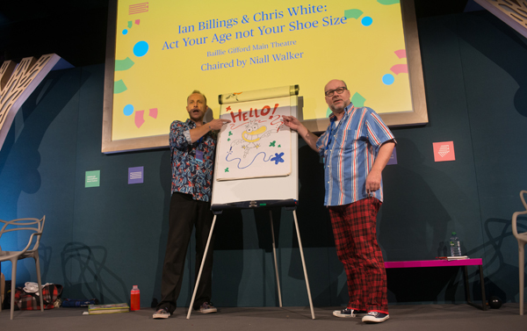
Design your own exciting author event for this year's
Edinburgh International Book Festival

This resource is great for:
Thinking about how to design and promote an event
Summary:
Watch a short video giving a snapshot of the Edinburgh International Book Festival. Then try planning your own imaginary Book Festival event, or series of activities. Send your ideas into us and you may see them at the Book Festival in future years!

Introduction
In 2018, as part of the Year of Young People, the Book Festival is working with a group of young co-designers to create a strand of events in this year’s programme.

The 8-14 year olds have been tasked with choosing authors, creating events and assisting in the promotion of the events.
Watch the video at the link below to get a sense of what happens at the Book Festival and then use the activities below to plan your own event or series of events: https://www.youtube.com/watch?v=ws95VbZ_3Go

Activity – Planning a Book Festival Event
Step One – Inviting your authors
Start by thinking which author(s) you would most like to see in a Book Festival event. This could be the author who has written your favourite book, an author who you think would be particularly entertaining, or someone who you know would speak about a topic that interests you.
Your event might feature one author, or you could pair two authors, or an author and an illustrator together, depending on what you think would make the most interesting event.
Once you’ve decided which author(s) you would like to invite, why not write them an imaginary invitation letter? In your letter, explain to them why you think they would be great in an event and why you would like to see them at the Book Festival. You could also highlight the benefits that they will get from an appearance at the Book Festival – the chance to meet their fans, see the beautiful city of Edinburgh etc.
Step Two – Creating your event
Next think about what’s going to happen during the event. Your event could feature a number of different elements:
- an audience Q&A – an opportunity for you to ask your burning questions
- live drawing – see the illustrations from the book come to life
- debate – a panel of people discussing an important issue
- interactive quizzes or games
- dressing up as characters from the book

- performance – music or a staged extract from the book
Be creative! Let your imagination run wild and think about what would make the most interesting event for an audience, while also being appropriate for the author and the content of their book.
Step Three – Accompanying activities
The Book Festival is about more than individual author events – there’s a brilliant Festival atmosphere to soak up as well, with lots of other activities taking place throughout each day. You could try planning some further activities to accompany your main event.
The Baillie Gifford Story Box in Charlotte Square Gardens is a drop-in space which schools can pop along to and take part in colourful craft activities. Is there a craft activity that could accompany your event? Perhaps you could create a collage of a scene from the featured book, or create a giant willow sculpture of one of the characters?
At the Book Festival, you can often find characters from your favourite books roaming around the Gardens, and on Baillie Gifford Gala Day see lots of exciting performers. Are there performers or characters who you could have moving around the Festival to entice people to come to your event?
If events at the Book Festival centre around difficult issues, there are sometimes drop-in clinics where audience members can discuss further the issues raised with a team of experts. Will your event feature discussions around issues that people may want to seek further advice on – such as gender identity or mental health? Do some research about what kind of experts you would want on hand to help.
Step Four – Promoting your event and activities
Now that you’ve planned your event and activities, you need to let people know about them!
Create a poster featuring lots of colourful images and information letting people know what’s going to happen in the event.

Alternatively, write a short article for a local newspaper highlighting the event and why people should come along.

Further information:
Send us your ideas! Once you’ve had a go at planning the perfect Book Festival event, why not send your ideas to us – maybe you will see your dreams become a reality…
Email us at learning@edbookfest.co.uk – we would love to see how creative you have been.

