Reimagining Your Town
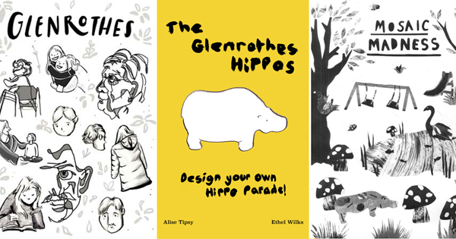
Explore your surroundings and then create activity sheets to inspire
others to do the same

This resource is great for:
Exploring your town and the public art you might find in it, and then getting creative!
Summary:
Look at the wonderful worksheets created by pupils from St Paul’s RC Primary School in Glenrothes, together with students from Edinburgh College of Art, and then be inspired to create some of your own based on the public art or points of interest in your own town, city or village.

Introduction
From totem poles to hippo parades, Scotland’s New Towns include lots of weird and wonderful examples of public art. As part of our ReimagiNation tour of the New Towns, we asked final year illustration students from Edinburgh College of Art (ECA), with help from P7 pupils at St Paul’s RC Primary School, to reimagine Glenrothes’ town art.

The result is a collection of wonderful activity sheets, which you can download from our On the Road site at the following link: https://ontheroad.edbookfest.co.uk/blog/reimagining-glenrothes-public-art/
Follow our instructions below and start thinking about the public art, or places of interest in your town. Then create your own activity sheets based around them and share them with other pupils at your school so that they can do their own exploring.

Activities
Part One
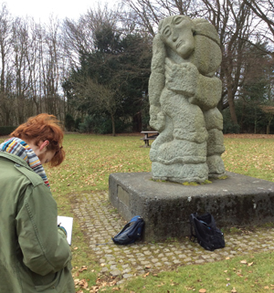
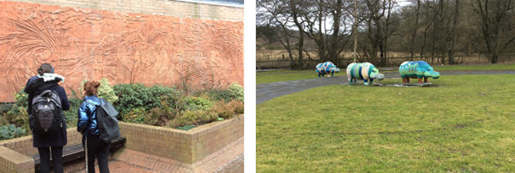
Take a look at the images of ECA students exploring Glenrothes’ town art below. Can you tell which piece of art corresponds to each activity sheet?
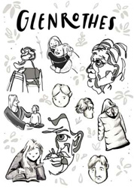
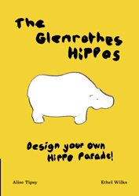
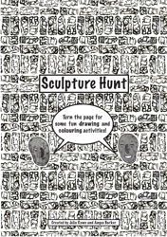

Look at the original statues and talk about how the students used them to create the activity sheets. Sometimes they ask you to design your own piece of art, and sometimes they ask you to reimagine an existing sculpture. They might ask you to imagine the story behind the artwork, or to do some creative writing around the themes. And sometimes they just inspire fun or silly activities!
Part Two
Are there any examples of public art in the place where you live? Or is there another point of interest? (If not, you could find a sculpture online, or in a museum).
Choose a sculpture or feature you like and create your own activity sheet around it. You will need to go and explore it so that you know it really well and do some research around how it came to be there.
Think about the ways in which pupils and students in Glenrothes used their statues as inspiration and come up with your own unique, creative and beautifully illustrated activities.
Part Three
Photocopy your activity sheets and swap with other pupils in your class or school. Then have lots of fun working through each other’s activities!

Further information:
You can download all the Glenrothes activity sheets at the following link: https://ontheroad.edbookfest.co.uk/blog/reimagining-glenrothes-public-art/
Our thanks go to Edinburgh College of Art and St Paul’s RC Primary School for their help in creating these activity sheets.

