Scintillating Science Fiction with Stephen Baxter
& Ken MacLeod
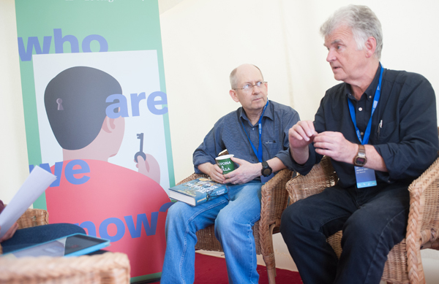
SF authors Stephen Baxter and Ken MacLeod give you an insight into the genre

This resource is great for:
Delving into Science Fiction with two greats of the genre, before imagining your own futuristic worlds and the stories which could take place in them.
Summary:
An interview with Science Fiction authors Stephen Baxter and Ken MacLeod, and some activities to get you writing stories of the genre.

Introduction
During the 2017 Edinburgh International Book Festival, young Science Fiction (SF) fans Sheena and Nathan took the opportunity to interview authors Stephen Baxter

and Ken MacLeod. They found out all about their new books, inspiration, SF recommended reads, and their tips for getting started on imagining your own SF universes.
Read the interview by clicking the link here and then use our SF creative writing tips below.

Creative Writing Activities
Part One
In the interview, Ken MacLeod gives this definition of Science Fiction:
Generally, I would say that Science Fiction is a fiction set in a world that is possible but hasn’t actually happened. So it’s an argued departure from the world that we know, because it’s set in the future, or because of a technological change, or because of something from outside our world.
Imagine what might happen in the future – it might be what you hope will happen, or something that you find really scary. Try to step into that world and imagine all of the different aspects of it. Then write a short description.
Some questions to get you started are:
- Who lives there? (Humans, aliens, robots..?)
- Where do they live?
- What conditions do they live under?
- Who is in control?
- What kind of society do they live in?
- How did our world become this world?
Stephen Baxter adds:
It’s fiction so it’s got people with feelings. How does it feel to live in a universe in which you’ve got smart robots doing all the work? How does it feel if the Martians invade? So it gets its power because it could happen this way – and how would we feel if it did?

Now find the story in your imagined world. Stephen suggests you ask yourself the question, ‘Who’s it hurting?’ So imagine who’s at the bottom rung of your society, or who’s most in danger, or being penalised. What would their story be? Do they try to rebel against society (or captors)?
Make sure you consider how living in that society would make your character(s) feel and try to create genuine personalities. Write some character studies of the people living in your world. What stories emerge for your protagonists?
Part Two
Stephen’s Book The Massacre of Mankind is a sequel to H G Wells’ famous The War of the Worlds. If you have a SF novel (or comic or TV series) which you enjoy, why not try writing a plot outline for a sequel? Imagine what could happen next. If the world is changed at the end, then imagine what living in that world would be like. Are the threats the same as in the original, or does something different happen? Use characters from the existing story or imagine your own ones who inhabit the same world.
Part Three
Some of the books which Ken and Stephen mention in the interview are examples of Climate Fiction, or ‘Cli-Fi’. These are books, often set in the near future, which describe the results of changes to our climate. For example, countries of the world being threatened by rising sea water, increased temperatures, plant species (and therefore food) dying out due to a decrease in the number of insects etc. Lots of people think Cli-Fi is important in giving people a description of the potential effects of climate change.
Think about what you know about climate change. Choose one aspect and imagine what the world would be like if that aspect was taken to an extreme. How would people be able to live in that changed world? Find the story and characters in the situation.
Part Four
Stephen and Ken mention lots of SF books and authors throughout the interview. Why not look some of them up and pick out a few to read? You may discover a love of Science Fiction that you never knew you had!

Further information
Young reporters Sheena and Nathan are taking part in What’s Your Story?, Scottish Book Trust’s development programme for teenage writers and illustrators. Find out more about the programme at www.thestoryis.co.uk

