Sing Along with Nick Cope
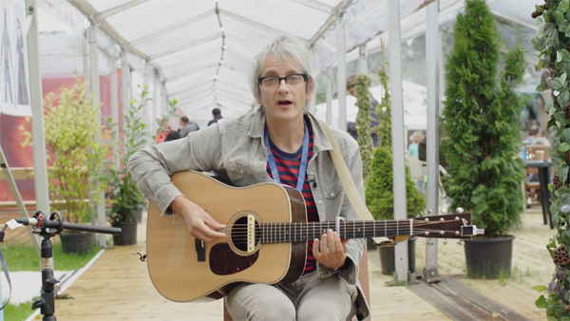
A fun sing-along with hilarious children's author Nick Cope and tips to write your own funny animal stories

This resource is great for:
Having fun, singing along and getting imaginative!
Summary:
Author and singer Nick Cope sings his hilarious song The Very Silly Dog, and gives you tips to make up your own funny story about a pet.

Introduction:
Nick Cope has been entertaining audiences with his hilarious songs for years, but in 2018 he joined us at the Edinburgh International Book Festival to share his first ever picture books, The Very Silly Dog, Why is the Sky Blue? and I Don’t Wanna Do That (complete with chords at the back so you can play and sing along with the story…)
Watch the video on YouTube at the following link and sing or clap along as Nick performs The Very Silly Dog: www.youtube.com/watch?v=ZXqthRk5G9I&t=1s

Activities
Part One – Pet Poems and Stories
In the video, Nick gives you some ideas to write a story or poem or song about a pet yourselves.
It could be a pet that you have, it could be a pet that you wish for, or a pet that maybe you miss. Or it could be a superhero pet, like a ninja kitten or a goldfish that becomes the president of the United States.
If you prefer drawing to writing, Nick suggests that you could draw your story as a cartoon, adding some speech bubbles with words.
Part Two – Imaginative Illustrations
Nick tells us that the illustrations in The Very Silly Dog were done by his son when he was 9 years old! Why not illustrate one of your own stories by taking the words of the story and turning them into pictures? Or if you want you could choose your favourite book – maybe one of Nick’s – and create your own original illustrations for it.

Further information:
You can find out all about Nick Cope, including more videos of his very silly songs, on his website: www.nickcope.co.uk

