Drawing Girafficorns with Barroux!
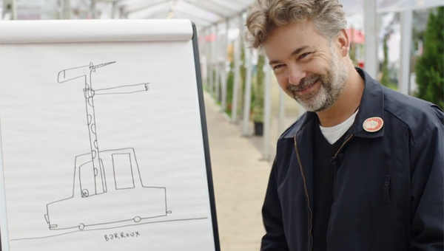
Get drawing crazy creatures with illustrator Barroux

This resource is great for:
Having fun and drawing some crazy creatures!
Summary:
Watch a video interview with children’s author and illustrator Barroux during which he draws an incredible Girafficorn! Then get drawing some of your own crazy creature inventions.
Introduction
The video link below is part of a series of films featuring our Year of Young People young programmers interviewing some of the wonderful authors they chose for their 2018 strand of events exploring the theme of Freedom in all its different forms.

Young programmers Unmol, Bruce and India jumped at the chance to interview Barroux, author and illustrator of How Many Trees? and Where’s the Elephant?, and illustrator of Michael Morpurgo’s In the Mouth of the Wolf.
Watch the interview here: https://www.youtube.com/watch?v=xw9IkwWcxoA#
Activities
Part One – Icebreaker Game
The first question which young programmer Unmol asks Barroux is taken from an icebreaker game which our young programmers used to play at the start of their planning sessions:
If you were a genre of book, what genre would you be?
Play the game in class by taking it in turns to think about how you feel at the moment and therefore what genre or type of book you would be. You don’t have to explain your choice if you don’t want – often the genre chosen can tell you quite a lot about how everyone is feeling on a particular day.
Try the same game but with some different questions – Which one book in particular would you be? If you could be any character in a book, which would you be?
Part Two – Creating Crazy Creatures
In the video, Bruce asks Barroux to draw a unicorn… but that’s not quite what he does!
Challenge yourself or your classmates to draw some crazy creatures by picking two different animals and merging them into one funny drawing. Remember you can include fictional animals like unicorns and dragons.
After you have drawn your creation, make sure you give them a brilliant blended name like Barroux’s Girafficorn!

Further information:
You can find out more about our young programmers and the events they programmed as part of their 2018 strand here: https://learning.edbookfest.co.uk/news/year-of-young-people-meet-our-young-programmers/

