Fighting for the Future with Hayley Barker
and Mary Watson
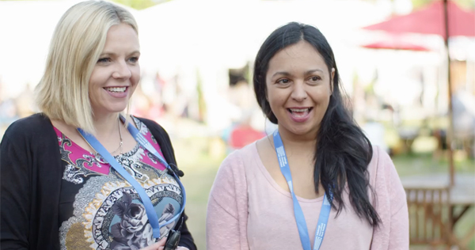
Hear from two authors of dark and action-packed novels and then get writing your own pieces merging current concerns and fantasy elements

This resource is great for:
Writing about issues that concern you – either in society or in your own life
Summary:
Watch a video interview with authors Hayley Barker and Mary Watson to find out what inspired their books, featuring fantasy elements and political messages. Then have your pen at the ready to get writing yourself!

Introduction
The video interview below is part of a series featuring our Year of Young People young programmers interviewing some of the wonderful authors they chose for their 2018 strand of events exploring the theme of Freedom in all its different forms.

Hayley Barker’s Show Stealer is a dystopian novel in which children must perform in a deadly circus. While in The Wren Hunt by Mary Watson, Wren Silke is caught in a battle between two ancient magics.
Hear directly from the authors of these dark and action-packed novels for young adults. Then use our accompanying activity to get writing your own stories, merging current concerns with fantasy elements.
Watch the video here: https://www.youtube.com/watch?v=an0_UGtjdok&t=1s

Activity
Get a selection of newspapers and magazines, or search on the internet, to find articles about issues which concern you – either in society or in your own life. Perhaps some of the articles might tie in with the 2018 Book Festival’s theme of Freedom.
Both Hayley and Mary’s books merge political and fantasy elements. Look through the news stories you’ve chosen and imagine which kind of character could be affected by the situations described in the articles. They could be:
- someone whose freedom has been jeopardised by the situation they are in.
- someone in power who has to make decisions which affect the lives of others.
Think about how your character would react to the situation? What power do they have to control their own lives (or the lives of others)? Are they able to fight for freedom, or are they carried along by other forces?
Now add a fantastical element to your story:
- does your character live in alternative universe or society?
- do they, or others around them, have fantastical powers (which might help or hinder them)?
How would these fantasy elements affect the issue which you decided to write about?

Try to immerse yourself in the issue and your fantastical elements. Hopefully you’ve got the start of a great story! All you have to do now is finish it…

Further information
You can find out more about our young programmers and the events they programmed as part of their 2018 strand here: https://learning.edbookfest.co.uk/news/year-of-young-people-meet-our-young-programmers/

