Thrilling Themes with Sarah Mussi and Nikesh Shukla
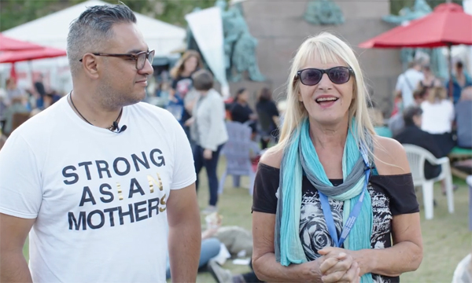
Start discussions in the classroom around freedom, society and politics

This resource is great for:
Kicking off discussions about some key issues in society.
Summary:
Watch a video interview with teen thriller writers Sarah Mussi and Nikesh Shukla from the 2018 Edinburgh International Book Festival. Then use our discussion points to get your class talking about some big topics.

Introduction
Sarah Mussi and Nikesh Shukla’s gripping thrillers for young adults merge fascinating plots and characters with strong political and societal themes. Freedoms are tested in Sarah Mussi’s Angel Dust and Breakdown as life and love are at stake. Nikesh Shukla’s Run, Riot is centred around two teenagers who witness the police shooting an unarmed man and find themselves running from those who are meant to protect them.

Our Year of Young People 2018 young programmers Joe and Jonathan got to grips with these themes as they interviewed Sarah and Nikesh before their event at the Book Festival. Watch the interview at the link below, then use our discussion points to get to grips with some of the themes yourselves.
Watch the interview here: https://www.youtube.com/watch?v=_yTZiwtV8tM&t=17s

Discussion Points
During the interview, young programmers Joe and Jonathan ask Sarah and Nikesh some great questions which we think would start some interesting discussion points in the classroom.
In your class, or in small groups, use the following as discussion prompts:
- What is the freedom you’re most grateful for in your life?
- What is the biggest challenge facing young people in society today and what do you think we can do about it?
- Have you read any books which have political or social themes? What were those themes and how did the books deal with them? What came across as more important – the theme or the characters – and what impact did that have?
- If you were going to write a story based on a political or social issue, what would you choose and why?
- Do you think fiction is a good medium to raise these issues? Why or why not?

Further information:
You can find out more about our young programmers and the events they programmed as part of their 2018 strand here: https://learning.edbookfest.co.uk/news/year-of-young-people-meet-our-young-programmers/

