Powerful Forces with Emily Dodd
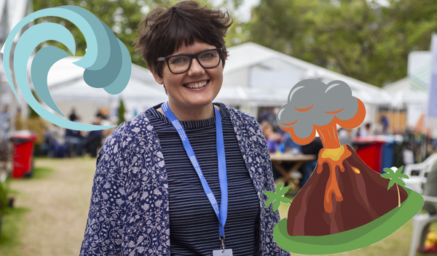
Learn more about the awesome power of nature with author and science communicator Emily Dodd
This resource is great for:
Learning about the forces of nature.
Summary:
An interview with author and science communicator Emily Dodd and associated activities designed to help your understanding of the forces of nature.
Introduction:
Emily Dodd is a fantastic author of both picture books and non-fiction. When we heard that her latest series explained forces of nature including tsunamis, volcanoes and wind power in a fascinating and accessible way, we jumped at the opportunity to ask her some questions. Prepare to be blown away!
Read the interview in full here

Activities
Part One – Wind Power
In the interview, Emily explains why wind power is a renewable and clean type of energy, and why it’s a great type to use in blowy Scotland!
- How many types of power can you name?
- Which ones of these are renewable, like wind power?
- Make a list of the good and bad things about each type of energy. For example, wind power is renewable BUT it can only be captured in places where there is a lot of wind.
- Choose one type of energy and research how we turn it into the power in our homes.
- In pairs, draw a picture (or series of pictures) which show how we turn your chosen energy into power in our homes.

Part Two – Volcanoes, Tsunamis & Earthquakes
Emily tells us about the Ring of Fire, the area with the most volcanoes, tsunamis and earthquakes in the world.
- Get a globe, map or online map and find the Ring of Fire.
- Which countries do you think will be affected by the tsunamis, volcanoes and earthquakes there?
- Search online – can you find examples of news stories about natural disasters in these areas?
- What effects do these types of disasters have on the people in these areas?

Part Three – Gravity
At the end of the interview, Emily talks you through a couple of easy exercises which demonstrate another powerful force – gravity. So get up on your feet, make like Isaac Newton, and discover the force of gravity!

