I Am: Writing a Self-Portrait Poem with Layla Josephine
Writing about self without worrying about structure or rhyming

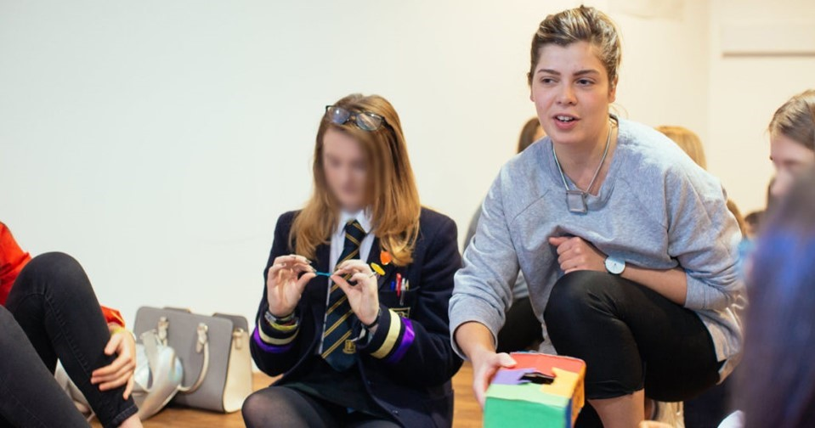
Summary:
Learn how to write poetry about yourself without worrying about structure or rhyming in this resource written by our Schools Writer in Residence Leyla Josephine.
This resource is great for:
Getting everyone - even those who are intimidated by poetry writing - to give it a go!

Introduction
This is the second in a series of activities exploring self-reflection and identity, created by Leyla Josephine, poet, performer, facilitator, theatre-maker, and one of our Citizen writers in residence.
Leyla says: “Poetry can be intimidating, nevermind writing poetry, nevermind writing poetry about yourself! It can seem really daunting at first but by simply asking your group some clever questions they can find their way into writing a poem that says more about themselves than they could ever come up with if they were asked.”
All of Leyla’s activities can be made simpler or more complex depending on or ability.

Step 1
Write “I am” twenty times down the left-hand side of a page.

Step 2
Next to each of the “I am”s answer each of the following questions*:
If you were an animal what animal would you be?
If you were a type of land what type of land would you be? (jungle, desert…)
If you were a colour/s what would you be?
If you were a time of day what time would you be?
If you were a type of plant, what would you be?
If you were a natural disaster what would you be?
If you were a season what season would you be?
If you were a building what building would you be?
If you were a body part what would you be?
What’s your favourite song?
What is a recognisable feature about yourself?
What is the best piece of advice you’ve been given?
What’s your personality like?
Who are the people that have influenced you?
What are your hopes and dreams?
What are you scared of?
What is your favourite piece of clothing?
What is your favourite place?
*These questions are just suggestions, please feel free to change them up.

Step 3
Go back through and pick out a few of your answers and add an explanation: “because…”.

Step 4
Go through what you’ve written and edit it so that it makes grammatical sense.
For example: for the best piece of advice you’ve been given, you might have written ‘I am … always be yourself.’ You could change it to ‘I am always trying to be myself’ or ‘I am myself’.
Maybe for your favourite song you’ve written ‘I am… rain on me’. Maybe you could change it to ‘I am listening to Rain on Me’.
Think about how it sounds.

Step 5
Play with the order. Take out anything you don’t think works well and add anything that does.

Step 6
You now have an individual list poem about yourself. You could display it beside your self-portrait which you made in the first activity.
Here’s an example of an “I Am” Poem:
I am Glasgow, with countless windows and doors
its wet streets and public arguments
I am a hurricane, better get out my way
I am a spider, my hair stands on end
I am a summer,
sunsets and red hot
I am purple and sometimes blue
I am a bridge, bringing people together

I am always looking forward, never looking
I am thoughtful, sensitive and moody
I am my mum and my aunts
the stars and the moon
I am singing along to Ariana Grande
always wearing my black jeans
I am my piggy nose and thick brown hair
I am a desert, my humour is dry
I am a tree with many branches
I am scared of being forgotten
and I hope that I find my way.

Further information
Find out more about Leyla's work in schools, part of our year-round programme of community events, here.

