A Squash and a Squeeze: A Sensory Story
Creating a Sensory Story to accompany a Julia Donaldson classic!
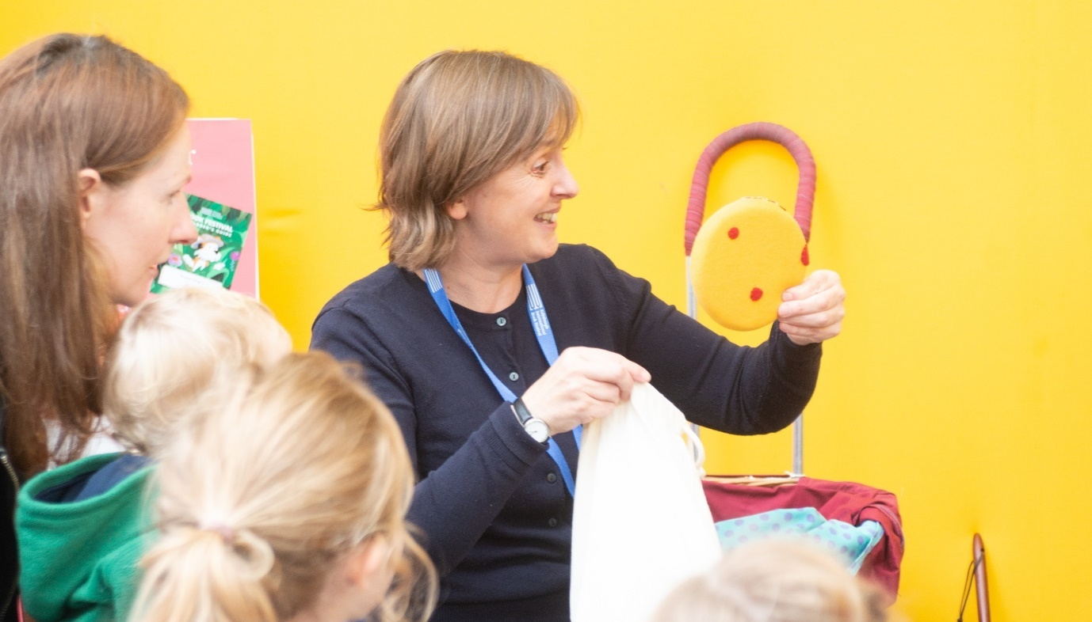

Summary:
Join Sensory Storyteller Ailie Finlay to create your own sensory story to accompany Julia Donaldson’s wonderful story A Squash and a Squeeze, which she will perform during her event Cooking and Drawing up a Storm at Edinburgh International Book Festival 2020.
This resource is great for:
Making sure that everyone can enjoy the Book Festival online, especially those with learning disabilities, by creating sensory stories to accompany events.

Introduction
Join in with Julia Donaldson’s performance of A Squash and a Squeeze by creating your own sensory story using props and sounds.

Step 1
Watch this video created by Sensory Storyteller Ailie Finlay in which she suggests props which you can gather or make from around your home.
https://youtu.be/kEAlfVWkVy4
Prop suggestions:
- Feathers or a marigold glove chicken wattle
- laundry detergent lid pig trotters
- scrubbing brush goat beard
- newspaper cow tail

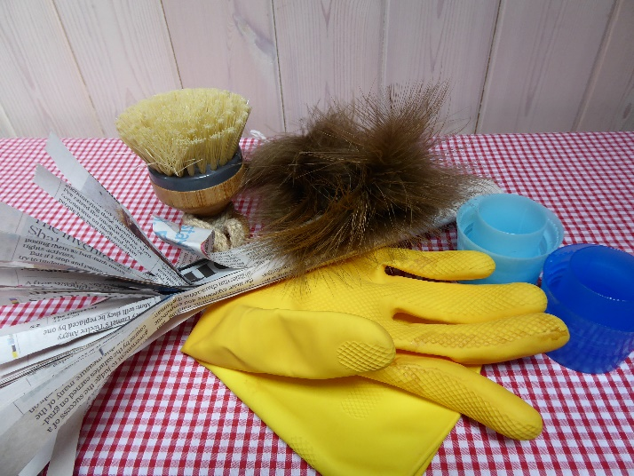

Step 2
If possible ‘introduce’ your child to the props before the show starts saying: ‘This is the feathery chicken. This is the goat with the bristly beard. This is the pig with the trit-trot trotters. And this is the cow with the swishy tail.’
Step 3
Watch Julia’s event Cooking and Drawing up a Storm. As Julia performs A Squash and a Squeeze join in by using the props above as each animal takes its turn in the song; brush the child’s hand with the feathers or ‘tail’, make clip-clop noises with the ‘trotters’, let the child feel the goat’s ‘beard’.
You could also act out actions for each animal, nibble for the goat, bang on the table for the cow etc, and join in with the animal noises! You could also give your child a ‘squash’ and ‘squeeze’ when these are mentioned; maybe a little ‘squash’ as you gently press their upper arms, or very softly ‘squeeze’ their hand. At the end of the song take the child’s hands and join in with a little ‘frolic’ with the little old lady and the wise old man.
Step 4
Remember children often enjoy a story more if they hear it several times. So, if possible, keep your collection of props together and read A Squash and a Squeeze to your child if you have a copy, or go back to view the song again.

Further information
If you would like your own copy of A Squash and a Squeeze it is available to buy from our independent online bookshop.

