Awesome Science Questions Answered with Dr Emily Grossman
Explore your inquisitive side with Brain-fizzing Facts

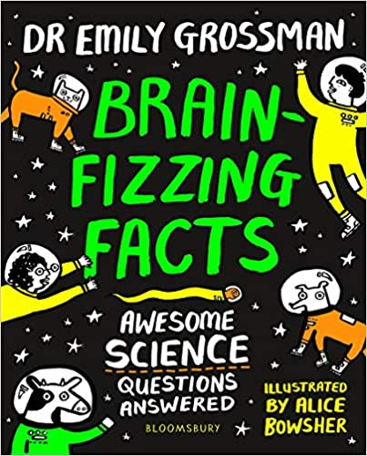

Level:
Second (P5-7) – KS2
Explore themes of:
√ Animals and How They Breathe √ Asking Scientific Questions √ Being Curious About the World √ Climate Change √ The Water Cycle
Subject Checklist:
√ Sciences √ Expressive Arts √ English Language √ Well-being and Health

At a Glance
Before watching the video or reading the extract!
- How does the book’s title make you curious?
- What do you like about the colours and illustrations?
- Are there any clues that this is a non-fiction book? What is non-fiction?

Book Cover Activity: What is a Scientist?
Look closely at the cover of Brain-fizzing Facts; is this a book you would pick up if you saw it on the shelf? Why/why not? On an A4 piece of card or paper, note down:
- What words or ideas spring to mind when you see the word ‘science?’
- What about the word ‘scientist’? Who do you picture in your mind? Sketch them! What personal qualities do they have?
Keep this safe as you will refer back to it later on!

Read the Extract
Taken from pages 159–163 of ‘Brain-fizzing Facts’
Discussion Questions
1. Which of the animals on page 159 do you think can breathe through their bottom?
2. How do human beings breathe? How is it different?
3. What do ‘all living creatures need to survive?’
4. How long are you able to stay underwater before coming up for air?
5. One page 161, roughly how long can dolphins stay underwater? How do they breathe?
6. On page 162, how long can sperm whales stay underwater for?
7. What is the human record? Why is this amazing?
8. What do you learn about frogs on page 163?
9. What about turtles? Write bullet points about the key information you learn.
10. Did you answer question 1 correctly? Which is your favourite fact of the book so far?
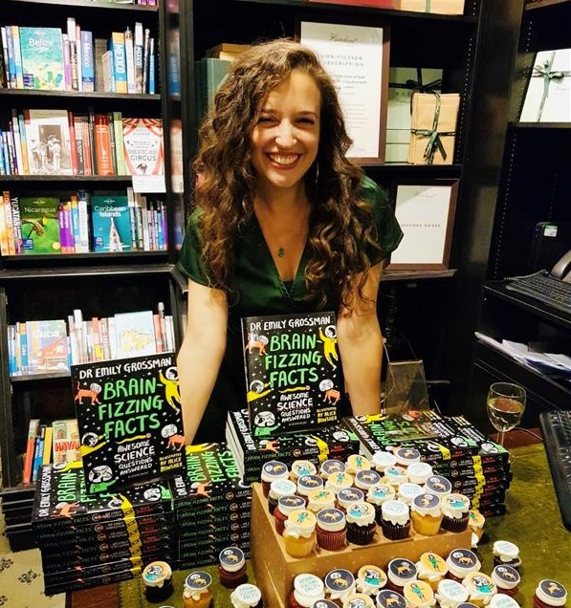
Watch the Video: Get to Know the Author!
Activity 1: Asking ‘Why?’
Emily explains what she loves about science / 5:20–12:20mins
- With a partner, discuss the importance of asking ‘why?’ What do we learn by asking questions? What stops us from asking questions sometimes?
- Look back at the work you did in the ‘Book Cover Activity’. How does this compare to what Dr Emily Grossman says in her video? Has this changed your mind about science and scientists in any way?
- Now it’s your turn to start asking why! Take a few moments to think about scientific questions you would love to know the answers to. Talk about them with a partner; can you answer any of all the resources you have available to you to see if you can find some answers. You might not able to answer them all today but keep being curious and you’ll get there eventually!
- Share some of your favourite facts together and see which questions are left unanswered … for now!

Activity 2: How to Block a Tickle
Emily talks about one of her favourite facts / pages 210–217 and 18:10–25:05mins
- Has anyone ever tickled you before? What feelings do you have when you are being tickled? Next, try to tickle yourself. Does it work?
- When you have watched Emily’s video clip or read the section from her book, discuss with a partner:
- How has the human brain changed over time?
- Why aren’t we able to tickle ourselves?
- What can we do to trick the brain?
- Draw a picture of a brain and inside it, write a summary giving a scientific explanation as to why it is impossible to tickle yourself and how to stop others tickling you. Use the key words below to help you:
BRAIN SURPRISE SURVIVAL INSTINCTS
EVOLVE PREDICTION TRICK
- If you are happy to, ask a friend to try and tickle you, trying out your new tactic to make it stop. Note: It’s very important that you stop when your partner asks you to and that no-one has to be tickled if they don’t want to be!
Your Turn: Develop Your Scientific Skills
Activity 1: Taking Action Against Climate Change
Illustration of fish in the sea from page 161

- Towards the end of her interview, Emily talks about the important issue of climate change. She says there are lots of things human beings could do or stop doing in order to slow down or stop the earth heating up.
- Emily points out that we have to work together in order to avoid the earth’s temperature rising even more, water shortages, storms and extreme weather conditions, ice melting and sea levels rising.
- In pairs, note down 5 ACTIONS that you or other people could take to try to stop climate change. Then, for each action, write down the positive IMPACT that this would have.
- Feedback your ideas together, adding a further 5 actions and impacts based on the discussions you have.
- At home, see if you can have a chat with your family about making some small changes to your lifestyles and routines in order to help save the planet!
Activity 2: Create your Own Cloud in a Bottle
It’s time for an experiment!

- For this experiment you will need:
- a plastic bottle (one you will re-use time and time again!)
- a bicycle pump or similar
- a cork to fit in the bottle with a hole in it for the pump’s nozzle

Step One: Take your bottle and place the cork in the top
Step Two: Attach your pump to the nozzle in your cork
Step Three: Begin pumping air into it
Step Four: Keep going! Give it a few more pumps
Step Five: Release the bottle really quickly and see the cloud you have created!

- Together, talk through your experiment and how it links to the Water Cycle and the process of clouds forming.
- Finally, use the key words below to draw and label a diagram about how clouds are formed. Add in any additional detail and facts that you can to make it as informative as possible!

WATER VAPOUR OCEANS RISES AND EXPANDS
INCREASE PRESSURE WARM EVAPORATION
DROPLETS OF WATER CLOUDS PRESSURE DROPS COLD

Reflection and Further Questions
Reflection Activity
Think over all that you have learnt today. Perhaps you’ve changed your mind about science in general and what it takes to be a scientist? Or maybe you’ve found out some ‘brain-fizzing facts’ that have made you hungry for more? Use these ideas to answer the questions below and share what you have learned with your family at home.
How has your opinion of science changed?
Do you think of scientists any differently after today? Explain why.
What is your favourite fact of the day?
What was your favourite activity and why?
Lastly, do you have any final scientific questions you would like to ask Emily if you got the chance? Try to think of at least two and make a note of them. Who knows, Emily may even answer them in her next book!

