**Changing the World with Nathan Bryon and Dapo Adeola**

Explore how you can make the world a better place with   
*Look Up!* and *Clean Up!*

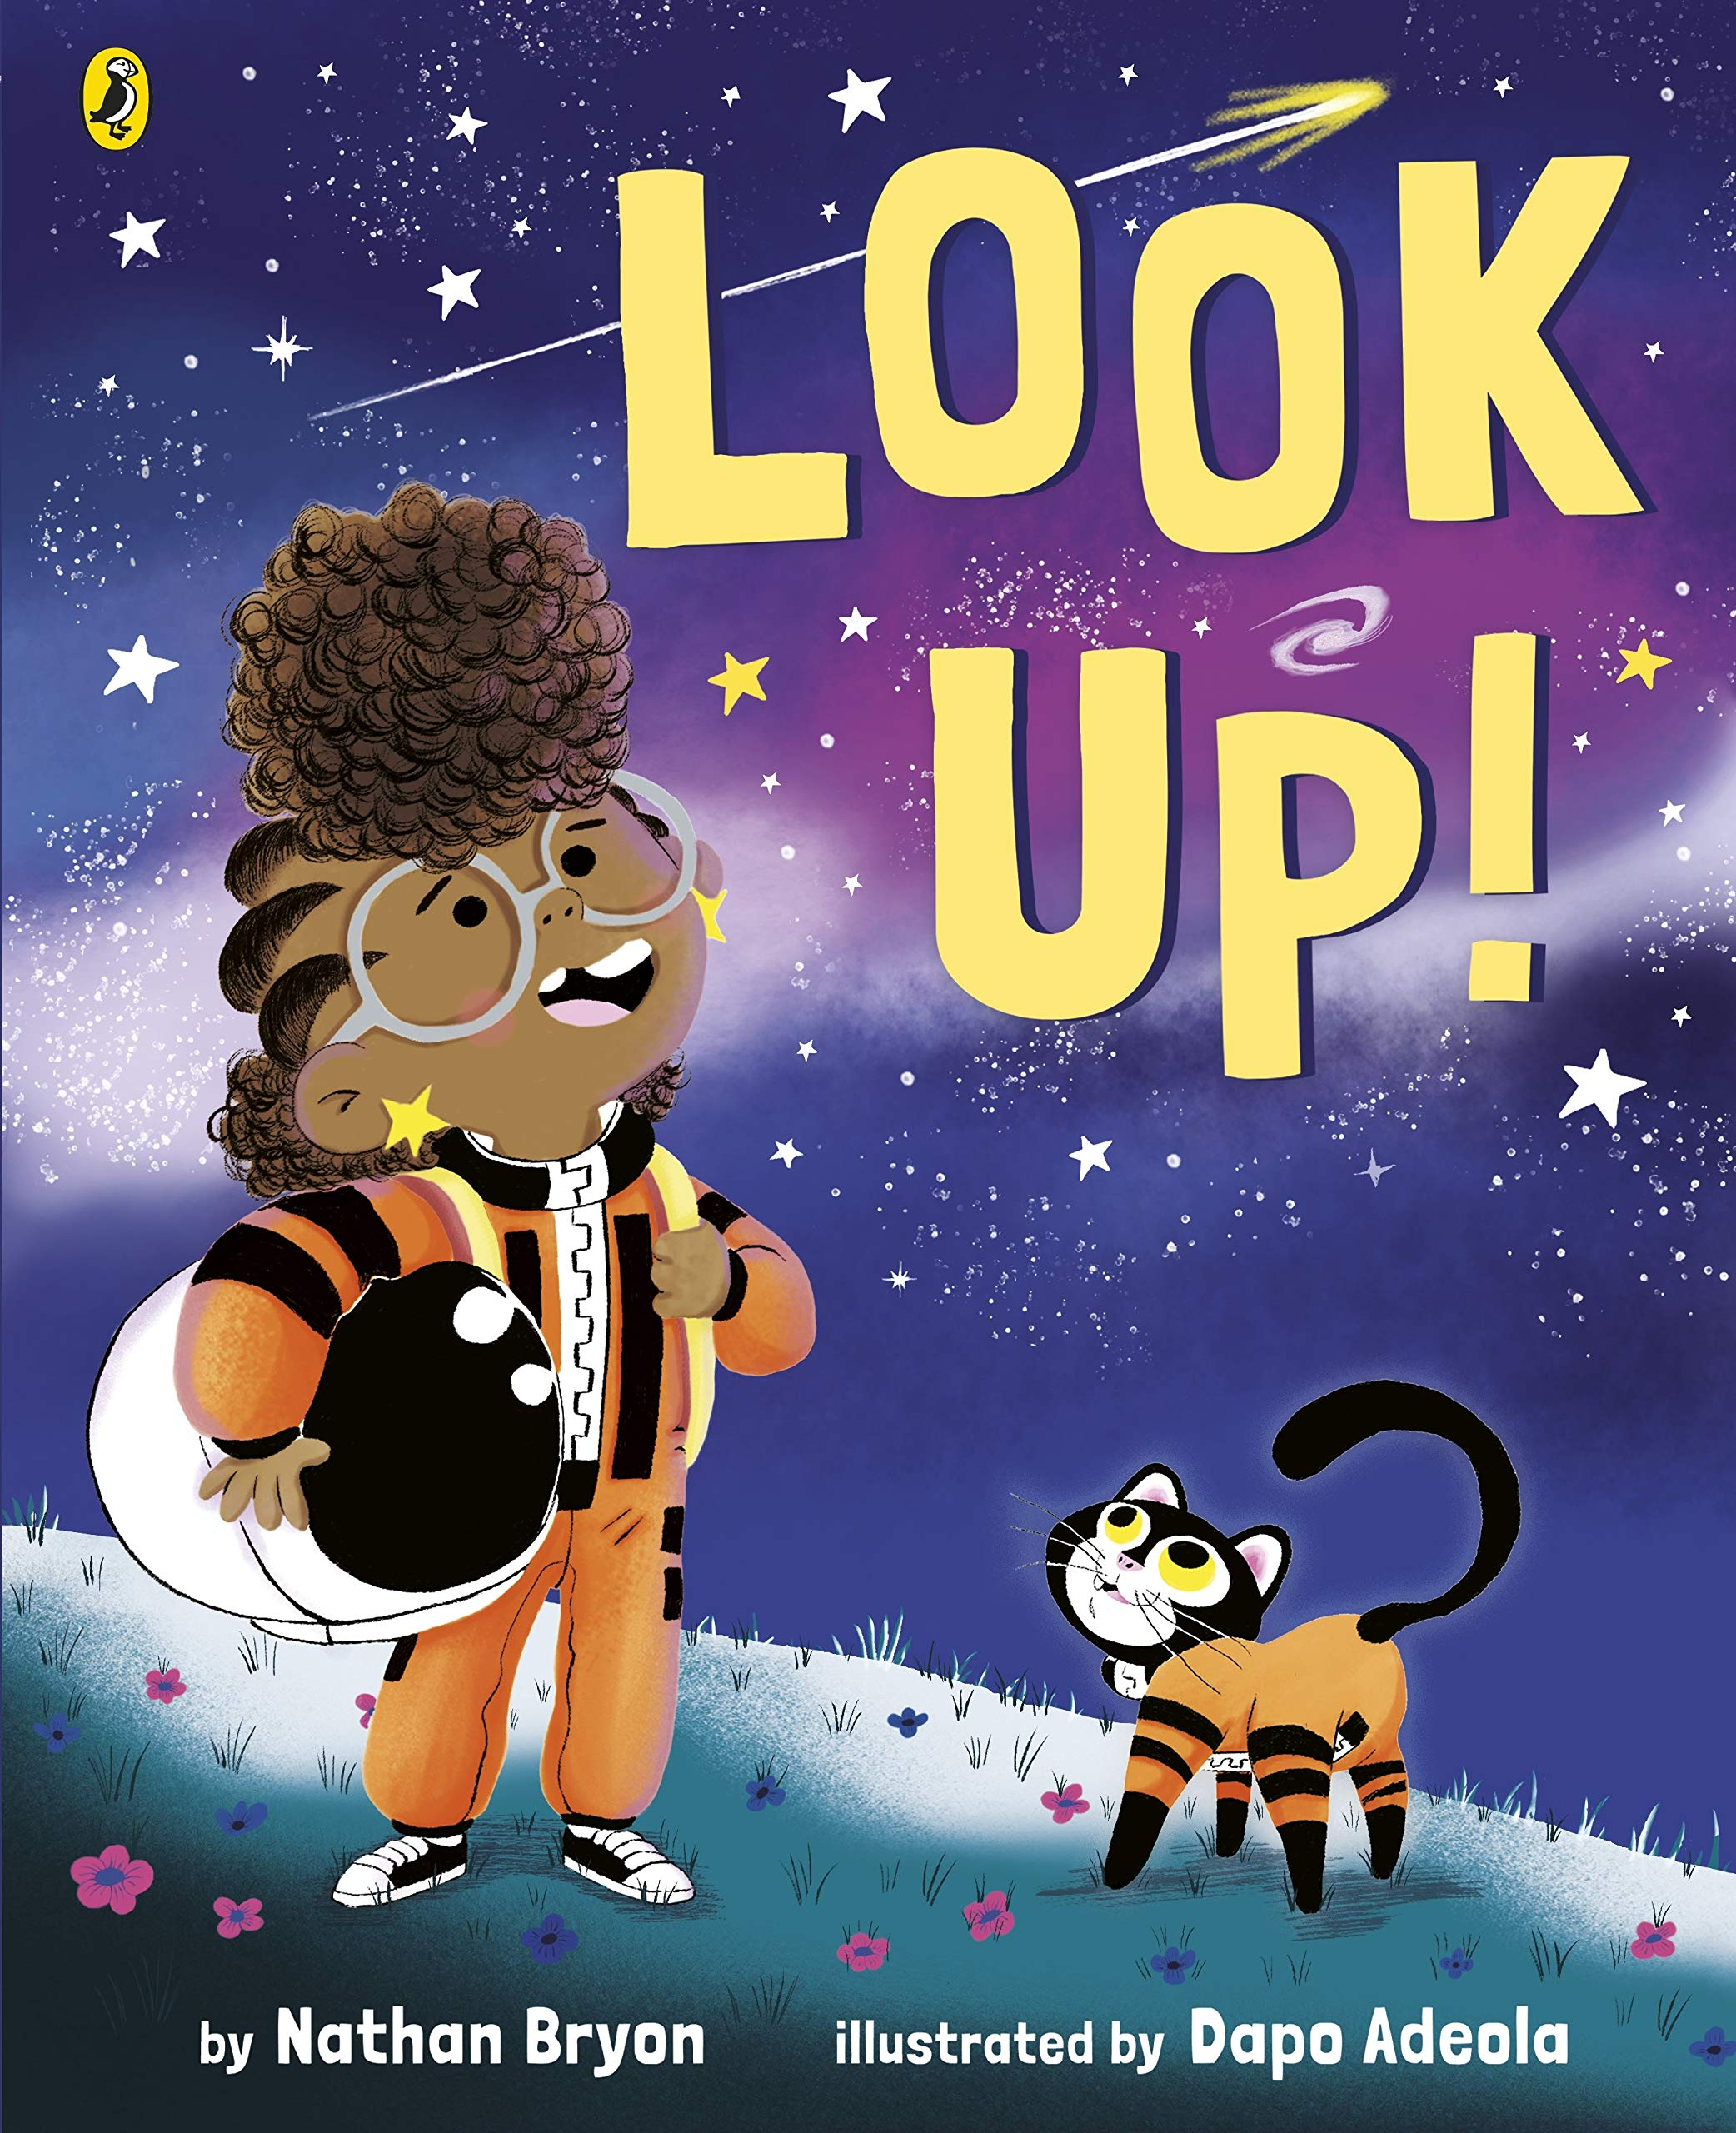 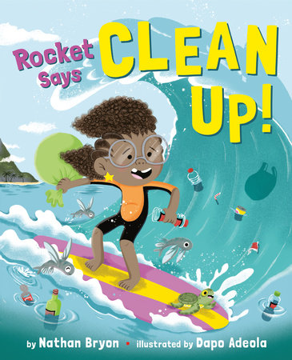

**Level:**First (P2–4) / KS1

**Explore themes of:**  
√ Appreciating the World √ Family √ Plastic Pollution √ The Beach √ Sea Creatures

**Subject Checklist:**  
√ Sciences √ Expressive Arts √ English Language √ Social Studies √ Well-being and Health

**At a Glance***Before watching the video or reading the books!*

1. What do these two book covers have in common? How do you think they will be similar? Think about the characters and themes.
2. How can you tell that both of these books are about the world we live in?
3. How does the main character feel about the world she lives in? How can you tell?

**Book Cover Activity: Who is the main character?**  
A book’s front cover gives the reader clues about the main character of the story. Look closely at the covers of *Look Up!* and *Clean Up!.* Then, make some predictions about the main character by filling in the blanks below.

*I think the girl pictured on both covers is feeling …*

*I think the girl is passionate about …*

*I think an important theme for the girl might be …*

*Three words I would use to describe the girl are …*

**Read the Books***Taken from ‘Look Up!’ and ‘Clean Up!’*

**Discussion Questions**

1. What does it mean if your head is ‘always floating in the clouds’? What sort of character is Rocket, judging from this description in *Look Up!*

2. What is Rocket’s relationship with her brother Jamal? What is he like?

3. What challenges does Rocket face in the two stories?

4. How does the illustrator, Dapo Adeola, show Rocket’s feelings in the stories?

5. In *Clean Up!* what is Rocket’s relationship with her Grandparents?

6. How do the pictures complement the words in the stories?

7. In *Clean Up!* what causes Rocket to feel sad?

8. How does Rocket try to fix things in both stories?

9. Have you ever felt like Rocket? Give an example.

10. Who do you think are Rocket’s role models? Who are your role models?



**Watch the Video: Get to Know the Author and Illustrator!**

**Activity 1: The Problem with Plastic   
*Nathan explains where he got the motivation to write Clean Up! / 6.44–11.03mins***

* **If you could picture the perfect beach in your mind’s eye, what would it look like? Consider the colours you would use, what the sand would look like, what the sea would look like, and who/what would be there. Which creatures might you see? Draw your perfect beach scene.**
* **Then, watch Nathan Bryon explain where he got his motivation to create *Clean Up!* What does he say? Draw the beach scene that Nathan describes. How is it different to the “perfect” beach you drew before?**
* **Nathan describes litter and plastic all over the beach. What kind of problems does this cause for creatures that live in the sea? Discuss with a partner. You can use the following ideas to help you: sea creatures eating the plastic, and sea creatures getting tangled in the plastic.**
* **The following two sea creatures are mentioned in the story. What happens to them? How are they affected by plastic, and how does Rocket feel about it?**
* ***Whales***
* ***Turtles***
* **Draw each of these creatures. Then, imagine if they could speak aloud, like humans can! Act in role as either a whale or a turtle, describing your thoughts about plastic pollution and humans leaving litter on the beach. If you want to, you can even write these creatures’ thoughts in speech bubbles next to your drawings.**

**Activity 2: Assemble Your Clean Up Crew!   
*Nathan reads Clean Up! / 20.36–26.20mins***

* **In the story, Rocket assembles a ‘Clean Up Crew’. What does she do this for? What does she want the Clean Up Crew to do?**
* **Think of your nearest beach. Where is it? How long does it take to get there? Imagine you need to organise a Clean Up Crew just like the one in the story, to clean all of the litter off the beach. Create a poster encouraging people to join your Clean Up Crew. Include the following things:**
  + ***Why the beach needs to be cleaned***
  + ***A persuasive reason for people to help***
  + ***Pictures of what the beach looks like***
  + ***A snappy call-to-action!***
* **You might want to include some of the facts mentioned in the story: *1. Whales eat the plastic and it makes them sick. 2. Nearly half the rubbish in the sea comes from careless people. 3. There are over 5.25 TRILLION pieces of plastic in the ocean.***
* **Once you have created your posters, think about what sorts of creative things you can do with all of the plastic you clean up on the beach. For example, in the story, Theresa’s Mum makes new bins. What other creative solutions can you think of?**

**Your Turn: Develop Your Illustration Skills**

**Activity 1: Illustrating Friends and Family Members   
*Dapo explains his inspiration for characters and settings / 6.44–11.03 and 15.03mins – Illustration from Look Up!***



* **Dapo Adeola describes how he based the character Rocket on his niece. He also describes how he bases Grammy in *Clean Up!* on his own Nan. What do you think Dapo’s niece and Nan must be like? How would you describe them, based on the characters in the stories?**
* **If you were to create a brand new character, who would you base it on? Choose a friend or family member who you think would make a brilliant character in a story. Consider their personality traits and their strengths/weaknesses.**
* **Draw a character based on your chosen friend or family member. Remember to change their names, and even their appearance if you think it would help to make the character unique!**
* **Think about how your character would act and speak. Walk around the room in role as your character. Say hello to your classmates’ characters, too!**
* **Finally, Dapo shares a spread from *Look Up!* in which he has named some of the shops in the street after his friends. If you could create a street of shops, which friends would you name them after and why? Create your own street settings and share them with your classmates!  
    
  Activity 2: Illustrating Your Imagination  
  *Dapo shares his favourite spreads / 18.17–20.30mins***
* **Dapo shares an illustration that shows what Rocket sees in the real world, as well as what Rocket is imagining in her head. Why is this effective?**
* **Think about what you see in your own imagination, or what dreams you might have. Do you ever think of a special place or event? Draw a scene that shows all of the things in your dreams or imagination!**
* **Then, consider how you can make your drawing look even more mysterious and dreamy. Consider how you use the following things:**

**COLOUR LIGHT/DARK STRANGE ELEMENTS BLURRING**

* **Show your Imagination Illustration to a friend, family member or classmate. What can they tell about you from the illustration? What sorts of things do you think about? Why is it important for others to understand that you are much more than what you present on the surface? It is normal to have lots going on in your head!**

**Reflection and Further Questions**

**Reflection Activity   
In both stories, the main character, Rocket, is a very curious, determined and strong person who wants to change the world and make it a better place. Think about what you’d really like to change about the world to make things better. Discuss with a partner or fill in the blanks below to write a reflection about what you’d like to change.**

***I am passionate about …***

***The thing I’d like to change about the world is …***

***The reason I’d like to change it is …***

***It would help make the world a better place because …***

**Lastly, do you have a question you would like to ask Nathan Bryon and Dapo Adeola if you got the chance? Make a note of it and share your questions together. Can you predict what their answers might be?**

**Keep your eye out for more beautiful stories from Nathan Bryon and Dapo Adeola, as well as the other authors from Edinburgh International Book Festival!**

