Delving Into Dark Themes with Liz Hyder
Explore life in the mines with Bearmouth

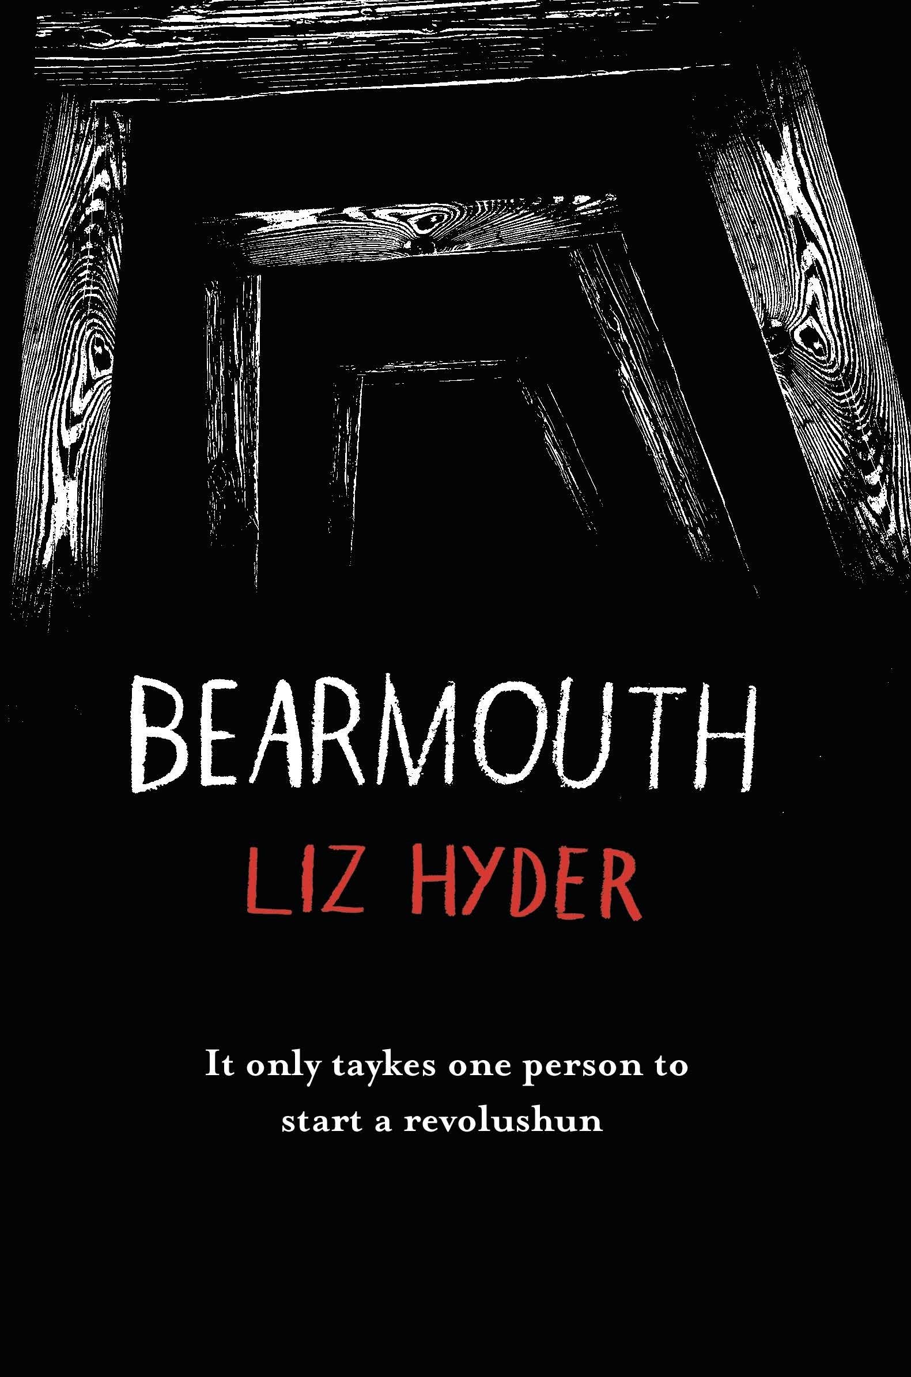
Level:
Third and fourth (S1-3) and Senior Phase (S4-6) / KS3 and KS4
Explore themes of:
√ Setting √ Narrative Voice √ Sensory Description √ Creating Contrasts
Subject Checklist:
√ Expressive Arts √ English Language √ Social Studies √ Creative Writing

At a Glance
Before watching the video or reading the extract!
- How does the book’s title make you want to pick it up to find out more?
- What is the effect of choosing dark colours for the cover?
- What does the word “revolushun” suggest to you? Why might it be spelled this way?

Book Cover Activity: Using the Cover to Show Themes
The cover of Bearmouth is very intriguing and points to some of the themes that might be explored in the book. With a partner or a friend, discuss what you think these themes might be. Then, look at some further example of themes below. If you were to design a book cover, how might you show some of the themes listed? Consider what colours and imagery you would use.
- Love
- Betrayal
- Loyalty
- Redemption
- Rebellion
- Good vs. Evil
Choose one or two of the themes and create a mock-cover, either by using collage techniques or by drawing. Share your cover with a partner. How successful were you at suggesting the themes that you chose?

Read the Extract
Taken from pages 47–48 of ‘Bearmouth’
Discussion Questions
1. How would you describe Newt’s ‘voice’? What is the effect of all the strange spellings?
2. How does the author create a contrast between inside / outside in the first paragraph?
3. Why do you think Newt says ‘Amen’? What does this suggest?
4. How effective is the simile: ‘all o us lyke little cogs’?
5. What dangers does Newt describe in the passage?
6. What does Newt ‘never want to see again’?
7. How does the author, Liz Hyder, create a sense that something bad is going to happen?
8. What do all the miners ‘dred’?

9. How does Liz Hyder create the feeling that everything is dark in the mine?
10. How is the description of the ‘xplosion’ effective? Can you feel the ‘rattles’ in your bones?
Watch the Video: Get to Know the Author!
Activity 1: Going into the Mine
Liz explains the inspiration behind the story / 6:42–9:35mins
- Liz describes how Bearmouth was inspired by her visit to a Victorian Slate Mine in North Wales. Carry out some research into Victorian Mines in Britain. What were they needed for? What were they like? Who worked in them?

- How does Liz describe the mine that she visited? Look at some of the words that Liz uses to describe the mine in her video interview below:
  - DAMP
  - MOSSY
  - CREEPY
  - BRUTAL
- How do these words create a sensory picture of the mine? For each of the five senses, consider what you might experience if you were to visit. Think about what you might be able to SMELL, TOUCH, HEAR, SEE and TASTE around you. Create five bubbles and write your ideas inside them.
- What sort of picture have you painted in your imagination? Would you like to visit a place like this? Would you like to work in a place like this? Why or why not?
- Write a diary entry in role as a young twelve-year-old child miner. Imagine that you have been in the mine all day. Describe the conditions, what happened, and how you felt.

Activity 2: Working in Darkness
Liz describes her fear of being in the dark / 16:38–17:38mins
- In the video, Liz describes how she is actually scared of the dark and hates to be underground. Do you agree? How do you feel about being in total darkness?
- To empathise with the Victorian child miners and with Newt’s experiences in the story, have a go at immersing yourself in darkness. Carry out the steps below to experience the dark safely and to note down your ideas. Remember, you don’t have to do anything you don’t want to do!
Step 1: Create your safe space to experience darkness. For example, you could close the curtains, wear a blindfold, or create a den. Try to ensure the space is as empty as possible except for a couple of sheets of paper and pencil to draw and write with.
Step 2: When you’re ready and with the help of a classmate, partner or friend, begin your time in your safe space.

Step 3: Take some time to get used to the darkness. Think about the sounds you can or can’t hear. Do you feel like your senses become heightened?
Step 4: Spend 5/10 minutes in the dark. While you sit quietly, use a pencil and a blank sheet of paper to note down your ideas. You can write or draw, whatever suits you best.
Step 5: When you have finished, reflect on your time in the dark. How did it make you feel? What do you now understand about the miners’ experience in the dark? Can you imagine how they must’ve felt to work in darkness all day?
- Write a poem or a short reflection piece or create an illustration to represent your experience in the dark.

Your Turn: Develop Your Reading Skills
Activity 1: Freeze-Framing Themes
Extract from ‘Bearmouth’ – pages 47–48
- There are several themes that are important in the story. Some of those can be inferred from the book cover design, and some from the extract. Using the extract, find examples of words or phrases that are linked to the following theme-binaries:
LIGHT/DARK INSIDE/OUTSIDE FAITH/FEAR ENSLAVEMENT/FREEDOM HOPE/DESPAIR PEACE/REBELLION ISOLATION/CONNECTION LOVE/HATE FEAR/COURAGE
- In pairs, choose one of the theme-binaries above. Think about how you could represent the binary in a freeze-frame. How can you use your body language, position, levels and facial expressions to show the contrast between the two oppositions within the binary?
- Create another freeze-frame, this time showing how Liz Hyder explores your chosen theme-binary in the extract. Perhaps one of you can be in role as Newt, and one of you can represent an abstract idea or concept. Be imaginative!
- Show your freeze-frame to your classmates. Can they guess which themes you are exploring? It might be more than one…

Activity 2: Mine Soundscape
Extract from ‘Bearmouth’ – pages 47–48

- Use the extract from Bearmouth to create a soundscape of the mine. You might need the following things:
- Musical instruments
- Props and objects
- Your own voices!
- In groups, pick out key points in the extract where you might be able to incorporate a sound to represent what is happening.
- Consider how you can use sounds to create emotions like fear or dread. Consider also how you might represent the ‘xplosion’ that occurs in the extract.
- Choose instruments or props/objects to represent the different sounds. How can you create a sense of darkness and claustrophobia in the mine? How might you use your own voices to convey Newt’s feelings in the extract?
- Perform your Soundscapes to the rest of the group. Discuss what is effective about each Soundscape that you listen to.

Reflection and Further Questions
Reflection Activity
Think over all that you have learned today. How might you incorporate some of the ideas that you’ve explored into your own creative writing? Which themes would you like to explore more fully in your own stories? Look at the different settings below. Which do you think you would choose to write about and why? If you can, think of your own unique setting.
A mine
A palace
A hospital
A forest
A cabin
Lastly, do you have any final questions you would like to ask Liz if you got the chance? Try to think of at least two and make a note of them.

