Felix After the Rain: A Sensory Story from PAMIS
Creating Multi-sensory Stories to accompany Picture Books.
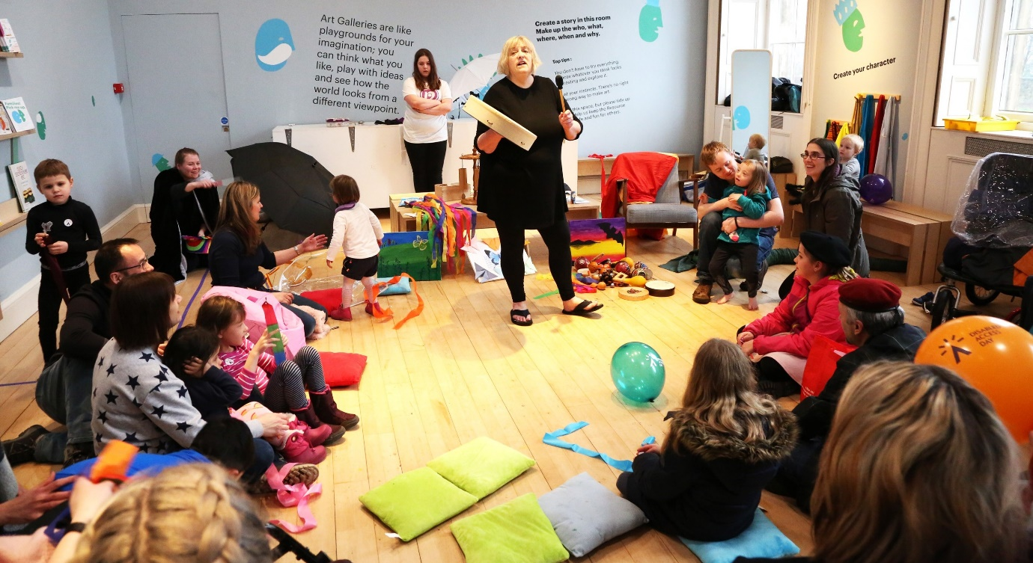

Summary:
Our friends at PAMIS have created this wonderful multi-sensory story to accompany Dunja Jogan’s story Felix After the Rain. Watch their video then get ready to make your own multi-sensory story to accompany Dunja Jogan’s event at Edinburgh International Book Festival.
This resource is great for:
Making sure that everyone can enjoy the Book Festival online, especially those with learning disabilities and PMLD, by creating multi-sensory stories to accompany events.

Introduction
Normally, during the Book Festival, we work alongside our friends at PAMIS, to pair up our wonderful children’s picture book authors with sensory storytellers to create magical story book events for people with Profound and Multiple Learning Disabilities. Sadly, this year, with the Book Festival moving online due to Covid-19, this isn’t possible. But we’d love you to create your own multi-sensory stories to accompany our events in your own home.

Step 1
Watch this video created by PAMIS featuring Sensory Storyteller Maureen Phillip, Musician Fiona Sharp and featuring special appearances from some of the people they work with. Grab some musical instruments to join in with the wonderful songs from Fiona and her musicians.
https://youtu.be/isod7At7OUw
Step 2
Maureen uses different musical instruments to recreate the sound of the sea and the rain in the story, as well as to gather everyone’s attention at the start. Make your own musical instruments to join in with the story using this great resource made by Fiona Sharp.
Step 3
Gather these props:
- A suitcase.
- Some musical instruments (either the ones you made in step 2, or any you already have such as rattles, bells or a tambourine.)
- Puppets (if you have any.)
- An umbrella
- Some fresh flowers collected on a walk.
- A balloon.
Or feel free to think of some of your own ones to accompany the story! Remember you will know the person you are supporting best, so choose stimuli you know the they will engage with and enjoy.
Step 4
Watch Dunja Jogan’s reading of Felix After the Rain at the Book Festival and join in with your own multi-sensory story using your props. Take time to explore the props, see how they feel, make sounds and have fun!
If you prefer you could also read the abbreviated version of the story which PAMIS have created.
Step 5
At the end of Dunja’s event you can watch while she paints a beautiful picture, accompanied by some lovely, relaxing music. Why not create a multi-sensory soundscape to accompany this part of the event using your musical instruments.

Further information
If you would like your own copy of Felix After the Rain it is available to buy from our independent online bookshop.

