Find out Your Superpower with Samantha Baines
Explore difference as something to be celebrated in Harriet Versus The Galaxy

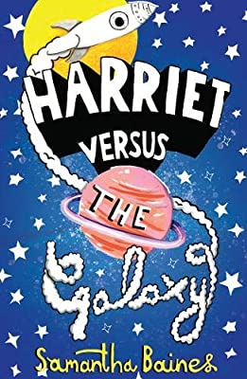

Level:
Second (P5–7) – KS2
Explore themes of:
√ Celebrating Difference √ Superpowers √ Creating Creatures √ My Favourite Planet
Subject Checklist:
√ PSHE √ Literacy √ Art, Design and Technology √ Health and Wellbeing √ Creative Writing

At a Glance
Before watching the video or reading the extract!
- What colours have been used to make the cover eye-catching?
- How does the title link to the illustrations?
- What is exciting or interesting about the title?
Book Cover Activity: Creating a Book Cover Presentation
Create a one-minute informal presentation about what you think makes a brilliant book cover. Think about what the design team try to do when creating a cover. What sorts of things catch your eye when you’re scanning the shelves? What does the saying: ‘don’t judge a book by its cover’ mean?
Write around 10 bullet points containing your main points on a cue card or piece of paper. Then perform your informal presentations to an audience.
Read the Extract
Taken from ‘Harriet Versus The Galaxy’ pages 1–7.
Discussion Questions
1. What is a hearing aid? What does it do?
2. Do you know anyone who uses a hearing aid?
3. What do we learn about Harriet’s living situation on page 1?
4. What do you find out about Harriet’s hearing aid on pages 1–2?
5. Why do you think Harriet might ‘panic’ about losing her hearing aid?
6. What does Harriet find ‘weird’ on page 3?
7. Who or what is illustrated on page 6? What do you like about the illustration?
8. On page 7, which adjectives are used to describe the creature?
9. How do you think you would react in this situation if you were Harriet?
10. What adventures do you think Harriet might have in the future?

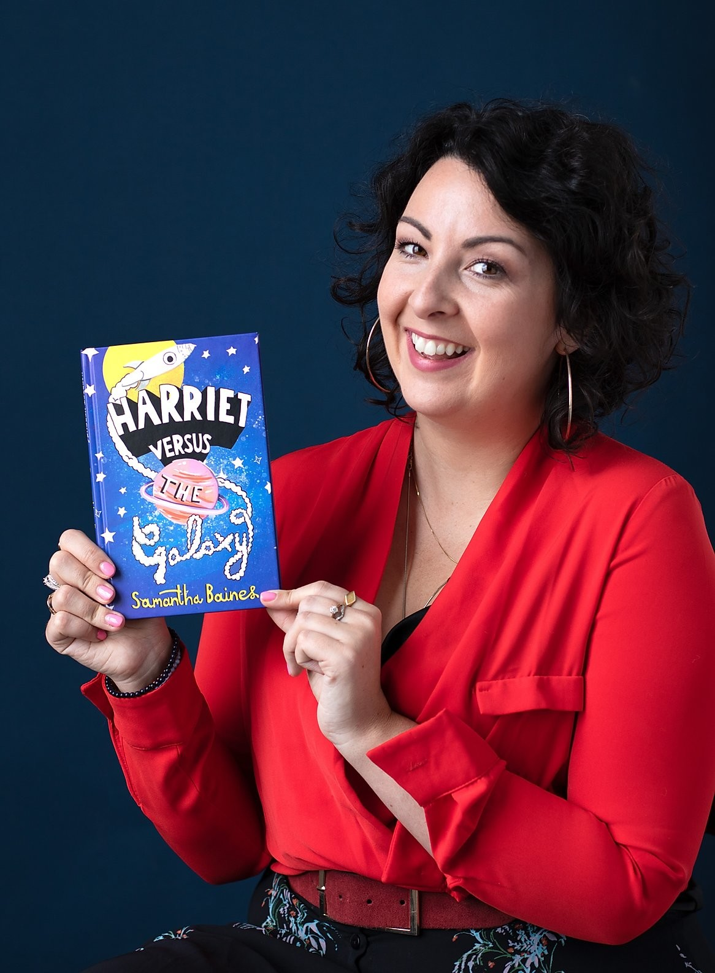
Watch the Video: Get to Know the Author!
Activity 1: Creating Diverse Stories
Samantha talks about how her own experiences influenced the book / 9:10–9:55mins
- In pairs, discuss: what does the author – Samantha – have in common with her character – Harriet?
- What did Samantha set out to do when writing about Harriet?
- Later in her interview, Samantha talks about the importance of us hearing and reading ‘diverse stories’. What does this mean? Can you think of any other books you’ve read that contain diverse stories?
- In pairs, role play how Harriet might feel about her hearing aid using the key words below to help you:
DIFFERENCE DIVERSITY CHALLENGES

DIFFICULTIES UNIQUE SPECIAL

- Then, individually, write two strong paragraphs from Harriet’s perspective reflecting on how she feels about her hearing aid.
- Swap your work with a partner and compare your responses. Reflect on the similarities and differences in your ideas, and how you have both captured Harriet’s diverse story.

Activity 2: Your Superpower
Samantha talks about Harriet’s ‘superpower’ / 12:45–13:55mins
- In the video, Samantha describes Harriet’s deafness as a ‘superpower’ rather than something that holds her back. Discuss what Harriet’s superpower allows her to do and why this is awesome!
- Take a moment to think about what makes you unique and different to other children in your class. This might be something you feel self-conscious about at times but remember we are all different in some way! Then, imagine this part of you as a superpower; what special capabilities does it give you? What does it allow you to do that other people can’t? How might this superpower get you into mischief at times?
- Draw a superhero cape and inside it, write as much information as you can about your superpower. Add colour and any other little illustrations you like to your cape to make it personalised.
- Take it in turns to share your superpowers together. Who has the most unusual superpower? Whose superpower might get them into trouble?

Your Turn: Develop Your Illustration Skills
Activity 1: Creating Your Own Cool Creature
Illustration of creature from page 6 of extract

- Harriet’s incredible adventures begin when she is looking under the bed for her hearing aid and instead finds the alien illustrated above!
- Think about the adventures that your superpower might take you on and what creatures you might find and be able to communicate with along the way. Discuss your ideas with a partner and remember, the wackier the better!
- Read back over the description of the creature Harriet finds on page 6 of the extract, then draw an illustration of your own creature, labelling its features and how you’re able to communicate with it. You could even add a speech bubble stating the creature’s first words or message to you.
- In small groups, take it in turns to role play a conversation between all of your creatures. Think about what questions they might like to ask each other and how they would all attempt to communicate with each other differently.
Activity 2: My Favourite Planet
Samantha describes two of her favourite planets from the book / 31:20–32:35 & 44:00–44:55
- What do you learn about each of these planets in the video? What is funny about each planet? Which of them would you like to visit the most and why?
- You are now going to use your imagination to come up with you own favourite planet that you are able to travel to and use your superpower. Use the points below to come up with ideas for your planet:
  - What is the name of your planet and why?
  - Who or what lives on this planet? E.g. your creature from Activity 1?
  - What is funny about this planet?
  - Why is it your favourite?
  - How does your superpower help you to communicate with its inhabitants?
- Write up a description of your planet using interesting adjectives to help the reader visualise this place. Then, use a table tennis ball or something similar to paint or colour in your planet. Try to use lots of colour and include some detail to match it to your description.
- Perform a ‘show and tell’ so that you can find out about other planets. Take your planet home and hang it from your ceiling, making sure you have permission first!

Reflection and Further Questions
Reflection Activity
Think over all the activities and discussions you have taken part in. Then, fill in the blanks of the sentences below to reflect on what you have learnt.
I am unique because …
Being different is awesome because …
In my lessons on ‘Harriet Versus The Universe’, I have learned that …
In the future I would like to incorporate … into my writing.
Lastly, do you have any final questions you would like to ask the author if you got the chance? Try to think of at least two questions and make a note of them.
Keep your eye out for more brilliant stories from Samantha Baines as well as the other authors from the Edinburgh International Book Festival!

