Get Adventurous with Lily Dyu and Helen Skelton
Explore the world and dream BIG with
Fantastic Female Adventurers and Wild Girl

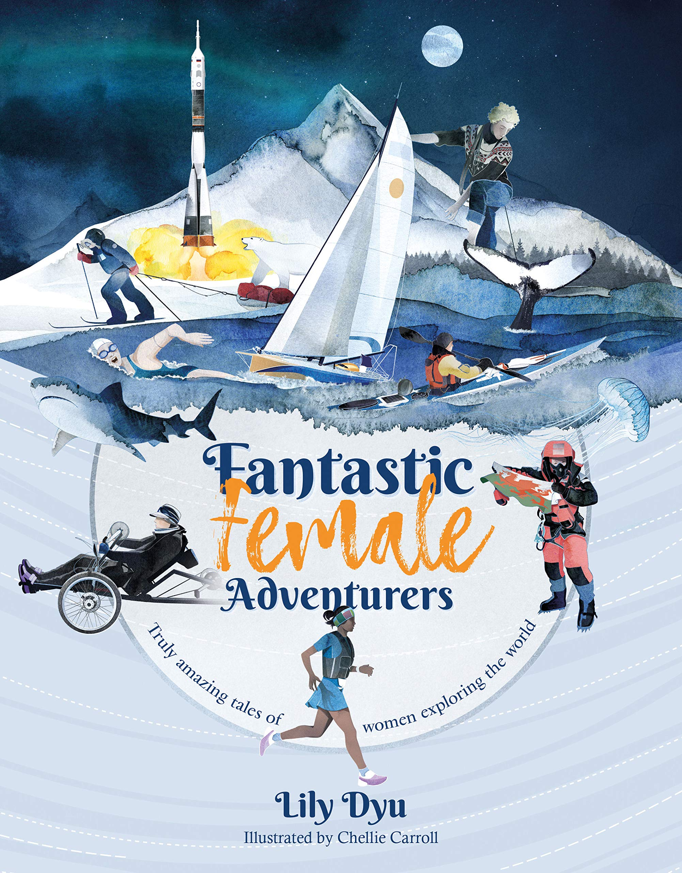
Level:
Second (P5-7) – KS2
Explore themes of:
√ Exploration and Adventure √ The World √ Challenges √ Setting Goals √ Role Models
Subject Checklist:
√ Sciences √ Expressive Arts √ English Language √ Social Studies √ Well-being and Health

At a Glance
Before watching the video or reading the extracts!
- How do the book’s titles and illustrations show the theme of adventure?
- What does the word ‘Wild’ make you think of?
- Where would you like to go on an adventure? Why?

Book Cover Activity: Defining an Adventure
There are lots of different types of adventures; some are small and some are big. Look closely at the two covers of Fantastic Female Adventurers and Wild Girl. Note down all of the different types of adventures you can see in the illustrations. Consider the following:
- Are they small or big adventures?
- Are the adventures in a foreign or exotic place?
- Do they take place on land, sea or in the sky?
- What activities are involved?
Think about an adventure that you’ve had recently. Where did you go? What did you do? How would you show your adventure in an illustration on a book cover?

Read the Extracts
Taken from pages 1–9 of ‘Fantastic Female Adventurers’ and pages 4–13 of ‘Wild Girl’
Discussion Questions
1. In Fantastic Female Adventurers, why do you think Ann Daniels is referred to as the ‘Ice Queen’? What does this tell you about her?
2. How do you get a sense of the dangers and challenges that Ann faced in the first paragraph? Do you think that all adventures have their challenges?
3. What was Ann trying to achieve in 2002? Where was she? Who was she with?
4. Can you list the goals and challenges that Ann set for herself? What do they tell you about her?
5. On page 9, why do you think Ann describes working ‘at the extreme ends of the Earth’ a ‘privilege and an honour’?
6. In Wild Girl, Helen Skelton also describes adventures in the snow. What are the similarities between Helen’s adventures and Ann’s adventures?
7. Where did Helen grow up? How do you think it influenced her? (page 6)
8. What is the lowest temperature ever recorded in Antarctica? (page 6)
9. On page 8, what challenge did Helen set herself in Antarctica?
10. Can you see any similarities between Helen’s preparation for her expedition and Ann’s training? (pages 10–11)
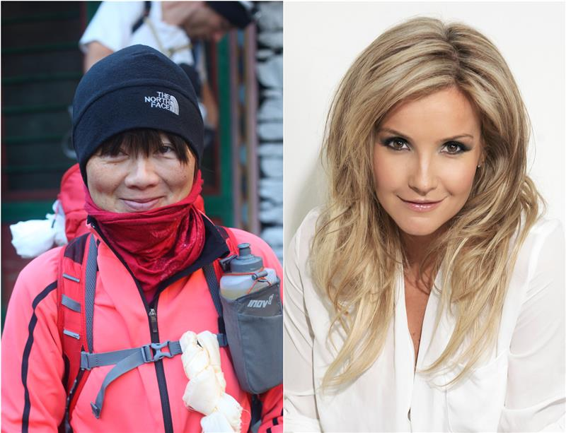
Watch the Video: Get to Know the Authors and the Books!
Activity 1: Journeys to the extreme ends of the Earth
Both Lily Dyu and Helen Skelton describe stories of adventures to the Arctic and Antarctica.
- Where is the Arctic? Where is Antarctica? Mark both places on a world map. Why do you think both of these places can be described as ‘extreme’?
- Choose either the Arctic or Antarctica. Use the extracts or carry out research into your chosen place. Then, create a Non-Chronological Report for your place. Where is it? What is it like? What is the climate? What species of animal live there? Use the headers below to help you create your Report:
  - An eye-catching heading in a large font
  - An introductory paragraph
  - Text split up into paragraphs and each paragraph on a different aspect of the subject
  - Sub-headings for each paragraph
  - Usually written in present tense
  - Pictures of the subject
  - Captions under each picture to explain what is in the picture
  - Diagrams with labels
  - Lists of facts in bullet points
  - Graphs or charts showing information about the subject
  - Boxes containing interesting individual facts to grab the attention of the reader
  - Technical vocabulary in bold, possibly with a glossary at the end

Activity 2: Qualities of an Adventurer
The female adventurers in both books have lots of qualities. What are they?
- What do we mean by personal ‘qualities’ or ‘character traits’? Can you think of any examples of personal qualities or character traits you possess or would like to possess?
- Work together in small groups to come up with definitions for each of the qualities or character traits below:
  - Courage
  - Honesty
  - Humour
  - Respect
  - Humility
  - Trustworthy
  - Leadership
  - Positivity
  - Integrity
  - Dedication
  - Kindness
  - Resilience
  - Athleticism
- Then, rank the traits from 1–13 with 1 being the most important quality/trait in your opinion and 13 being the least. Think about why these traits are crucial in everyday life but especially when you are working to achieve a big goal.
- Feedback as a class which traits were most popular and why.

Your Turn: Develop Your Inner Adventurer!
Activity 1: Big Dreams and Goals
The women in these books are go-getters with big dreams. How do they inspire you?
- Why is it important to have big dreams and goals in life?
- Both of these books are about go-getting women who have become explorers and adventurers, showing that anything is possible when you make the most of your talents. In pairs, reflect on how some of the women you have learned about so far have shown you the importance of having big dreams and setting goals.

- Look at the statement below. Discuss as a class your thoughts and ideas about the statement, including whether you agree or disagree and why, as well as whether you would add to the statement:
It is important to set goals and to have big dreams if you want to achieve anything in life.
- Consider the inspirational women that we have thought about so far in these lessons. Which woman inspires you the most? Why?
- Complete a Female Role Model Profile for your chosen woman. Include a short biography, her goals and talents, her qualities, the challenges she faced, and how she overcame them.
Activity 2: Setting My Own Goals
What dream do you have in your heart? Where would you like to go on your next adventure?
- It’s time to get on the path of achieving your own Adventuring Goal or Dream! Use your Profile from the previous task as inspiration for setting some of your own goals. Consider something you’d like to achieve, somewhere you’d like to go, or something you’d like to do. Your goal might be small or very big; you might be able to achieve it in one hour, or in ten years!
- Decide what your ‘Adventuring Goal’ is going to be. It might be a goal for the end of the week, the end of the year, ten years’ time, or even way ahead into the future!
- Draw a star-shaped template and write your Adventuring Goal inside it. Share your star with a partner.
- Finally, create some steps for how you are going to achieve your goal. (TIP: Some of these steps should be small, and some of them should be much bigger!)
- Share your goal and your 5 steps with a partner; ask them for their feedback, and give them yours. Good luck embarking on your adventure!

Reflection and Further Questions
Reflection Activity
Think over all that you have learned today. Perhaps you have found a new role model?

Or you’ve been inspired to go on an adventure? Which Fantastic Female Adventurer would you like to know more about?
On a map of the world, place pins or stickers to mark FIVE different places you’ve been inspired to visit and explore. On post-it notes, write your reasons for choosing each place.
Lastly, do you have any final questions you would like to ask Lily or Helen if you got the chance? Try to think of at least two and make a note of them.
Keep your eye out for more awesome books from Lily Dyu and Helen Skelton, as well as the other authors from the Edinburgh International Book Festival!

