Illustrating Feelings with Dunja Jogan
Explore feelings through art in Felix After the Rain

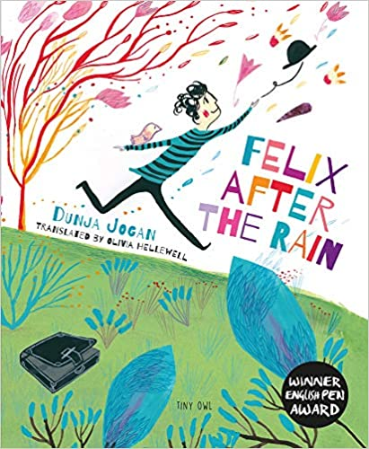

Level:
Early (pre-school to P1) and First (P2–4) / EYFS and KS1
Explore themes of:
√ Sharing Feelings √ Worries and Anxieties √ Nature √ Friendship
Subject Checklist:
√ Expressive Arts √ English Language √ Well-being and Health √ Creative Writing

At a Glance
Before watching the video or reading the book!
- What colours have been used to make the cover eye-catching?
- What is happening in the illustration? How does it make you feel?
- What examples of nature can you see?

Book Cover Activity: Making predictions about the story
A book’s front cover gives the reader clues about the story inside. Look closely at the cover of Felix After The Rain. Then, make some predictions about the text by filling in the blanks below.
I think the boy on the front cover is feeling …
I think the main character is called …
I think an important object in the story might be a …
I think this story will be about …
Read the Book
Taken from ‘Felix After The Rain.’
Discussion Questions
1. How is Felix described in the first line of the story?
2. What object does he drag everywhere with him?
3. Which things have ‘appeared’, ‘hidden’, and ‘burrowed’ into this object?
4. What does Felix’s body language tell you about how he’s feeling?
5. How do the illustrations of nature reflect how Felix is feeling?
6. What are Felix’s tears compared to?
7. How does the boy help Felix? What does he do?
8. How does Felix feel ‘after the rain’? How can you tell?
9. How do the colours in the second half of the book change?
10. Have you ever felt like Felix? Can you give an example?
Watch the Video: Get to Know the Author!
Activity 1: Nature in Black and White
Dunja completes her first painting / 8:05–9:20 & 23:20–25:20mins
- Together, discuss: what is Dunja painting? What do you like about her painting? What details can you spot? What colour(s) has she used? Does the painting end up how you thought it would?
- Then, paint or draw your own picture of a tree or plant using only black. Think about how you will begin your picture and what details you will add. Think about how you can bring nature to life just using one colour.
- Share your painting or drawing with a partner but don’t tell them anything about your work yet! Give each other feedback using these 3 sentence starters:
- I think this is a picture of …
- I like the way you have …
- By using black you have made nature …
- When you have both given each other feedback, reflect on how your pictures compare to Dunja’s. What is similar? What is different?

Activity 2: Nature in Colour
Dunja completes her second painting / 25:20–26:35 & 35:50–36:44mins
- Together, discuss: how does Dunja’s second painting compare with her first? What similarities or differences can you spot? Which colours has she used? How has her use of colour changed the mood and emotions?
- Then, paint or draw your second picture of a tree or plant. This time try to use lots of interesting colours. Again, think about how you will begin your picture and what details you will add. How will you bring nature to life by using colour?
- When you have finished your second picture, put both pictures next to each other on a table or wall to create your own art gallery.
- Spend a few minutes walking around the gallery looking at the other images of nature. Think about how the colours used enhance each picture. What feelings are reflected in nature? What do the pictures have in common? What makes them different?

Your Turn: Develop Your Empathy Skills
Activity 1: What’s in your Suitcase?
Felix from the book

- We all have worries and anxieties that we carry around with us. Felix feels that his are like a very heavy suitcase that he can barely move at times. Take a moment to think about when you have felt like Felix. What sorts of worries do you carry around with you?
- Sketch a large picture of your own suitcase. Inside it, write and draw some of the things that are inside it. For example, there may be some small things, like your hair being a bit messy today. Or there may be some bigger things inside, like a poorly family member or someone you have fallen out with.
- When you have finished your suitcase. Find a new partner and tell them about something that is in your suitcase. It might just be something small but that’s okay! Have a chat together about your suitcases. Do you feel a little lighter for having shared something?
- Try to remember this exercise and that it is important to let our worries out instead of keeping them squashed and hidden in your suitcase.

Activity 2: Before and After Sharing Feelings
Illustration of Felix from the book

- When Felix shares his feelings with the curious boy his heart is ‘full of happiness’ and ‘it lifted him off the ground like a balloon’. Together, discuss what this means. How does the illustration help you to understand Felix’s feelings?
- Close your eyes and think of a time you were upset or worried about something. How did it make you feel? Then, think about a time you shared a worry from your suitcase with someone. Did you feel a bit better afterwards?
- Then, sort the feelings below into BEFORE or AFTER you shared your worries.
- Together, talk through which feelings you labelled as BEFORE or AFTER. Were there any you found tricky? Could you add any more feelings? What have you learnt about yourself from this activity?

Reflection and Further Questions
Reflection Activity
The curious boy is a good friend to Felix and makes him feel better. A good friend makes us feel lighter and the world around us brighter and more colourful. Think about a time that you were a good friend to someone. Fill in the blanks below to write a reflection about a time you helped them.
I am a good friend because …
I once helped a friend by …
Before I helped them, they felt …
After I helped them, they felt …
Lastly, do you have a question you would like to ask the author if you got the chance? Make a note of it and share your questions together. Can you predict what the author might say?

