Retelling Tales with Joseph Coelho, Juno Dawson and Kiran Millwood Hargrave
Subvert classic stories with The Girl Who Became a Tree,
Wonderland and The Deathless Girls

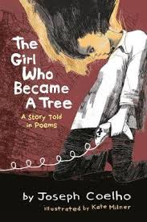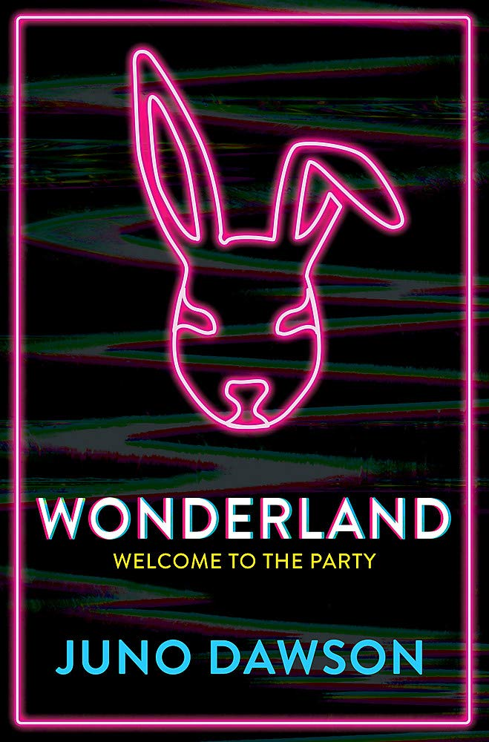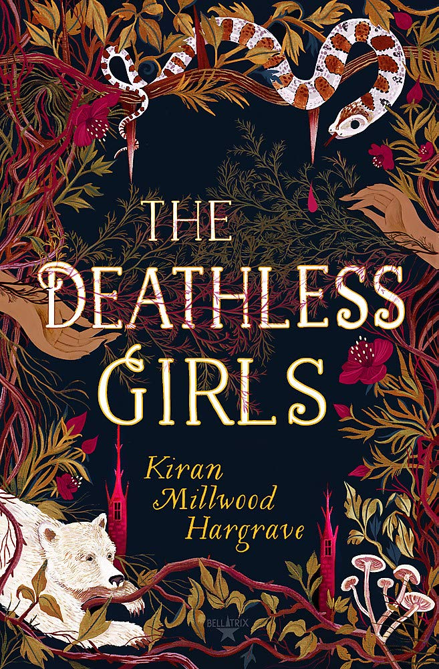

Level:
Senior Phase (S4-6) / KS4 and KS5
Explore themes of:
√ Storytelling √ Myths and Legends √ Subversion √ Modern Themes √ Fairytales
Subject Checklist:
√ Expressive Arts √ English Language √ Social Studies √ Creative Writing
Note to teachers: These books contain some material that may not be suitable for some students. We recommend that teachers read the books carefully before using it in the classroom or recommending it to students and/or seek parental guidance.

At a Glance
Before watching the video or reading the books!
- Can you guess which classic story each book is retelling? How?
- Which book draws you in the most? Why?

- How different is the cover of Wonderland to the original cover of the tale it re-imagines? Why does this draw the reader in?
Book Cover Activity: Modernising Original Covers
Choose a front cover of a classic story that you know or have read. You can choose a classic cover from the library, or even carry out some research online. Create a brand new, 2020 cover for your chosen title. Consider the following things:
- How can you modernise your cover for a reader in 2020?
- Will your main character be the same or different to the original? How? Why?
- What styles and colours can you use to create a bold new design?
- How will the title you choose differ from the original?
Share your covers with your friends, family members and classmates. Can they guess which classic story you have modernised?

Read the Extract
Taken from pages 14–17 of ‘The Girl Who Became a Tree’.
Discussion Questions
1. What do you notice about the structure and form of Joseph Coelho’s retelling?
2. According to Greek Mythology, who was Daphne? What happened to her?
3. Why might the title ‘DAFT-KNEE’ be considered funny? How is this an example of the story’s modernisation?
4. Do you think you have to change the language when you modernise a story? Why? Can you find any examples of modernised language in the extract?
5. On pages 14–15, what can you tell about Daphne’s relationship with her father?
6. How does Joseph Coelho convey the imagery of trees on pages 14–15? Pick out examples.
7. What do you think happens on pages 16–17? Do you think the story is closer to the original here? How can you tell?

8. Why do you think the background of pages 14–15 is white, whereas the background of pages 16–17 is black? How do Kate Milner’s illustrations help to convey meaning?
9. On page 16, Daphne says ‘mirrored waters must stay the same’. What does she mean by this? Why is the idea of ‘mirroring’ important in Coelho’s retelling?
10. What are the differences between the two spreads ‘DAFT-KNEE’ and ‘DAPHNE AND HER FATHER PENEUS’? How do they complement each other?
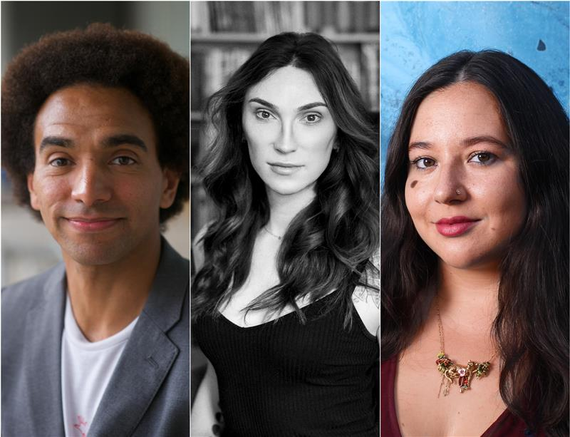
Watch the Video: Get to Know the Authors!
Activity 1: Comparing the Original and the Retelling
All three books are based on very well known classic tales. What are these tales – and how radical are the retellings?

- In pairs or groups, choose one of the pairings below:
  - The Girl Who Became a Tree // The Ancient Legend of Daphne (from Greek Mythology)
  - Wonderland // Alice in Wonderland
  - The Deathless Girls // Dracula
- Carry out some research into the original story. Find out: when it was written; the characteristics of the main protagonist; the basic plot; and important themes. Then, discuss how you would choose to modernise the story if you had the chance.
- Consider how the author of your chosen retelling has changed or modernised the original story. Do any of their choices surprise you? Why?
- On a large sheet of paper, create a Venn Diagram – where one circle represents the original story and the other represents the retelling.
- In the blank space of each circle, write the ways in which the two stories differ. In the overlapping space at the centre, between the two circles, write down all the things that remain the same between the two stories. If you want to get extra detailed, you might create a new Venn Diagram for each category (protagonist, plot, themes).
- Share your Venn Diagrams with your classmates. What do they teach you about each retelling?
Activity 2: Modern themes
What are the important things that we need to consider when we modernise stories? What are the most prominent ideas and issues in 2020?
- Why do you think Joseph Coelho, Juno Dawson and Kiran Millwood Hargrave were compelled to modernise these three stories?
- If you were to write a list of prominent ideas and issues in 2020, what would they be? Write them down.
- Look at the description of each modernisation below:
  - In The Girl Who Became a Tree, Joseph Coelho weaves the ancient legend of Daphne through a highly original verse story about a teenager who discovers a hidden world in her local library.
  - In Wonderland, Juno Dawson addresses themes of drugs, sexual assault and mental health, taking us on a journey with Alice – her pansexual, transgender protagonist.
  - In The Deathless Girls, Kiran Millwood Hargrave resurrects the gothic tale of Dracula to tell the story of his two brides, whose legends have been buried until now.

- For each story, list the main interests of the author. What prominent ideas and issues do they feel most strongly about? Why have they integrated these ideas and issues into their retellings?
- Which of the three retellings do you consider to be most radical? Why?
- Choose a classic story of your own and consider which ideas and issues you would like to introduce into the story to make it relevant for a modern audience in 2020.
Your Turn: Subverting Classic Stories
Activity 1: The Features of a Fairytale
Before it is possible to subvert or change a classic story, it is useful to look at the features of the original. Which features are still relevant for a modern audience?
- Think about a classic fairytale, like Snow White. Can you list at least x5 features of the fairytale?
- Can you find examples of each feature listed below in Snow White?
  - Characters are put to a test
  - Magical setting or characters
  - Honesty or cleverness is rewarded
  - Foolishness or evil is punished
  - Characters are transformed into something better
  - Female characters marry into royalty
  - Characters live happily ever after

- Create a table with two columns: ‘Features that are still relevant’ and ‘Features that must be challenged/subverted.’ Organise the plot features into the columns. Which features need to be changed for a modern audience?
- Once you have completed your table, choose one of the features that you think should be challenged or subverted. With a partner, discuss how you might do this. Share your ideas with the class.

Activity 2: Modern Fairytales
Now that you have identified the features of a traditional fairytale, create a new version of the same story for a modern audience.

- Using your ideas from Activity 1, think about how you would retell the classic story of Snow White (or another fairytale of your choosing).
- Consider which modern ideas and issues you might want to focus on. For example, maybe you want to challenge the presentation of female characters, or change the protagonist’s race or gender – maybe you want to integrate more themes around mental health, or change the setting. Maybe you want to do all these things!
- Create an annotated outline of your story and share it with a partner or workshop it with your classmates.
- Finally, before you start writing, create a storyboard for your Modern Fairytale. If you want, you can include illustrations to help develop characters and plot.
- When are you ready, start writing! Share your Modern Fairytales with your classmates. Whose retelling is the most radical? Whose do you like the best?

Reflection and Further Questions
Reflection Activity
Think over all that you have learned today. How do ideas and themes change in stories through History? Do you think some ideas and themes stay the same, for all audiences?
Create a chronological timeline of your favourite literature through the ages. For each book that you choose, consider the prominent ideas and themes of the time. Which writers were the most radical? What prominent ideas and themes do you predict in 50 years’ time?
Lastly, do you have any final questions you would like to ask Joseph, Juno and Kiran if you got the chance? Try to think of at least two and make a note of them.
Keep your eye out for more awesome books from Joseph Coelho, Juno Dawson and Kiran Millwood Hargrave as well as the other authors from the Edinburgh International Book Festival!
