Shine On with Dean Atta and George Lester
Celebrate self-empowerment with The Black Flamingo and Boy Queen

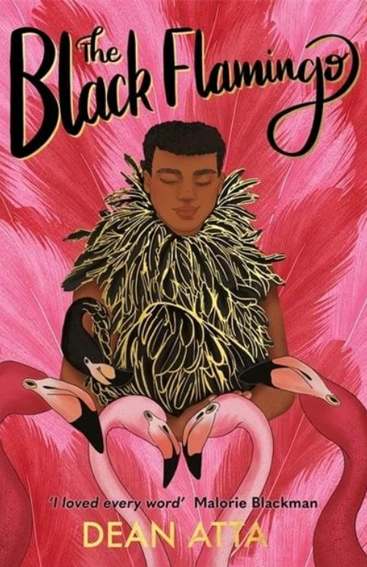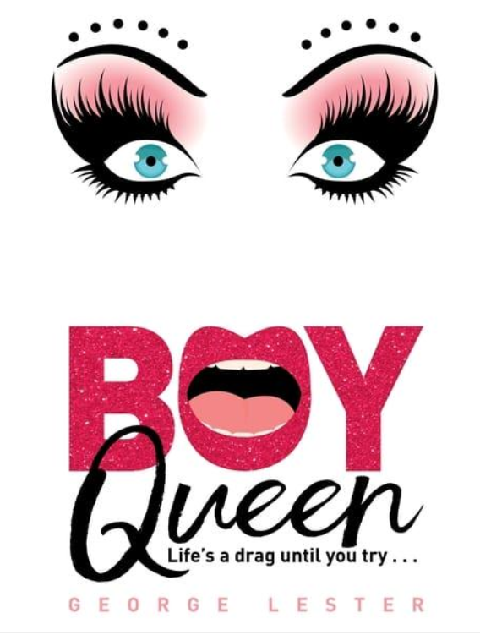

Level:
Senior Phase (S4-6) / KS4
Explore themes of:
√ Identity √ Inclusion and Representation √ Diversity √ Human Rights √ Self-expression
Subject Checklist:
√ Expressive Arts √ English Language √ Social Studies √ Creative Writing
Note to teachers: These books contain some material that may not be suitable for some students. We recommend that teachers read the books carefully before using it in the classroom or recommending it to students and/or seek parental guidance.

At a Glance
Before watching the video or reading the books!
- What do you think these two stories might have in common? Why?
- How do the covers stand out to you? Why might the design be described as bold or unique?

- How do the two covers use the concept of ‘colour’ in clever and unique ways? How do they use ‘blank space’ to convey the themes of the stories?
Book Cover Activity: Making Predictions
Examine the front covers for The Black Flamingo and Boy Queen. In pairs, consider the following questions.
- What do you think these books might be about?
- What is the audience for these books? How do the covers appeal to multiple audiences? Is this important?
- Look at the words in the titles of both books. What connotations can you think of for each word used – i.e. ‘black’; ‘flamingo’; ‘boy’; and ‘queen’.
- How do the covers and titles play with oppositions and subverting stereotypes?
Discuss your ideas together. Can you come up with a title for a book that presents an opposition or subversion for the reader?

Read the Extract
Taken from pages 1–20 of ‘Boy Queen’.
Discussion Questions
1. Where is the narrator at the beginning of Chapter One? What is the narrator doing?
2. Why do you think the phrase, ‘(even some of the boys)’ is put in brackets on page 1?
3. Why do you think Robin wants to be ‘a little more Priya’? What qualities does Priya possess?
4. What does Robin describe as ‘like flying, I swear’ on page 3? What is Robin passionate about?
5. On page 8, Miss Emily says: ‘You need to be seen. Take up some room for once, Robin’. What does this tell you about Robin?
6. What is Robin’s relationship with Miss Emily? What is Robin’s relationship with Natalie?

7. What gender do you automatically assign to Robin in the first few pages of the extract? Why do you do this? Is it important?
8. Who is Robin’s love interest? Do you think this will be a big theme in the book? Why?
9. What can you tell about Robin’s personality and character in the extract?
10. What challenges do you predict Robin will face in the story? Why?
Watch the Video: Get to Know the Authors!
Activity 1: Important Ideas and Themes for the Authors
These two authors share similar interests in ideas and themes; what are they?
- Below are nine suggestions for the prominent themes and ideas in The Black Flamingo and Boy Queen. Can you add any more of your own?
- Working on your own, in a pair, or in a small group, rearrange them into a ‘Themes Diamond’.

- The formation of the diamond should flow as follows: x1 suggestion at the top, x2 suggestions below, x3 across the middle, x2 underneath, and x1 suggestion at the bottom – forming the shape of a diamond. The suggestions placed towards the top of the diamond would be the more important themes in the books, in your opinion.
- If possible, compare your ideas with other readers and discuss any differences.
  - Prejudice and difference
  - Family
  - What it means to be ‘masculine’
  - Daring to be different
  - Finding a place to fit in
  - Gender and sexuality
  - The importance of accepting others for who they are
  - Learning to love yourself
  - Coming out as gay

Activity 2: Thinking About Prejudice
Both protagonists in the books, Michael and Robin, suffer prejudice and aggression at times. Why do you think people who are perceived to be different are often discriminated against?
- What is prejudice? Can you think of examples of prejudiced views? How and why are the two protagonists victims of prejudice in these books?
- As a class, sit in a circle and close your eyes. Nominate someone to read out the key words listed below, while you picture in your mind which types of people you associate with that word and what these people look like. Make sure you focus on the first image that comes into your head.
- After each key word, take it in turns to describe the person that you pictured in your mind. Then, open up questions to your classmates encouraging a wider discussion on these issues – what inner prejudices do you have? Why should they be challenged?
- Doctor – Why do we associate certain genders with certain jobs? What does this tell us?
- Marriage – Did anyone picture two men or two women? What do you feel about these ideas?
- Make-up – Did anyone picture a boy or man? If not, why not?

- Dancer – Do we associate certain genders with certain actions? What does this tell us?
- Successful – Is the person you are picturing young or old? What ethnicity or race is the person you picture? What does this tell us about society?

Your Turn: Celebrating Difference
Activity 1: My Unique Identity
Self-expression is a huge theme in these two books. What is self-expression? Do you think you are confident in presenting your true identity to others?
- Think about what makes you different and why this is awesome. Design a personal badge, poster or collage to show what makes you different and special.
- You badge, poster or collage might include symbols, words, or drawings relating to your heritage, beliefs, hobbies, sexuality, ethnicity – or anything else that relates to your identity.
- Take your design home and show it to your family and friends, explaining what each element of the design means to you. Put it on display to show that you are proud of who you are!

Activity 2: My Inclusive School
Why do Michael and Robin find it difficult to find ‘the perfect fit’? What stops them from feeling as though they ‘fit in’ and why is it important to address this?
- Use the discussions around these texts and activities that you’ve completed to create a leaflet about helping others to ‘fit in’. It should inform other students in your school about the importance of celebrating who we are and of the need to challenge prejudice in order to make sure everyone in society feels valued and included.
- Ideas for sub-headings or content could include:
  - What makes us different?
  - Why are some people scared of these differences?
  - What is prejudice?
  - How does it affect different people and groups in society?
  - What can we do to challenge it?
  - Why we should celebrate difference?

- Put your leaflets on display around the school to remind everyone about these important topics, so that your school can continue to be a safe and inclusive place to learn and have fun!

Reflection and Further Questions
Reflection Activity
Think over all that you have learned today. How might you incorporate some of the ideas that you’ve explored into your own daily life? Which types of discrimination in society do you feel most passionate about? What do you want to fight for?
Keep a diary entry for a week about the ways in which you have challenged prejudice or celebrated either your own or someone else’s difference. At the end of the week, consider how much you have achieved and how much you would still like to achieve. Make a pledge to yourself to SHINE ON and lead the way for others around you.
Lastly, do you have any final questions you would like to ask George and Dean if you got the chance? Try to think of at least two and make a note of them.
Keep your eye out for more awesome books from Dean Atta and George Lester as well as the other authors from the Edinburgh International Book Festival!

