Super Sleuths with Sharna Jackson and Robin Stevens
Become a Dynamic Story Detective with the
Murder Most Unladylike and High-Rise Mystery series

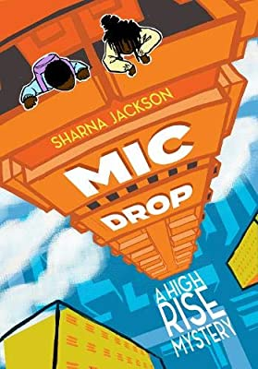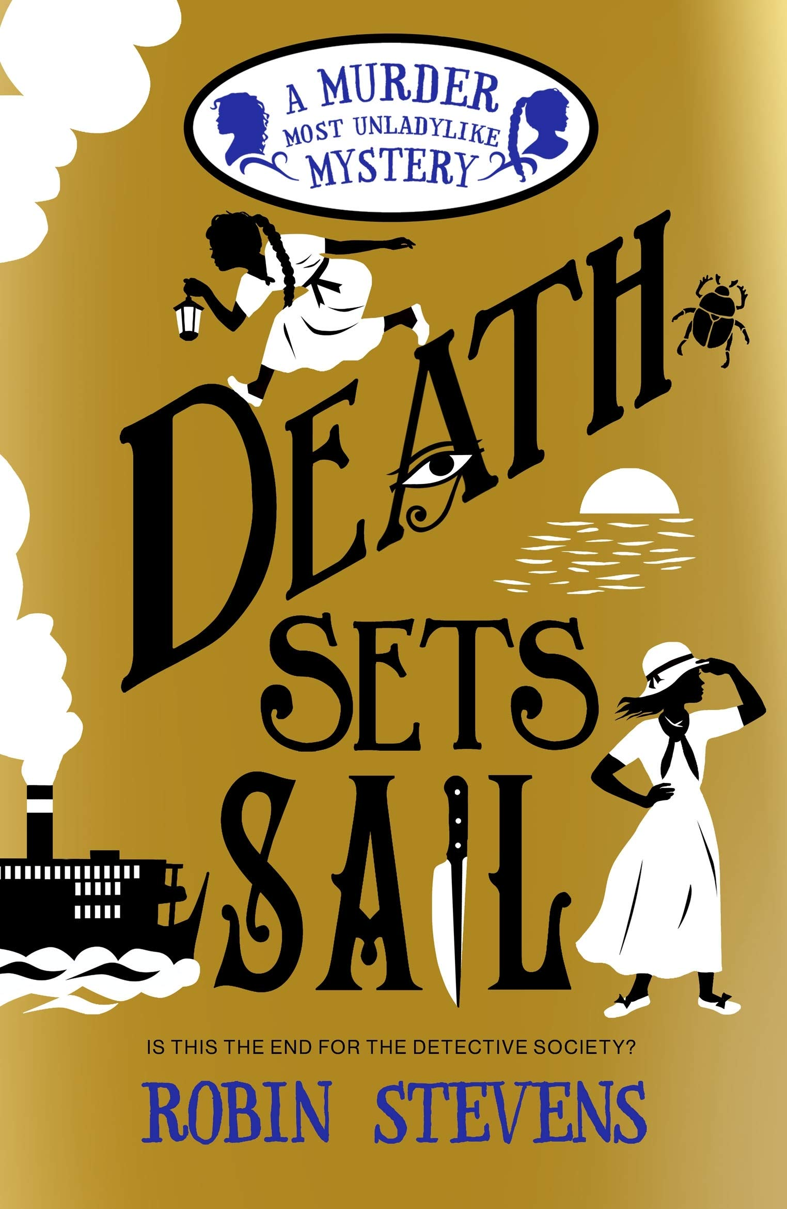
Level:
Second (P5-7) – KS2
Explore themes of:
√ Mystery √ Genre √ Strong Protagonists √ Setting √ Sensory Description
Subject Checklist:
√ Expressive Arts √ English Language √ Creative Writing

At a Glance
Before watching the video or reading the extracts!
- How do the book’s titles and illustrations show the theme of mystery?
- What intriguing details are included on both covers? How do they make you want to read the book?

- How are the settings of the two stories different? How can you tell?
Book Cover Activity: Making Inferences About Characters
For each book cover pictured, make a list of the characters that you can see. Then, consider what the characters might be doing, and what their relationships with each other might be. Create dialogue bubbles between the characters or thought bubbles to show your predictions about what they might be saying/thinking. Consider the following:
- On the ‘Mic Drop’ cover, what are the two characters doing? Why?
- What are they saying to each other?
- On the ‘Death Sets Sail’ cover, what are the two characters pictured doing? If you could write their thoughts in thought bubbles, what would they be?

Read the Extracts
Taken from pages 1–8 of ‘Mic Drop’ and pages 3–5 of ‘Death Sets Sail’.
Discussion Questions
1. In Mic Drop, who or what is TrojKat? What do you find out about Trojkat in the ‘news release’?
2. Why do you think the author Sharna Jackson switches quickly from a journalism style to first person narration in italics? Who is speaking?
3. What can you tell about the setting of Mic Drop from the extract? What is ‘The Tri’?
4. Why does Sharna Jackson use short, snappy sentences at the end of the italicised text? What is the effect of this on the reader?
5. In Chapter 1 of Mic Drop, Norva Alexander is introduced. Who is she? What can you tell about her? What is her relationship to the narrator?
6. In Death Sets Sail, who are ‘Wells and Wong’?
7. Why is Hazel ‘heartbroken’?

8. What two settings are described in the extract?
9. What is Hazel’s motivation for writing what she calls: ‘our last murder mystery’?
10. Compare and contrast how both extracts create a sense of mystery for the reader. What techniques do the writers use to create intrigue?
Watch the Video: Get to Know the Authors and the Books!
Activity 1: Detective Duos and Super Sleuths
At the heart of the ‘Murder Most Unladylike’ and ‘High-Rise Mystery’ series are two sets of dynamic duo detectives!
- Choose one of the detective duos from Mic Drop or Death Sets Sail – either: Nik and Norva; or Wells and Wong.
- Consider the relationship between the two super sleuths in your duo. Are they relatives or friends? Do they get along? Do they love each other? How do you know?
- Draw a large circle on an A3 or A4 sheet of paper and split it into two halves – one for each member of the duo. Inside each half, write down different qualities or character traits to describe each character.
- Around the outside of the circle, write down any quotations from the extracts or the books themselves that help you to understand the characters.
- Then, look at all the describing words you’ve written inside your circle. How are the two characters stronger together than they are apart? How do they balance each other out?

- Do you have any relatives or friends that you are particularly close to? Create your own dynamic detective duo and draw a new circle to represent it!

Activity 2: Looking at Genre
Detective or Crime stories are a particular type of story. But what are their ingredients?
- What is your favourite ‘type’ of story to read? What do we mean by the word ‘genre’?
- Consider the different genres listed below. In pairs or groups, think of a book that fits into each genre. You can come up with more genres if you like!
  - Horror
  - Adventure
  - Comedy
  - Mystery
  - Romance
- Is it possible for a book to fit into more than one genre? Which genre would you put Mic Drop and Death Sets Sail into?
- Different genres have different features or ‘ingredients’ – like a food recipe. For example, ‘adventure’ stories often include a journey to a faraway place and a heroic central character.
- Can you list five features or ‘ingredients’ for the Mystery genre, based on what you know about Sharna Jackson and Robin Stevens’s books?

Your Turn: Develop Your Detective Stories!
Activity 1: Crime Scene Storyboards
Both Sharna Jackson and Robin Stevens create stories in which their protagonists solve a huge crime or mystery…
- As a class, be inspired to think like a detective by playing the classroom crime scene game. If you can, place fake police tape around the room to cordon off your crime scene.

- On the tables in your classroom, lay out different objects that might serve as clues or evidence in a crime scene. Evidence might include things listed below – but feel free to be as creative as you want!
  - The outline of a body
  - A handwritten note or letter
  - A broken pair of glasses
  - A bottle
  - Partially eaten food or drink
  - A news release

- In small groups, visit the crime scene and analyse or make notes about various bits of evidence placed on different tables. As you walk around the room, take notes about what you see – but be careful not to touch anything.
- After gathering your notes, use inspiration from Sharna Jackson and Robin Stevens to turn them into a suspenseful short story! Consider the following:
  - Who is at the centre of the mystery?
  - What happened to them?
  - How did it happen?
  - Where did it happen?
- Before you start writing, create a Storyboard or use post-it notes to sketch out the various stages of your storyline.
Activity 2: Sensory Settings
Consider the settings of the two stories: where is the perfect place for a crime story?
- Think about the setting in Mic Drop – how is this setting different to settings that you normally read about? Do you like the setting? Why?
- In the opening extract of Death Sets Sail, the author Robin Stevens describes Egypt: ‘the wide light of it, the sparks of sun off the Nile, the hum and churn of our cruise ship moving under my feet.’ Why is this an effective description? How does it tap into the five senses: sight, sound, taste, touch and smell?
- A good setting will evoke each of the five senses for the reader. Choose your own setting to describe; perhaps it’s somewhere exotic, like a rainforest or a desert island, a mode of transport like a train, or a more ‘normal’ setting, like a classroom.
- Have a go at completing the following sentences, imagining that you are standing in your given setting:

  - I can smell…
  - I can hear…
  - I can touch…
  - I can taste…
  - I can see…
- Now, still thinking about your imagined setting, write a postcard describing what it is like and how you feel, incorporating as many of the senses as possible.
- Send your written postcard to another person in the class. Can they draw a picture of your setting on the other side of the postcard, based on your description?

Reflection and Further Questions
Reflection Activity
Think over all that you have learned today. Perhaps you have found out the ingredients of the ‘Mystery’ genre? Or you’ve been inspired to write a new crime story? Or you’ve developed your detective skills…
Draw an outline of a detective’s magnifying glass and, inside it, write down all of the things you have learned from listening to Sharna Jackson and Robin Stevens, and from reading their books.
Lastly, do you have any final questions you would like to ask Sharna or Robin if you got the chance? Try to think of at least two and make a note of them.
Keep your eye out for more awesome books from Sharna Jackson and Robin Stevens, as well as the other authors from the Edinburgh International Book Festival!

