Taking Poems off the Page with Joseph Coelho
Explore the art of poetry performance with Poems Aloud

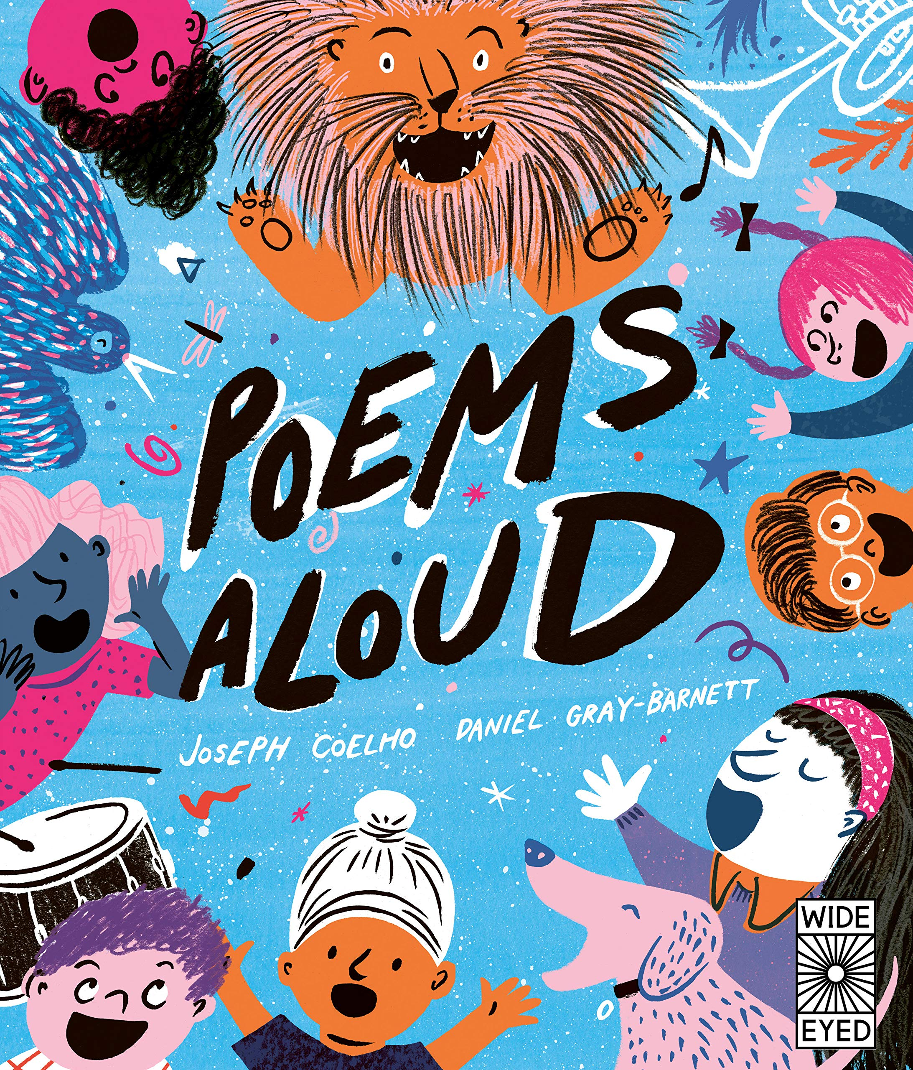
Level:
First (P2–4) and Second (P5–P7) / KS1 and KS2
Explore themes of:
√ Poetry √ Performance √ Reading and Writing Techniques √ Finding Inspiration
Subject Checklist:
√ Expressive Arts √ English Language √ Well-being and Health √ Creative Writing

At a Glance
Before watching the video or reading the poems!
- What sorts of illustrations are included on the cover? What do you guess some of the poems might be about?
- How do the illustrations make you feel? Why?
- How can you tell from the cover that the poems inside should be read aloud?
Book Cover Activity: Ways of Reading Aloud
Look closely at the cover of Poems Aloud. Can you find any small illustrations that give us clues about how we can read poems aloud? We’ve picked some out for you below. Discuss them with a partner!
The illustrations of a drum and a trumpet suggest …
The illustrations of the different people together suggest …
The illustrations of people with smiling faces suggest …

Read the Poems
Taken from ‘Poems Aloud’
Discussion Questions
1. What technique does Joseph Coelho use in ‘Tongue Twisters’, where most of the words begin with the same letter?
2. Look at the poems ‘To the Countryside’ and ‘Turn the Radio Up’. What is ‘diminuendo’? What is the opposite of diminuendo?
3. What can you do to create ‘loud’ or ‘quiet’ when performing poetry?
4. What is the rhyme scheme of ‘Funny Fish’? How does the rhyme scheme create comedy?
5. Can you find examples of how Joe’s poems incorporate the natural world?
6. Read out ‘The Shockadile Crocodile’ as a class. Why is this a fun poem to read?
7. Why is the technique of ‘repetition’ effective in ‘The Shockadile Crocodile’?
8. What is a ‘riddle’ poem? Can you guess the answer to each of Joe’s riddles?
9. Why do you think Joe has written his ‘Animals’ poems in the first person?
10. Which ‘Say How You Feel’ poem is your favourite? Why?
Watch the Video: Get to Know the Author!
Activity 1: Inspiration Out My Window
Joe describes where he grew up and how he gets his inspiration / 4:46–8.03mins
- Where is Joe from? Can you locate which window he might’ve looked out of from his building? Is Joe’s home similar to yours? How / how not?
- Joe talks about the importance of looking outside for inspiration. He also describes how he loved to play outside as a child and now likes to go on long walks by the sea. What inspires you when you look outside?
- On blank A4 or A3 sheet of paper, draw a huge window frame. When you go home tonight or at the weekend, or even when you look out of the classroom window, spend some time looking outside. What is the view?
- On your blank sheet of paper, draw or annotate all of the things you can see.
- Spend several days adding to your window frame. When you have finished, bring it into the classroom to share with your teacher, friends and classmates. What is the view from your window? How does it inspire you?
- Write a poem inspired by the view out of your window. When you’ve finished, read it (aloud, of course!) and share it with your classmates.

Activity 2: Performing A Poem
Joe explains the ways we can read aloud / 8.02–8.46mins
- In pairs or groups, choose one of Joe’s poems. Before reading it aloud, mark where you could experiment with the following things:
  - Changing the volume
  - Changing the speed
  - Using actions
  - Emphasising specific sounds or rhymes
- Make a list of any musical instruments that you think would help when reading your chosen poem aloud. Can you identify any specific lines where certain musical instruments would help to convey the meaning of the poem?
- In your pairs or groups, create a performance of your given poem. Use props in the classroom (or even from outside!) to make sounds, as well as musical instruments. Don’t forget to give everyone a part of the poem to read, and to focus on using the overall performance to convey meaning.
- Ask your teacher to record your performances so that you can watch them and decide where you did well and where you could improve next time. Most of all; enjoy reading and spread the love of poetry!

Your Turn: Develop Your Own Poetry Skills
Activity 1: My Emotions Poem
Joe explores how we can perform our emotions / 39.40–42.04 and ‘Say How You Feel’
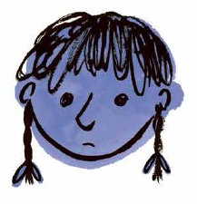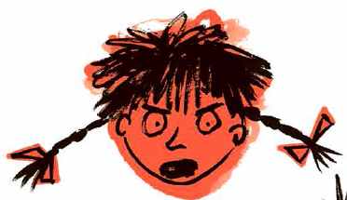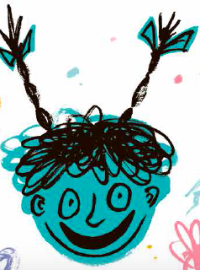
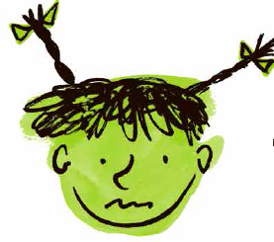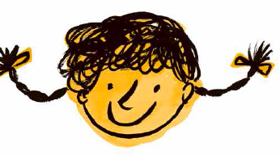

- Can you determine the different emotions just from looking at Daniel Gray-Barnett’s illustrations for ‘Say How You Feel’?
- Are any emotions missing here? Which emotion do you feel the most? Which would you most like to write about?
- Daniel Gray-Barnett has used different colours to illustrate the different emotions here. Discuss the colours used with a partner. What are the connotations of each colour? Can you add any more to the list?
  - PURPLE
  - RED
  - BLUE
  - GREEN
  - YELLOW
- Write your own emotion poem. First, choose your emotion. Consider the different colours and images that you associate with that emotion. How can you integrate these colours and images into your poem?
- Then, read your poem aloud by performing it in the emotion that you have chosen. Can you classmates guess which emotion your poem is about?
- Try swapping poems and performing them with different emotions; for example, perform a ‘happy’ poem in an ‘angry’ voice. How does this change the meaning of the poem?
Activity 2: Keeping a Rhyme Book
Joe describes poems that rhyme / 14.40–18.47 and ‘Funny Fish’
- When Joe reads his Shakespearean sonnet, he talks about the importance of emphasising the rhymes at the end of the lines. Can you detect the rhyme scheme of his sonnet?
- How is the rhyme scheme of Joe’s sonnet different to the rhyme scheme in ‘Funny Fish’? Which word is repeated throughout ‘Funny Fish’ and how does this contribute to the comedy of the poem?

- To help you with your own poetry writing, create your own Rhyme Book. Use a notebook or a plain pad, or even lots of scraps of paper or post-its that you can stick to your wall or classroom display.
- Over the next week, note down all of the rhymes that you can think of – the more weird and wonderful they are, the better! Share your rhymes with your classmates so that you all have access to an amazing bank of rhyming words.
- Then, create a poem using your bank of rhyming words. Perform them aloud – and remember, emphasise the rhymes using your voice, or even a musical instrument! Have lots of fun performing your rhyming poems aloud together.

Reflection and Further Questions
Reflection Activity
Think about all the things you have learned from Joseph Coelho’s video and book of poems. Under each header below, write a reflection sentence showing what you can do for each to improve your poetry performance!
VOICE VOLUME SPEED ACTIONS
RHYME COMEDY EMOTION
Lastly, do you have a question you would like to ask Joe if you got the chance? Make a note of it and share your questions together. Can you predict what the author might say?
Keep your eye out for more beautiful poems and stories from Joseph Coelho as well as the other authors from Edinburgh International Book Festival!

