The Teeny Weeny Genie: A Sensory Story
Creating a sensory story to accompany Julia Donaldson’s
wonderful picture book.
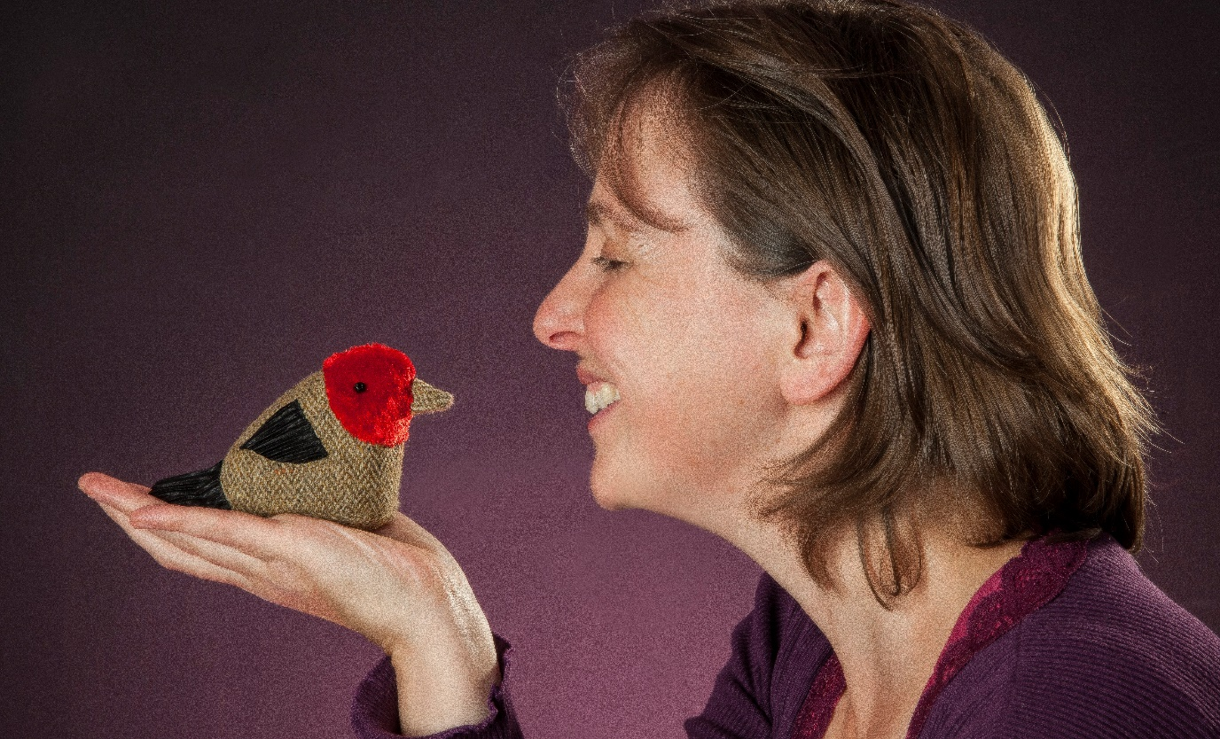

Summary:
Join Sensory Storyteller Ailie Finlay to create your own sensory story to accompany Julia Donaldson’s wonderful story The Teeny Weeny Genie, which she will perform during her event Gruffalos, Conjurors and Teeny Weeny Genies at Edinburgh International Book Festival 2020.
This resource is great for:
Making sure that everyone can enjoy the Book Festival online, especially those with learning disabilities, by creating sensory stories to accompany events.

Introduction
Join in with Julia Donaldson’s performance of The Teeny Weeny Genie by creating your own sensory story using props and sounds, in this resource created by Storyteller Ailie Finlay.

Step 1
Watch this video created by Ailie in which she suggests props which you can gather or make from around your home.
https://youtu.be/Z4XlFbiYuNw
Prop suggestions:
- Two teeny weeny genie puppets (Ailie made hers out of socks!)
- A teapot
- A massage roller (or toy tractor and fire engine)
- A small suitcase
- A pastry brush (for the cat’s whiskers)
- A squeaky toy (for the mouse)
- A hammer, ruler or other safe tool
- A baby doll
- A rattle
- A doll’s blanket or other cloth for the baby’s cape
- Drums and other musical instruments (or you can improvise with things from your kitchen
- A rain stick (or bottle filled with sand or shells) to represent the sea
- Two teacups

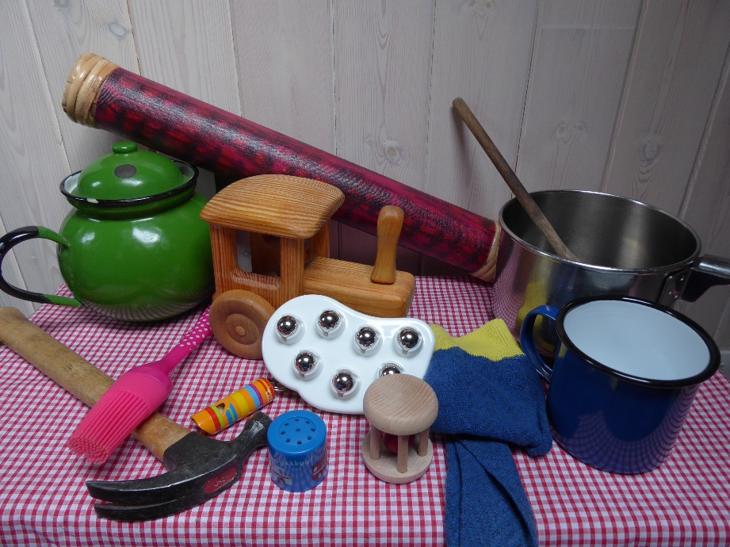
Step 2
Watch Julia’s event Gruffalos, Conjurors and Teeny Weeny Genies. As Julia performs The Teeny Weeny Genie join in by using the props above. Hide your genie in a teapot and then pull it out at the right time, do some hammering, cuddle your baby doll, drink your ‘tea’ etc. And do lots of tummy rubbing and head patting!
Enjoy making the noises, using a whistle, drums (or pots and pans) and loud voices. If your child enjoys tactile sensations, then you can run a massage roller or toy car up and down their arm for the vehicles, brush the back of their hand with a pastry brush (or something similar) for the cat’s whiskers and then let them feel some sand or shells at the end of the story.
Step 4
Remember children often enjoy a story more if they hear it several times. So, if possible, keep your collection of props together and read The Teeny Weeny Genie to your child if you have a copy, or go back to view the event again.

Further information
If you would like your own copy of The Teeny Weeny Genie it is available to buy from our independent online bookshop.
You can find more sensory story ideas on Ailie’s website, http://www.flotsamandjetsam.co.uk/

