Voices from the Past with Patrice Lawrence and Bali Rai
Discover unsung stories through history with
Diver’s Daughter: A Tudor Story and Now or Never: A Dunkirk Story

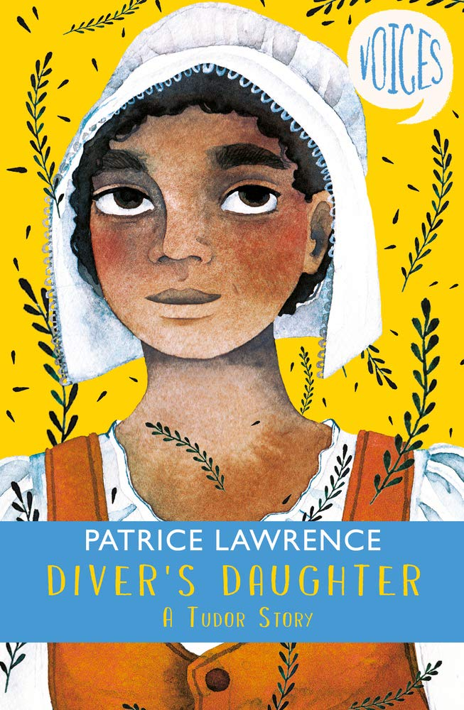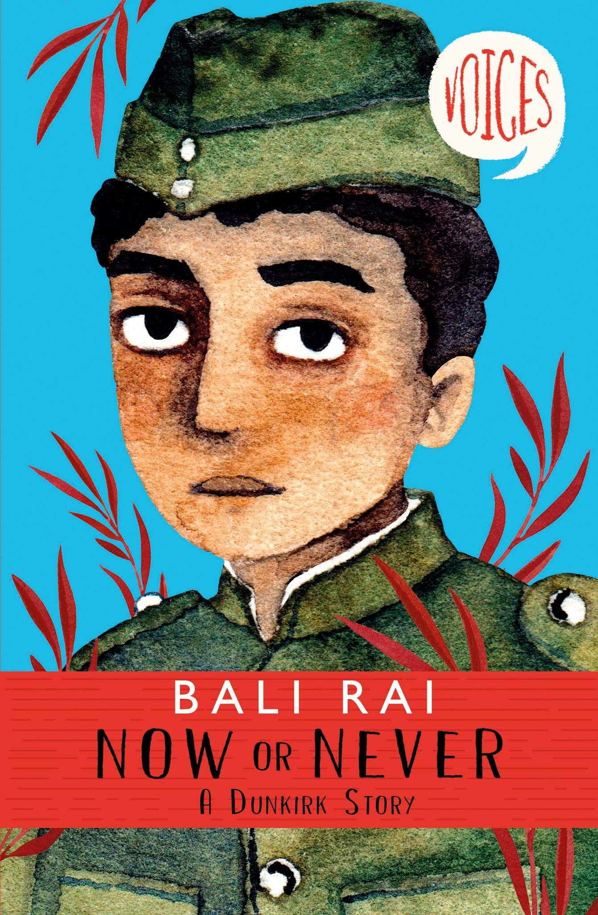

Level:
Second (P5-7) – KS2
Explore themes of:
√ Diversity √ Different Perspectives √ History √ Role Models √ Overcoming Prejudice
Subject Checklist:
√ English Language √ Social Studies √ Expressive Arts
At a Glance
Before watching the video or reading the extracts!
- In which historical periods are these two books set? What do you know of these periods?
- Why do you think the designer has chosen a portrait of the protagonist as the main element of the cover?
- Whose ‘voices’ do you think you will hear in these stories?

Book Cover Activity: Portraits
Create a portrait in the same style as the two pictured here. Your portrait should be of someone you find inspirational or interesting – maybe a local hero or a relative, but someone who you consider to be an unsung hero or role model. Create your portrait and consider the following things:
- What colours you will use
- How you will present the person’s facial expressions to show some of their character traits
- What features you can add to show the period in which they live
- The title of their story

Read the Extracts
Taken from pages 1–9 of ‘Now or Never’ and pages 1–19 of ‘Diver’s Daughter’
Discussion Questions
1. Why do you think Now or Never: A Dunkirk Story and Diver’s Daughter: A Tudor Story have both been written from the first person perspective?
2. In the Prologue of Now or Never, what are Faz’s feelings as he leaves his family and sets off on his journey?
3. Where is Rawalpindi? What is the difference between Faz’s home in Rawalpindi and his posting in Marseille?
4. What does Mush mean when he says: “We are just Indians. These people do not think of us as equals. This is not our war, Faz”?
5. In Diver’s Daughter, what year was Eve born in? Why is this year significant?
6. Eve describes how ‘People sometimes look at us because our skin is browner than everyone else’s.’ How do you think Eve feels about this?
7. How does Patrice Lawrence create a vivid picture of Tudor life and the River Thames?
8. On page 13, how can you tell that Eve and her Mama don’t have a lot of money?

9. Why does Mama ‘draw herself up’ on page 16? What kinds of discrimination do Eve and her Mama face?
10. Can you see any similarities between the two stories by Patrice Lawrence and Bali Rai?
Watch the Video: Get to Know the Authors and the Books!
Activity 1: Feeling Voiceless
The ‘Voices’ series tells the stories of people who have had to fight to make their voices heard.
- In Diver’s Daughter: A Tudor Story and Now or Never: A Dunkirk Story, the main characters face discrimination from those around them on the basis of their skin colour. Can you find examples of this in both extracts?
- For the characters involved, write down their thoughts and feelings in these moments. How do they react? How do you think they feel to be treated this way? How do these moments make Eve, Eve’s Mama and Faz feel ‘voiceless’?
- Look again at the examples of Eve, Eve’s Mama and Faz facing discrimination. To represent each character, draw x3 gingerbread-man templates. On the outside of the templates, write words that show how Eve, Eve’s Mama and Faz react. On the inside of the templates, write how they really feel deep down.

- Then, in your pairs again, act out the scenarios together. Consider how you can use dramatic techniques (e.g. monologue / facial expressions and body language) to show the characters’ reactions, but also their inner thoughts and feelings.
- Do you think people still feel voiceless today? Who? Can you remember a time when you were made to feel this way? Discuss with a partner and create a list of the emotions you felt. Then, act out your own example of feeling voiceless.
- Take some time to reflect on how completing this activity has made you feel.
Activity 2: Author Biographies
Patrice Lawrence and Bali Rai are passionate about sharing these forgotten histories. Why?
- Patrice Lawrence and Bali Rai are the authors of the first two books in the ‘Voices’ series. Why do you think they wanted to write these stories? What motivated them to write about these unsung heroes in History?
- Using the video and any information that you can find online, including any interviews, carry out some research into either Patrice Lawrence or Bali Rai and create a short Biography.
- You Biography should include the following headers:
  - Image or Illustration
  - Early Life (Home, Culture, Religion, Family, Education)
  - Later Life (Profession, Skills, Talents, Achievements)
  - Books Written
  - Interests and Passions
- In what ways do you think Patrice Lawrence and Bali Rai empathise with the characters that they write about in the ‘Voices’ series? How have their own experiences motivated them to write these stories?

Your Turn: Develop Your Inner Historian!
Activity 1: Different Perspectives in History
This series challenges our view of History by presenting previously unheard stories. Why is this a good thing?

- Look at the statement below. Discuss as a class your thoughts and ideas about the statement, including whether you agree or disagree and why, as well as whether you would add to the statement:
It is important for children to read about the lives of other children from different cultures and ethnic groups to their own, especially in a historical context.
- Consider your view of History – for example of the Tudor period and World War II. What is your understanding of these periods? Why do you think this is?
- Who writes History, and why is this an important question to ask?
- History is often about power and perspective, or bias. Those with the strongest or most powerful voices are the loudest. Experiment with these ideas by writing at least
two accounts based on a single event. The event can either be something you’ve seen in the news or something that you’ve witnessed in your local community – or even something on the playground.
- Consider the different perspectives of those involved in the event that you’ve chosen. How would their accounts be different?
- When you’ve written at least two accounts of the same event, reflect on how different they are. Then, imagine that only one of these articles survives in the future. How would this effect people’s interpretation of what actually happened?
Activity 2: History Timeline: From the Tudors to Dunkirk
These two books are set in very different historical periods; what do you know about them?
- Diver’s Daughter describes the journey that the African slaves in the story went on (Mama and Master Jacque Francis, the diver).
- Importantly, the year 1420 marked the Portuguese exploration of West Africa and the beginnings of the Slave Trade. Carry out some research about the Slave Trade from this point and throughout the Tudor period.
- Create a chronological timeline documenting important moments and facts between 1420 and 1603. How did the Slave Trade intersect with what was happening in Tudor Britain? What was the wider context? What other

- important historical events occurred during this time (e.g. Wars; Exploration).
- Jump forward a few years! Bali Rai’s story interweaves the experience of Indian Soldiers as they fight on behalf of the British during World War II. Why did they have to do this?
- Carry out some research into British Colonial Rule in India, which ended in 1947, just after the end of WWII.
- How do the events of WWII intersect with what was happening in India? How do you think someone like Faz must’ve felt about fighting for the British?
- Consider what these multiple timelines show you about History. For example: do you think History is simply one straight line, or lots of different interweaving lines criss-crossing each other? Share your ideas with your classmates.

Reflection and Further Questions
Reflection Activity
Think over all that you have learned today. What have you realised about History? Who would you like to know more about? Whose story do you want to hear?
Carry out your own research into a forgotten or unsung historical figure. How can you help to tell their story? Carry out some initial research and create a collage of your findings to present your ideas.

Lastly, do you have any final questions you would like to ask Patrice or Bali if you got the chance? Try to think of at least two and make a note of them.
Keep your eye out for more awesome books from Patrice Lawrence and Bali Rai, as well as the other authors from Edinburgh International Book Festival!

