Writing Resistance with Nikita Gill and Nic Stone
Fight against social injustice with SLAM! and Dear Justyce

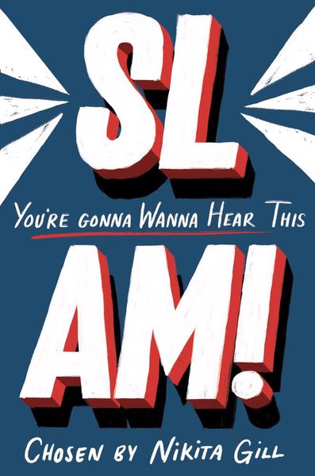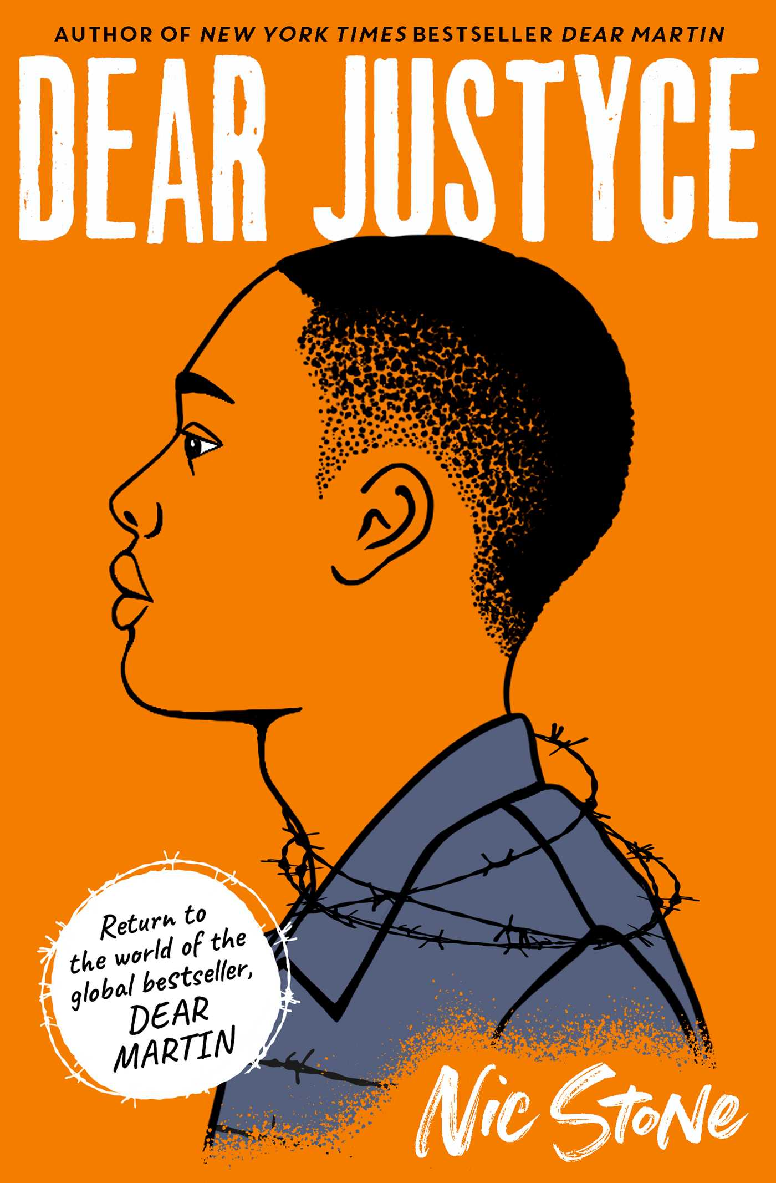
Level:
Third and fourth (S1-3) and Senior Phase (S4-6) / KS3 and KS4
Explore themes of:
√ Poetry √ Resistance and Activism √ Social Justice √ Racism √ Challenging Prejudice
Subject Checklist:
√ Expressive Arts √ English Language √ Social Studies √ Creative Writing
Note to teachers: These books contain some material that may not be suitable for some students. We recommend that teachers read the books carefully before using it in the classroom or recommending it to students and/or seek parental guidance.

At a Glance
Before reading the extract or books!
- What does the word ‘SLAM!’ make you think about? What about the word ‘Justyce’?

- How can you tell that both of these books might have a strong and important message about society?
- What is the effect of having the character on the cover of Dear Justyce in side-profile?
Book Cover Activity: Freedom and Limitation
Examine the front covers for SLAM! and Dear Justyce. How do both covers explore the ideas of ‘freedom’ and ‘limitation’? What details can you see in both covers that contribute to these two themes? Consider any illustrations, characters, words/punctuation you can see.
- Write down the word FREEDOM: around the word, draw or write down what you associate with it.
- Then, write down the word LIMITATION: around this word, draw or write down what you associate with it.
- What is your understanding of ‘freedom’ and ‘limitation’? What are your own experiences of these two things? Do some people experience freedom and limitation more than others in their lives? Why?
- Create your own book cover using these two ideas as your inspiration.

Read the Extract
Taken from the Introduction of ‘SLAM!’ – pages v–vii.
Discussion Questions
1. According to Nikita Gill, what are the reasons that poetry has become ‘the fastest growing art form in Britain’?
2. What is ‘a slam’? Would you like to see a slam? Why?
3. Why does Nikita place a lot of importance on the ‘medium’ she chooses for her poetry?
4. What does Nikita mean when she says that poetry has been ‘sequestered to the classroom as something that made us groan’. Do you agree with her?
5. Nikita describes poetry as the language of ‘fire, fury and freedom’. What imagery does this description conjure for you?

6. What is the connection between performance poetry and revolution?
7. Why are slams considered to be an ‘inclusive, open space’?
8. What does the phrase, ‘manifesto for change’ mean?
9. Nikita describes the collection as including voices that are ‘urgent’. What does she mean by this?
10. How do you think poetry can be ‘a war cry – a battle song’?
Get to Know the Authors!
Activity 1: A War Cry – a Battle Song
Both of these authors are interested in how writing can ignite change to challenge stereotypes and fight against discrimination.
- Nikita and Nic are concerned with social justice and how writing can be a powerful force in the fight for equality. How far do you agree that writing has the capacity to ‘ignite change’? Can you think of examples where this has happened?
- In Dear Martin and Dear Justyce, Nic Stone looks at how African American boys and minorities are discriminated against in the American justice system. What do you know about the American justice system?
- In a small group, discuss the different things on the list below. What are they and how are they conected?
  - Social Justice
  - Black Lives Matter
  - Police Brutality
  - Justice
  - White Privilege
  - Education
  - Anti-racism

- Think about how all of these issues relate to your life and the community you live in. What positive changes are happening? What more needs to be done?
- Write a reflection on why, in 2020, it is important to challenge racism in all its forms. Why is it important to be anti-racist?
Activity 2: Resistance and Activism
Why is it important to stand up to social injustice? What can you do in the fight for justice?
- Where do you see social injustice in your daily life? Perhaps you feel like you experience injustice. How? When? Keep a diary for a week of all the instances that you see or experience social injustice. Consider whether the injustice you see is based on race, class, gender, sexuality, disability – or something else?
- What do we mean by the word ‘activism’? How do you think writing can be a type of activism? How does activism help us to overcome social injustice?
- Start thinking about the things that you are passionate about. What cause would you fight for? What do you want to change?
- Unleash your inner activist. Imagine you are going to a protest or presenting your ideas to a group of people. Create a persuasive banner, poster or protest placard. Remember to include the following:
- The reasons that you want change. Do you have any real-life examples or statistics that can help to persuade others to join your cause?
- The impact on real people. How can change help others for the better?
- Why you are so passionate about your cause. What makes you want to use your voice to fight for justice?

Your Turn: Finding Your Voice
Activity 1: My Manifesto for Change
In the Introduction to ‘SLAM!’ – Nikita Gill describes poetry as the language of ‘fire, fury and freedom’. How can writing itself spark a revolution?
- Using Nikita Gill’s description of poetry as the language of ‘fire, fury and freedom’ – write a poem entitled ‘My Manifesto for Change’.

- You poem should be made up of three stanzas; each stanza inspired by each of these three words – ‘fire’, ‘fury’ and ‘freedom’.
- First, choose the social justice cause that you are most passionate about. Perhaps it is the same cause that you created your protest banner for.
- In Stanza 1 of your poem, think about the imagery of FIRE to help you write it. What is the fire in your belly? What is the thing that burns inside you and forces you to write?
- In Stanza 2, think about the imagery of FURY. What are you angry about? Why? What actions do you want to take?
- Finally, in Stanza 3, think about the imagery of FREEDOM. How can change create freedom? How can it lead to a better world, free of injustice?
Activity 2: Classroom SLAM!
Nikita describes performance poetry as a reminder of ‘the revolution poetry incites’.
- Discuss in pairs or small groups how performance poetry might ‘incite’ revolution. What do we mean by revolution? What examples of revolution can you think of throughout History?
- How can we experiment when performing poetry to evoke the emotions of an audience? Use the headers below to come up with ideas:
  - Voice
  - Volume
  - Speed
  - Body Language
  - Facial Expression
  - Pauses
  - Movement
  - Music
- Practice reading your Manifesto for Change poem from Activity 1 aloud, at home with your family or in front of friends. Then, with your entire class (or school!), host a Poetry Slam Day in which everyone performs their poems. Reflect on how each poem inspired you – do you feel ready to action change?

Reflection and Further Questions
Reflection Activity
Think over all that you have learned today. Looking forward, what actions can you take to ensure that you are fighting for a fair society? Make pledges or promises to yourself about actions that you will take. Think about the positive impact this will make.
I will become more informed about …
I will engage more with …
I will challenge my own viewpoint on …
I will support resistance movements such as …
Lastly, do you have any final questions you would like to ask Nikita and Nic if you got the chance? Try to think of at least two and make a note of them.
Keep your eye out for more awesome books from Nikita Gill and Nic Stone as well as the other authors from Edinburgh International Book Festival!

