Yours Faithfully: Letter Writing with Leyla Josephine
Bringing back an ancient way of communicating.

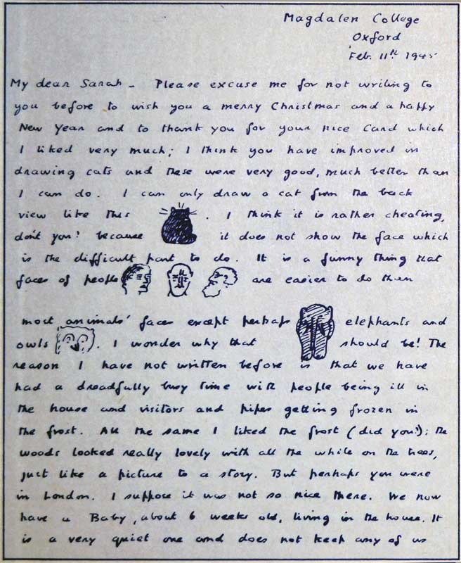
A letter from C.S. Lewis to one of his young fans.

Summary:
This reflective writing exercise, devised by our Citizen Schools Writer in Residence, helps provide a structure for a personal piece of writing.
This resource is great for:
Anyone! The worldwide understanding of letter writing opens up so many opportunities for the writer and reader.

Introduction
This is the fourth in a series of activities exploring self-reflection and identity, created by Leyla Josephine, poet, performer, facilitator, theatre-maker, and one of our Citizen writers in residence.

All of Leyla’s activities can be made simpler or more complex depending on ability.
Writing letters is one oldest forms of communication. In this ever-digital age, writing a letter holds a power of expression that can help writers find their voice.
You will need
- envelopes
- paper
- pens/pencils
Preparation
Include a letter writing prompt in each individual envelope. It’s good to have a couple of extras in case someone doesn’t like their prompt.
Sample prompts:
Write a letter to the future.
Write a letter to someone in the past.
Write a letter to your adult self.
Write a letter to your child self.
Write a letter to a neighbour.
Write a letter to the prime minister.
Write a letter to someone you don’t know.
Write a letter to your best friend.
Write a letter to someone you argue with.
Write a letter to a place.

Write a letter to a building.
Write a letter to an animal you know.
Write a letter to a famous person.

Step 1
Ask the participants to pick an envelope.
Step 2
Ask for the participants to respond to the writing prompt. Remind them to include who it is to and who it is from.
Step 3
Ask the participants to put their own letter into the envelope they were given.
Step 4
Pass the envelopes out so everyone has a new letter.
Step 5
Offer an opportunity to share the new letter they’ve been given.

Further information
Find out more about Leyla's work in schools, part of our year-round programme of community events, here.

