Formidable Females
with Lari Don and Eilidh Muldoon
Use myths and legends featuring strong women and girls to inspire your own creative writing and drawing.

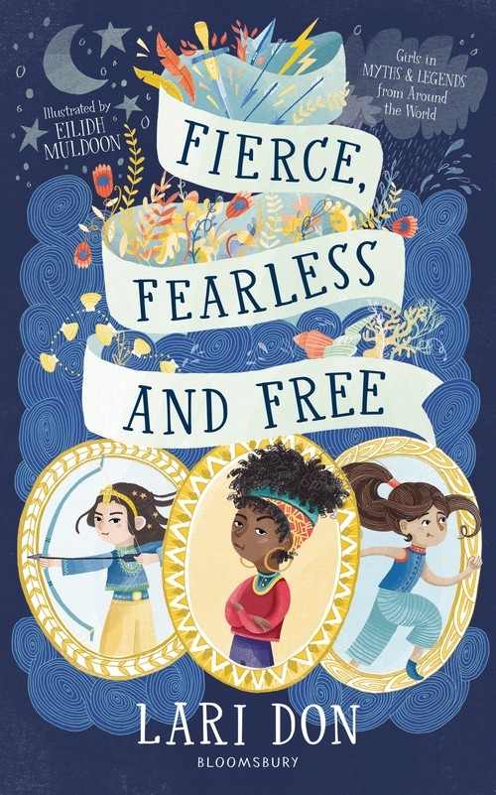

Level:
First (P2-4) – KS1
Second (P5-7) – KS2
Explore themes of:
√ Diversity √ Different Perspectives √ History √ Role Models √ Overcoming Prejudice √ Traditional Tales
Subject Checklist:
√ English Language √ Social Studies √ Expressive Arts
At a Glance
Before watching the video or reading the extracts!
- Looking at the title and cover, what do you think this book is about?
- What do the words “Fierce, Fearless and Free” make you think about?

- When and where do you think the stories are set?
- What do you think all of the characters in the book will have in common?
Book Cover Activity: A picture is worth a thousand words
Choose one of the three characters you can see on the book cover. How much can you tell about them from the image? Where are they from and which time period? Can you tell anything about why they might feature in the book?
Use your imagination to fill in the details which aren’t obvious from the picture?
- What do you think the character’s name might be?
- Where are they from? Are they rich or poor?
- Do they have any special talents?
- Is there something that they need to overcome and fight against
- How does their special talent help them to do this
Once you read Fierce, Fearless and Free you can see just how much you got right! But perhaps you can also use your ideas to write your own story!
Read the Extracts
Altyn Aryg and the Snake’s Belly from Fierce, Fearless and Free p133 – 138.
Discussion Questions
1. What do you think about the Khan? Why do you think he wants a son instead of a daughter?
2. What does “heir” mean? Why can Altyn Aryg not be her father’s heir?
3. How is the snake which Altyn Aryg is hunting described? Do you think the description of the snake is accurate? Why or why not?
4. Do you think Altyn Aryg is right to try to impress her father in this way?
5. Imagine you’re one of the people living inside the snake? How would you feel? What would you do? What ways do you think they have tried to escape the snake’s belly?
6. Why do you think the snake has black blood? What does that symbolise?

7. Why does Altyn Aryg refuse her rewards from the tribes?
8. Do you think Altyn Aryg’s reward from her father is appropriate? Is there anything else she might have wanted?
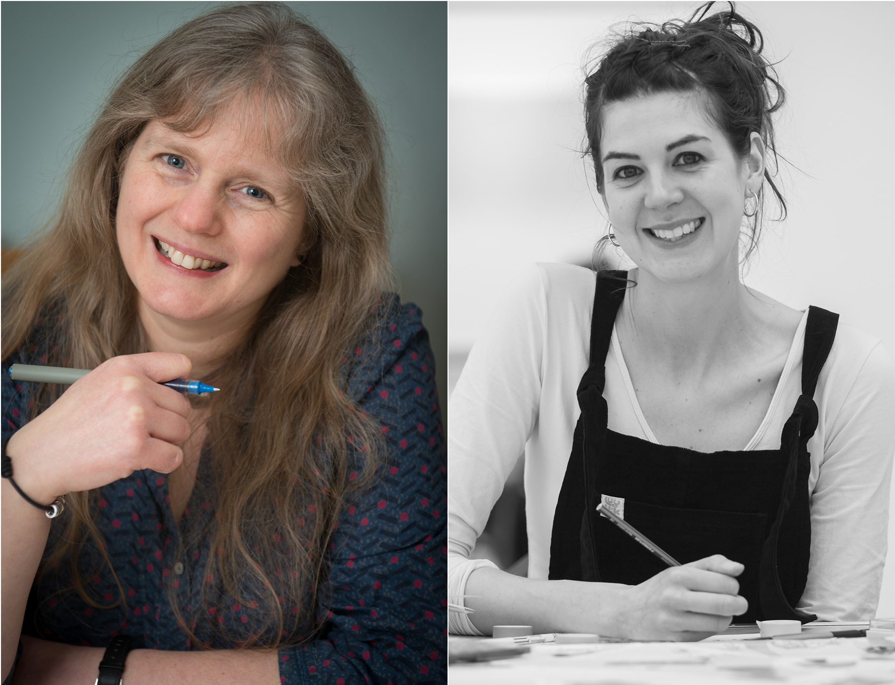
Watch the Video: Get to Know the Authors and the Books!
Activity 1: Create your own Fierce, Fearless and Free Character!
In the event Eilidh sets a drawing activity, challenging you to create your own Fierce, Fearless and Free character. You could choose one of the characters from the book, make one up, or even base them on yourself! Grab some pens, pencils and paper and let’s get ready / 24.35 – 33.05m
Eilidh says:
“An illustration shouldn’t tell the same story as the words, because the words already do that and you wouldn’t need the pictures. So, what you want to do is get them working alongside each other.”

For example, think about what your character likes to do in their spare time? What is their favourite food? Use these things to inspire your drawing.
- Think about the emotions of your character. What are they thinking and feeling and how can you communicate that in their facial expression and the poses they’re in? Follow Eilidh’s tips on how to use facial features and pose to communicate emotions.
- Setting the scene. What is your character dressed in? Is it suitable for what they’re about to do? Where do they live and where does story take place? What is in the background (which is or isn’t mentioned in the story!)
- Composition. How do you group all of these things together to communicate the atmosphere? Put all these things together to create your final illustration. What’s in the background? What colours will you use and what effect do they give?
This is all about getting rough ideas and inspiration down on paper so you can create your character from there. So, don’t worry about trying to get everything perfect.
Eilidh says:
“Have fun and just keep drawing. If you think that you’re making a mistake with it or a drawing’s not going very well just keep going anyway, because I find that the ones that I think are rubbish end up being the most useful because you can look at it and think what you did wrong and maybe make the next one even better.”
Activity 2: Reimagining Traditional Tales
At the end of the event Lari gives several prompts to get you writing your own stories, based on traditional tales / 33.25 – 41.30m
Lari says:
“The absolute best thing about old stories is that they can inspire new stories... What I love most of all is how my brain comes up with new stories, while I’m spending time with the old stories.”
Use one of the ideas below as a writing prompt:
- What else could Altyn Aryg have done to impress her father which wasn’t quite as dangerous as defeating a monster?
- Put your character into a trap with no obvious way out. How will your heroine escape?
- Fierce, Fearless and Free features some very odd and unlikely baddies including a mountain and a hippo. Imagine a really unlikely person, animal

or object to be the baddy in your story. What would that baddy want (perhaps something to take or steal?) How would your baddy be defeated?
- Some traditional tales involve talking animals granting favours. Bear in mind that favours are different to wishes – a favour needs to be something that the animal can actually do. What adventure could your character go on where a favour from an animal (maybe a fox, eagle or dormouse) could actually be helpful? Does the animal grant the favour in a helpful or unhelpful way? Lari says it always helps the story when things go wrong!

Top tip: before you start writing tell your story out loud to family, friends or your class. When you write the story try to use the same voice that you used when you were telling it.

Reflection and Further Questions
Why do you think it’s important to share and celebrate traditional stories about strong girls and women?
What stories do you know from your culture or upbringing that feature strong females. In your class why not create your own anthology featuring these stories or the ones that you created earlier? Don’t forget to illustrate each!
Do any of the stories that you know rely on a traditional “happily ever after” ending? If so, why not write your own ending imagining what would be a more fitting reward for your Fierce, Fearless and Free heroines!
Lastly, do you have any questions you would like to ask Lari or Eilidh if you got the chance? Try to think of at least two and make a note of them. Send your questions to learning@edbookfest.co.uk and you might even get a reply from Lari or Eilidh!
Keep your eye out for more awesome books from Lari Don and Eilidh Muldoon, as well as the other authors from Edinburgh International Book Festival!

