Be the Change with Gina Martin
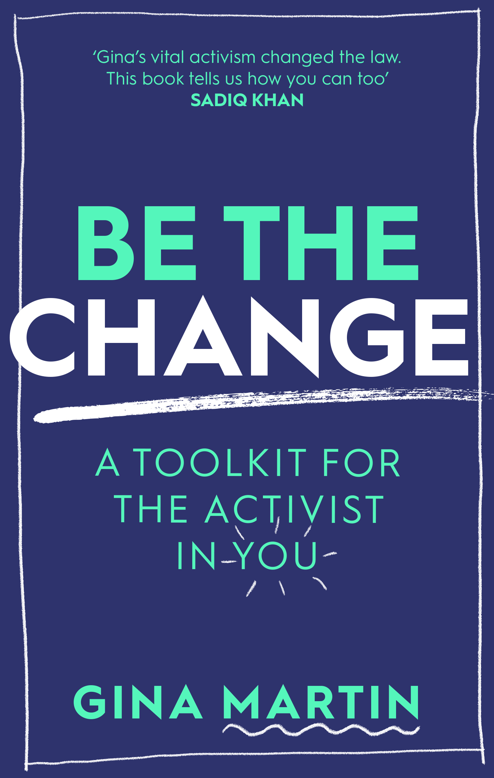

Discover the courage to challenge injustice and
fight for a cause you care about with Be the Change
Level:
Third/Fourth Level – KS4/5
Explore themes of:
√ Activism √ Campaigning √ Citizenship √ Human Rights √ Injustice √ Fighting for a Cause
Subject Checklist:
√ English Language √ Social Studies √ Expressive Arts √ Well-being and Health

At a Glance
Before watching the event or reading the extract!
- What do you think it means to ‘be’ the change? Why is this an inspiring title?
- When you think of an ‘activist’ – what kind of person do you see in your mind?
- What issues are you passionate about? What would you like to change in the world?
Book Cover Activity: Defining Activism
Consider what the word ACTIVISM means to you.
On a piece of paper, write each letter of the word vertically down the page to create an acrostic. For each letter, write a word or phrase beginning with that letter to help define the word ‘activism’.
For example for the letter ‘A’ you might choose one (or all) of the three As that Gina describes in her book: Awareness, Advocacy and Action.
Read the Extract
Taken from pages 24–25 of ‘Be the Change’
Discussion Questions
1. What does it mean to have ‘privilege’?
2. What do you think are the ‘myriad forms’ of privilege that Gina refers to on page 24?
3. Why might the capacity to make change be linked with having privilege? Why is it important to challenge this?
4. What do you think Gina Martin means when she says ‘there is no recipe for an activist’?
5. How did the word ‘activist’ make Gina feel before she began her activism journey?
6. What was Gina’s view of an activist? How has it changed?
7. When Gina says that ‘certain personality traits may make becoming an activist an easier mission’ – what personality traits do you think she’s referring to?
8. Gina says that ‘not every activist is a ‘remarkable’ person’; what does she mean?
9. What traits does Gina list as helping her start and become successful in her activism?
10. Which of the traits listed do you think are most important? Do you possess any of them? What are the personality traits that might help you on your own activism journey?

Get to Know the Author and the Book!
Activity 1: Inspiring Change-Makers
Gina is one of many bright, bold and passionate change-makers through history that have inspired others and helped to build a fairer society.
- In 2017, Gina Martin was ‘upskirted’ – a man took a photograph up her skirt at a music festival. Eighteen months later, Gina had changed the law and made upskirting a criminal offence. Gina is an example of how one person can help to bring vital change in society. Discuss with a partner: how does Gina’s story inspire you? What is she passionate about? What positive change as she made, and for who?
- Be more Gina. Think about the qualities that Gina showed to help bring about change. On a large sheet of A3 paper, write these qualities down.
- There are several examples of change-makers who got us here and who are active in the modern day mentioned in Gina’s book. Choose one from pages 28–48 and create a ‘Change-Maker Profile’ for them; include information about their background, what inspired them, their qualities and their passions.
- Can you think of an activist who has inspired you? Who are they? What are they passionate about? What have they achieved? Present your ideas to your classmates.
- Discuss the quote below together. What does it mean to ‘unlearn’? Why is this important for growth in a society that is always shifting and evolving?
“The first problem for all of us, men and women, is not to learn, but to unlearn.” – Gloria Steinem, US feminist and political activist (page 28)
Activity 2: Facing Injustice
There are many injustices in the modern world that it is important to fight against – what are these injustices?
- Discuss with a partner: which social injustice did Gina Martin fight against? Why did she feel motivated to do this?
- Below are just some of the social injustices that we face in 2021. Can you think of any others to add to this list?
  - Racial Injustice
  - Gender Inequality
  - LGBTQ+ Rights
  - Climate Justice
  - Child Poverty
  - Refugee Crisis
- Organise these different injustices into the things you are passionate about. Which of these issues are most important to you and why? Which is most urgent in your local community – or which do you think about most often?
- Consider the recent ‘Me Too’ and ‘Black Lives Matter’ movements. What issues were these two campaigns related to? Which injustices did they fight against? How did they create change?

Your Turn: Develop Your Inner Activist
Activity 1: Picking Your Cause
Picking something to focus on can be overwhelming, so Gina advises first writing down your absolute core values.
- You core values are the very basis of what you care about, your fundamental beliefs – what’s vital to you, others and the world around you.
- Gina shares her core values on page 153:
  - Honesty
  - Optimism
  - Respect
  - Integrity
  - Communication
- Gina advises that the causes that you choose should always be related to your core values; ‘the problem you will want to solve will sit in direct opposition to them, and the solution you come up with should fit in with them.’
- Spend ten minutes reflecting on your own core values. Do you share any of Gina’s? Write down a list of five.

Activity 2: Distilling and Digging
Sometimes it can be hard to pinpoint the issue you want to act on. The trick is to find the piece of the big puzzle to solve, rather than trying to solve the whole puzzle at once.
- On page 155, Gina talks about ‘distilling’ (filtering broad problems into more manageable issues) and ‘digging’ (doing research on your chosen issue). This helps to break down large problems into more achievable campaign objectives.
- Follow Gina’s advice by creating an A3 Mind Map using the instructions below.
  - At the Top: note down two main ‘Broad Issues’ that you care about. Examples are ‘Gender Inequality’ or ‘Climate Change’. This is your first layer.
  - Second Layer: explode your ‘Broad Issues’ into ‘Sub-Problems’ – e.g. ‘Sexual Abuse’ might come under ‘Gender Inequality’.
  - Third Layer: continue to distil your issue into smaller, more digestible parts – e.g. ‘Sexual Abuse’ might now become ‘Sexual Harassment’ or ‘Rape’. The more specific you get, the easier it is to find an issue to focus on.
  - Final Layer: take one of the specific issues you have discovered and interrogate it. Ask the questions below and carry out further research. Use Gina’s answers on pages 158–159 to help you.
    - What are the causes of the issue? (list all)
    - What are the immediate consequences of the issue? (list all)
    - What problems does this issue lead to in the long run? (list all)
- Share your A3 Mind Maps with a classmate or friend. Discuss the similarities and differences between your Mind Maps. Why is it important that everyone has different ideas and different issues that they care about?

Reflection and Further Questions
Reflection Activity
Think over all that you have learned today. What have you realised about the power of activism? What steps have you taken to start your own activism journey?
Create an Activism Journal. On the first page, write down how you have been inspired by Gina Martin’s story and her book. You might want to include quotes, examples of previous activists and their campaigns, tips from Gina, or some of your own ideas. As Gina says in ‘Be the Change’: getting started on your activism journey is the most important part.
Lastly, do you have any final questions you would like to ask Gina if you got the chance? Try to think of at least two and make a note of them.
Keep your eye out for more awesome books from Gina Martin, as well as the other authors from the Edinburgh International Book Festival!

