Discover a world of wildlife
with Neal Layton
Find out how every plant and animal on earth is part of the
amazing web of life with A World Full of Wildlife!

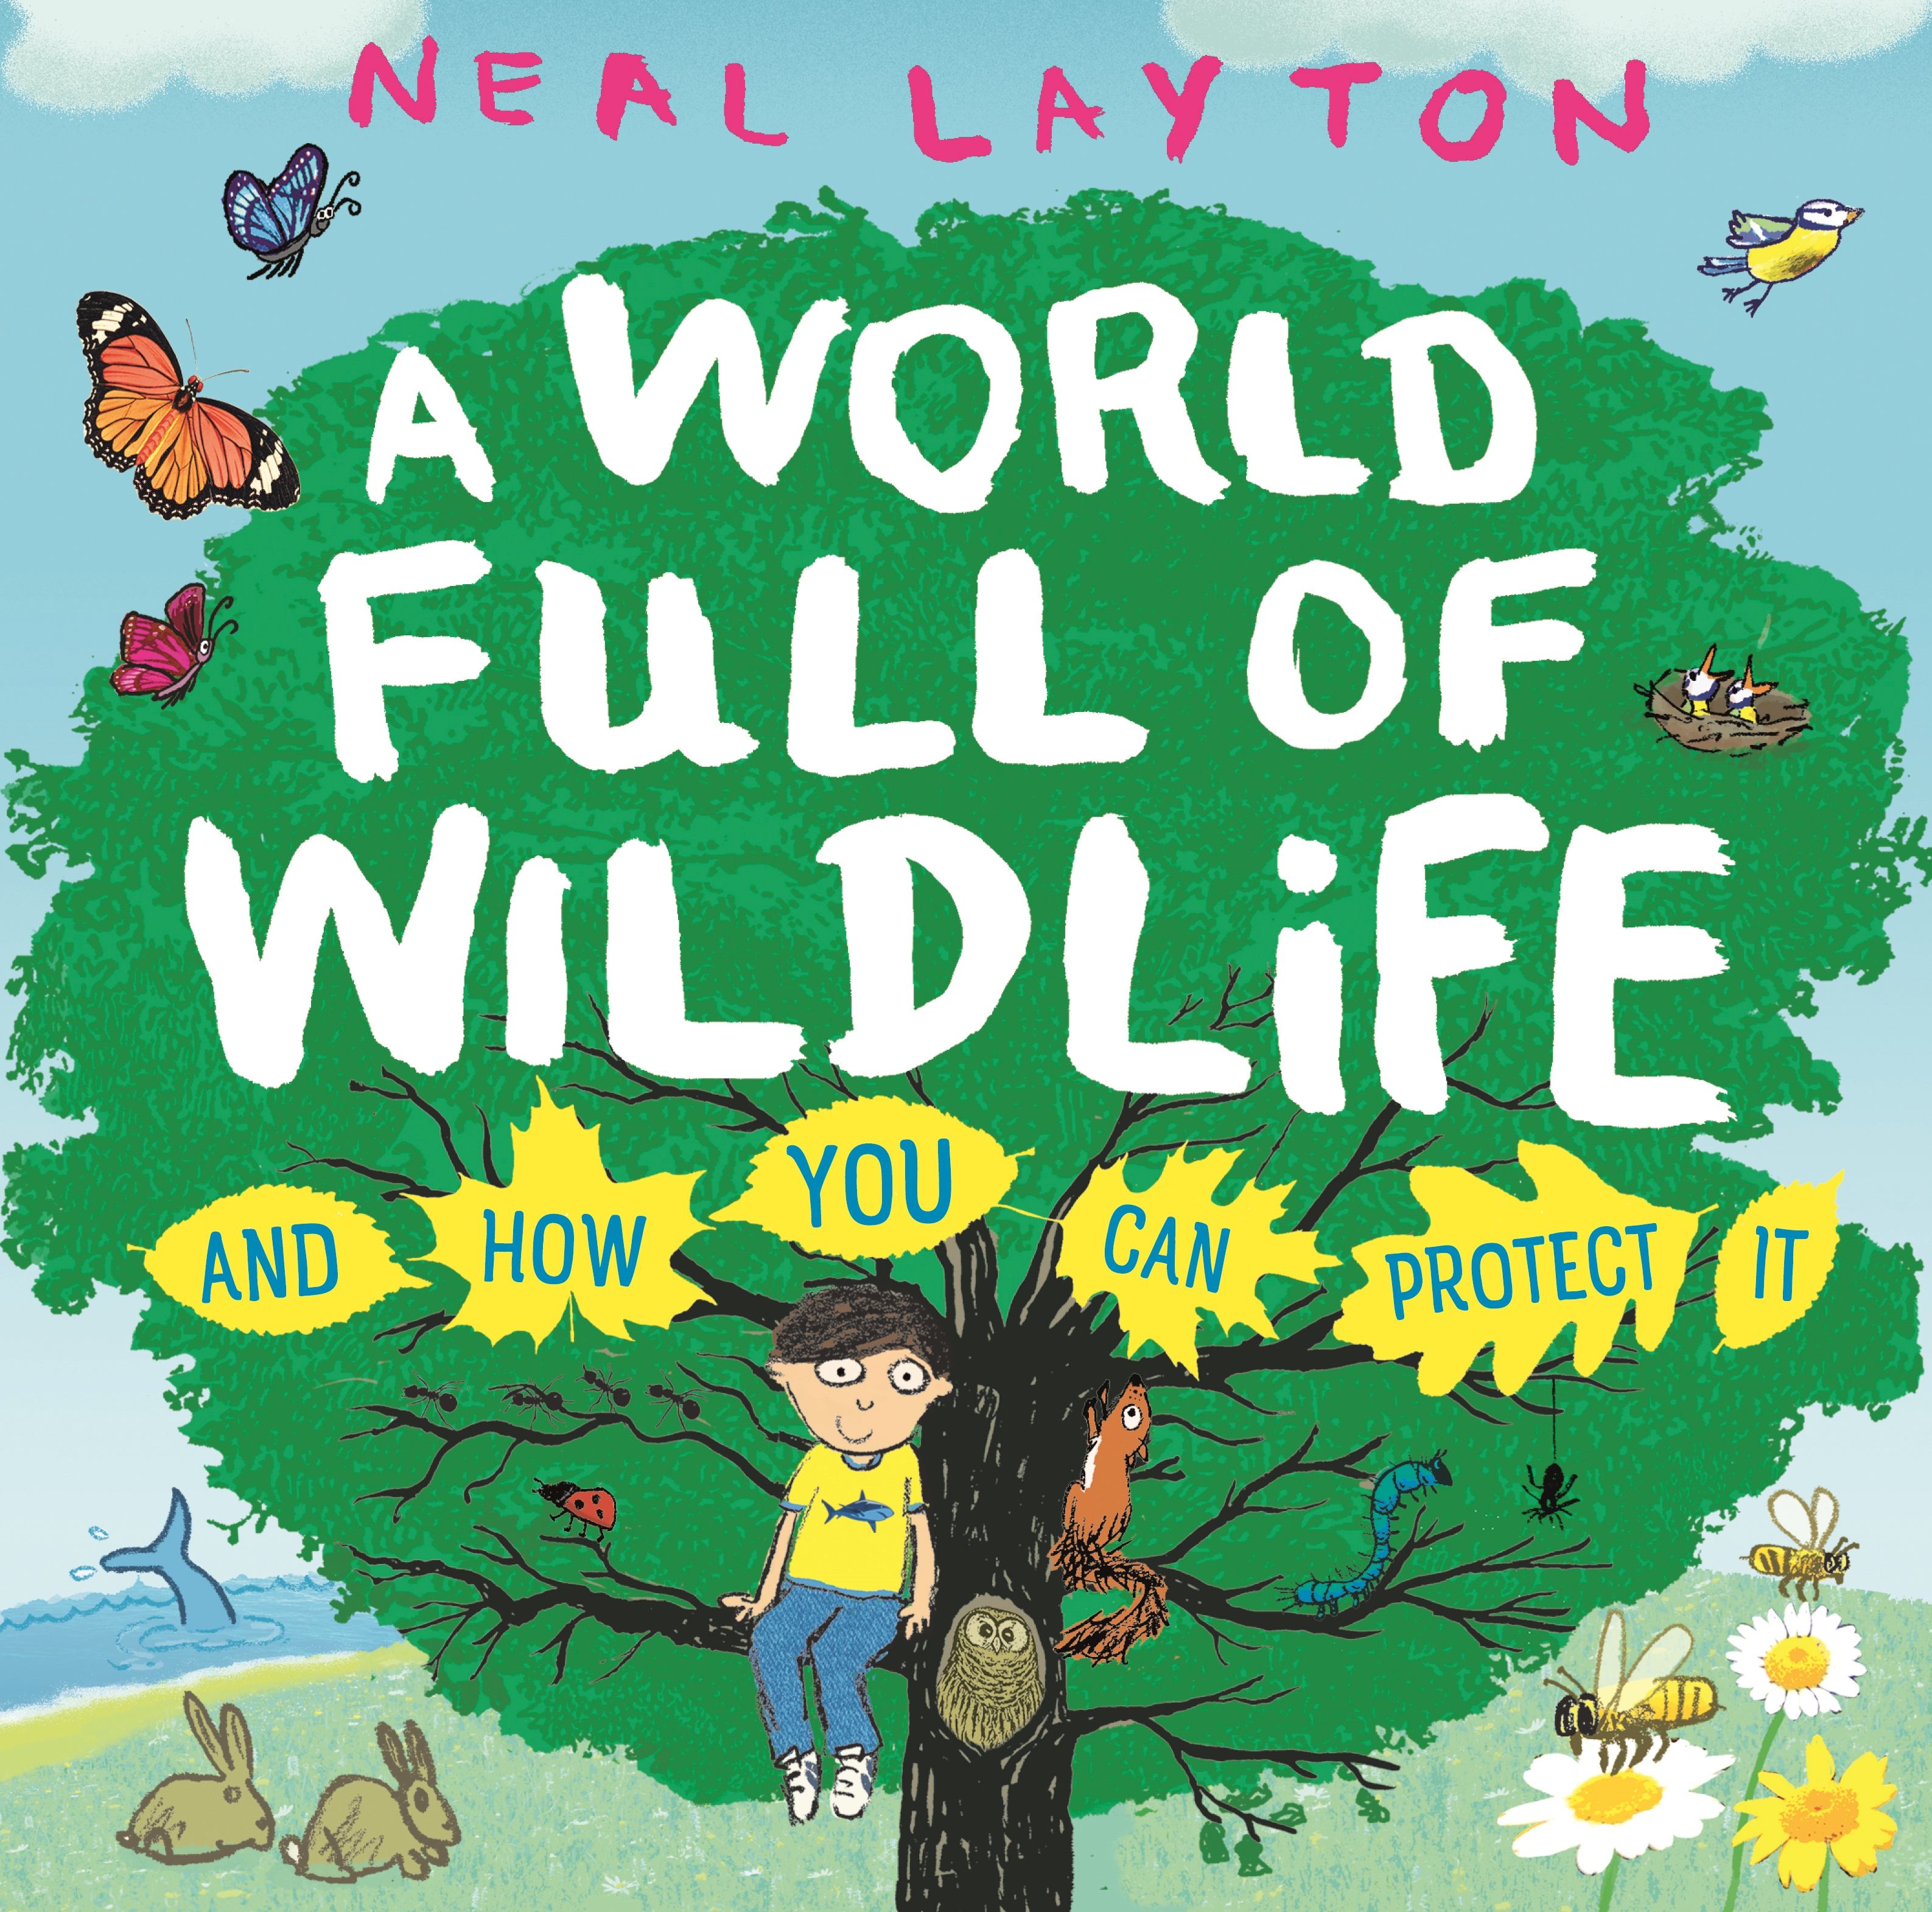
Level:
Early Level / First Level – KS1/2
Explore themes of:
√ Appreciating the World √ Biodiversity √ Plants & Animals √ Habitat √ Protecting the Planet
Subject Checklist:
√ Sciences √ Expressive Arts √ English Language √ Social Studies √ Well-being and Health

At a Glance
Before watching the event or reading the book!
- What different creatures can you see on the cover of A World Full of Wildlife? Rank them in order of size – from biggest to smallest!
- Where is the boy sitting on the front cover? What does it tell you about him? What does he enjoy?
- Why do you think it is important to protect wildlife?

Book Cover Activity: Take a Look Outside

Neal Layton’s book is a celebration of our planet; he talks about how LUCKY we are to live somewhere that is teeming with extraordinary life. Take a moment to reflect: what life do you see when you look outside?

- Choose an outdoor space near you – it might be your school field, your garden or your local park. Make a note of all the wonderful life you can see. Are there any small creatures below your feet? What about in the sky above your head?
- Reflect on why you are lucky to be surrounded by all this life. Write a reflection – it can just be one sentence or a longer paragraph. It can begin with the words: I am lucky to live here because........................................................................................................................
- Share your reflections with each other!

Read the Extract
Taken from ‘A World Full of Wildlife’.
Discussion Questions
1. What does the boy say he ‘loves’ on pages 1–2 of the book?
2. We don’t just have animals on our planet, we have other things too. What are they?
3. What do all living things need to survive? List at least two.
4. Can you define the word ‘habitat’? What different habitats are there on Earth?
5. What does the word ‘biodiversity’ mean? Neal Layton describes how ‘biodiversity is everywhere’ – ‘even if you live in a city’. Can you find examples outside your front door?
6. What is ‘THE WEB OF LIFE’? Where do humans fit into the web of life?
7. How does a leopard connect with an insect, for example, or with grass?
8. What things do humans do to make the web of life weaker? List at least three.
9. What will happen if we break the connections in the web of life? Why?
10. What can we do to stop hurting the beautiful natural world around us? List three things.
Get to Know the Author and the Book!
Activity 1: Celebrate Life on Our Planet
Neal Layton shows us that the world is very big place jam-packed with amazing natural wonders, wildlife, and habitats. Let’s think about why it’s important to celebrate it!
- Consider why the Earth is a beautiful place that deserves our protection. Split one A4 page into three horizontal boxes with the following categories – ‘LAND’, ‘SEA’ and ‘SKY’ – write down or draw any words, ideas or images that you think of in the boxes.
- What amazing natural things do you find on land? What brilliant creatures live in the sea? What do you see when you look to the sky? You might want to use Neal’s book A World Full of Wildlife to find some inspiration!
- When you have written your initial ideas down, choose one of the categories and create a collage. Finally, put all of your collages together in one single classroom display – to remind you of the Earth’s variety and beauty.
- Think about how you could host a classroom Earth Party to celebrate all of the wonderful life we find on our planet – on land, in the sea AND in the sky!
- Here are some other ideas to get your started with your Earth Party planning:
  - Design your own Earth Party invitations
  - Create an Earth Party playlist
  - Bake an Earth Party cake
  - Create some Earth Party classroom decorations – like bunting and banners!
  - Turn the different classrooms in your school into different habitats!
  - Plan party games for everyone to learn about our planet
Activity 2: A Trip Around the World!
There are many different habitats on Earth – and many different plants and animals that live in them! It’s time to explore our wonderful world . . .
- Let’s get to know the earth and everything in it a little better. On a world map, see if you can locate and label any of the habitats that Neal describes in his book.
  - Polar Regions
  - Deserts
  - Oceans
  - Jungles and Rivers
  - Grasslands
- Have you ever visited any of these habitats? What were they like?
- Split your class into five different groups, with each group representing one of the habitats listed.
- In your group, try to recreate your habitat. Use pens, paper and crafts to represent what your habitat looks like. Think about the colours you can use and how you can show whether it is hot or cold, icy or sandy, wet or dry. You might even want to dress up for the weather!
- Then, draw pictures of the sorts of animals you might find in your habitat – you might find some examples in Neal’s book. Are there camels or polar bears? Whales or alligators? Zebras or penguins?
- If you want to, you can create a little fact-file for your habitat, with key information about the climate, the landscape, and the different wildlife.
- When every group has finished, explore each habitat in the classroom! What do you see? What do you learn about the great variety of life on earth?

Your Turn: Protecting the Planet
Activity 1: Threats to the Web of Life
The Web of Life is the invisible spider’s web linking all living things together. And we humans are woven into this amazing web of life, too!
- In his book, Neal Layton uses the example of a leopard to show how things are connected in the web of life. Try to do the same thing but for another animal of your choice. Why is it so amazing that all living things are connected?
- Consider the things that humans are doing to break the web of life. Split an A3 sheet of paper into 26 boxes or spaces, one for each letter of the alphabet. This is your ‘A–Z of Environmental Problems’. Challenge yourself to fill in every letter – for example, for the letter ‘A’, you might choose ‘Air Pollution’. Use A World Full of Wildlife to help you, and see if you can add some ideas of your own.

- If you can’t think of anything for some of the letters, try to think of animal or plant that you’d like to protect instead!
- All of the things on you’re A-Z board are making the web of life weaker. This means that some animals and plants are disappearing. In his book, Neal Layton explains that ‘scientists estimate we are losing more than 27,000 species a year.’ How do you feel about this fact?
Activity 2: Saving the Web of Life
Neal Layton is passionate about looking after our planet so that animals and humans can thrive and live happily together.
- In pairs, think about the statement below from A World Full of Wildlife. Do you agree or disagree? Why or why not?
If we look after the natural world, we can all live in a happier, healthier world and live happier, healthier lives.
- There are some really inspiring people out there who have worked hard to help protect our planet and create a better world for future generations. Who are they? What have they done? TIP: you can find some mentioned at the end of Neal’s book!
- It’s important to remember that if lots of people make small changes, then this adds up to a BIG CHANGE. Think about small changes that you and your classmates could make in order to celebrate the Earth and also help to protect it.
- With a classmate or friend, use the ideas presented in A World Full of Wildlife to discuss how YOU can do your bit.
- Then, create your own pledges to protect the web of life. These pledges should be small, manageable things that you and your classmates can do. In trying to make these changes, you can help to save the web of life!
  - I will try to . . . . . . . . . .
  - I will avoid . . . . . . . . . .
  - I will make sure I . . . . . . . . . .
  - I will reduce the amount of . . . . . . . . . .

Reflection and Further Questions
Reflection Activity
Think over all that you have learned today. Perhaps you have been inspired to find out more about life on Earth? Or maybe you’ve thought more about how you can protect it . . .
Come up with some ideas for how you can share with others why it is important to protect the planet. You might want to create a school assembly or some posters for the classroom, film a video – or even come up with a plan for an eco-friendly school!
Lastly, do you have a question you would like to ask Neal if you got the chance? Make a note of it and share your questions together. Can you predict what the author might say?
Keep your eye out for more beautiful poems from Neal Layton as well as the other authors from the Edinburgh International Book Festival!

