Flash Forward with Femi Fadugba, Ben Oliver
and Jonathan Stroud
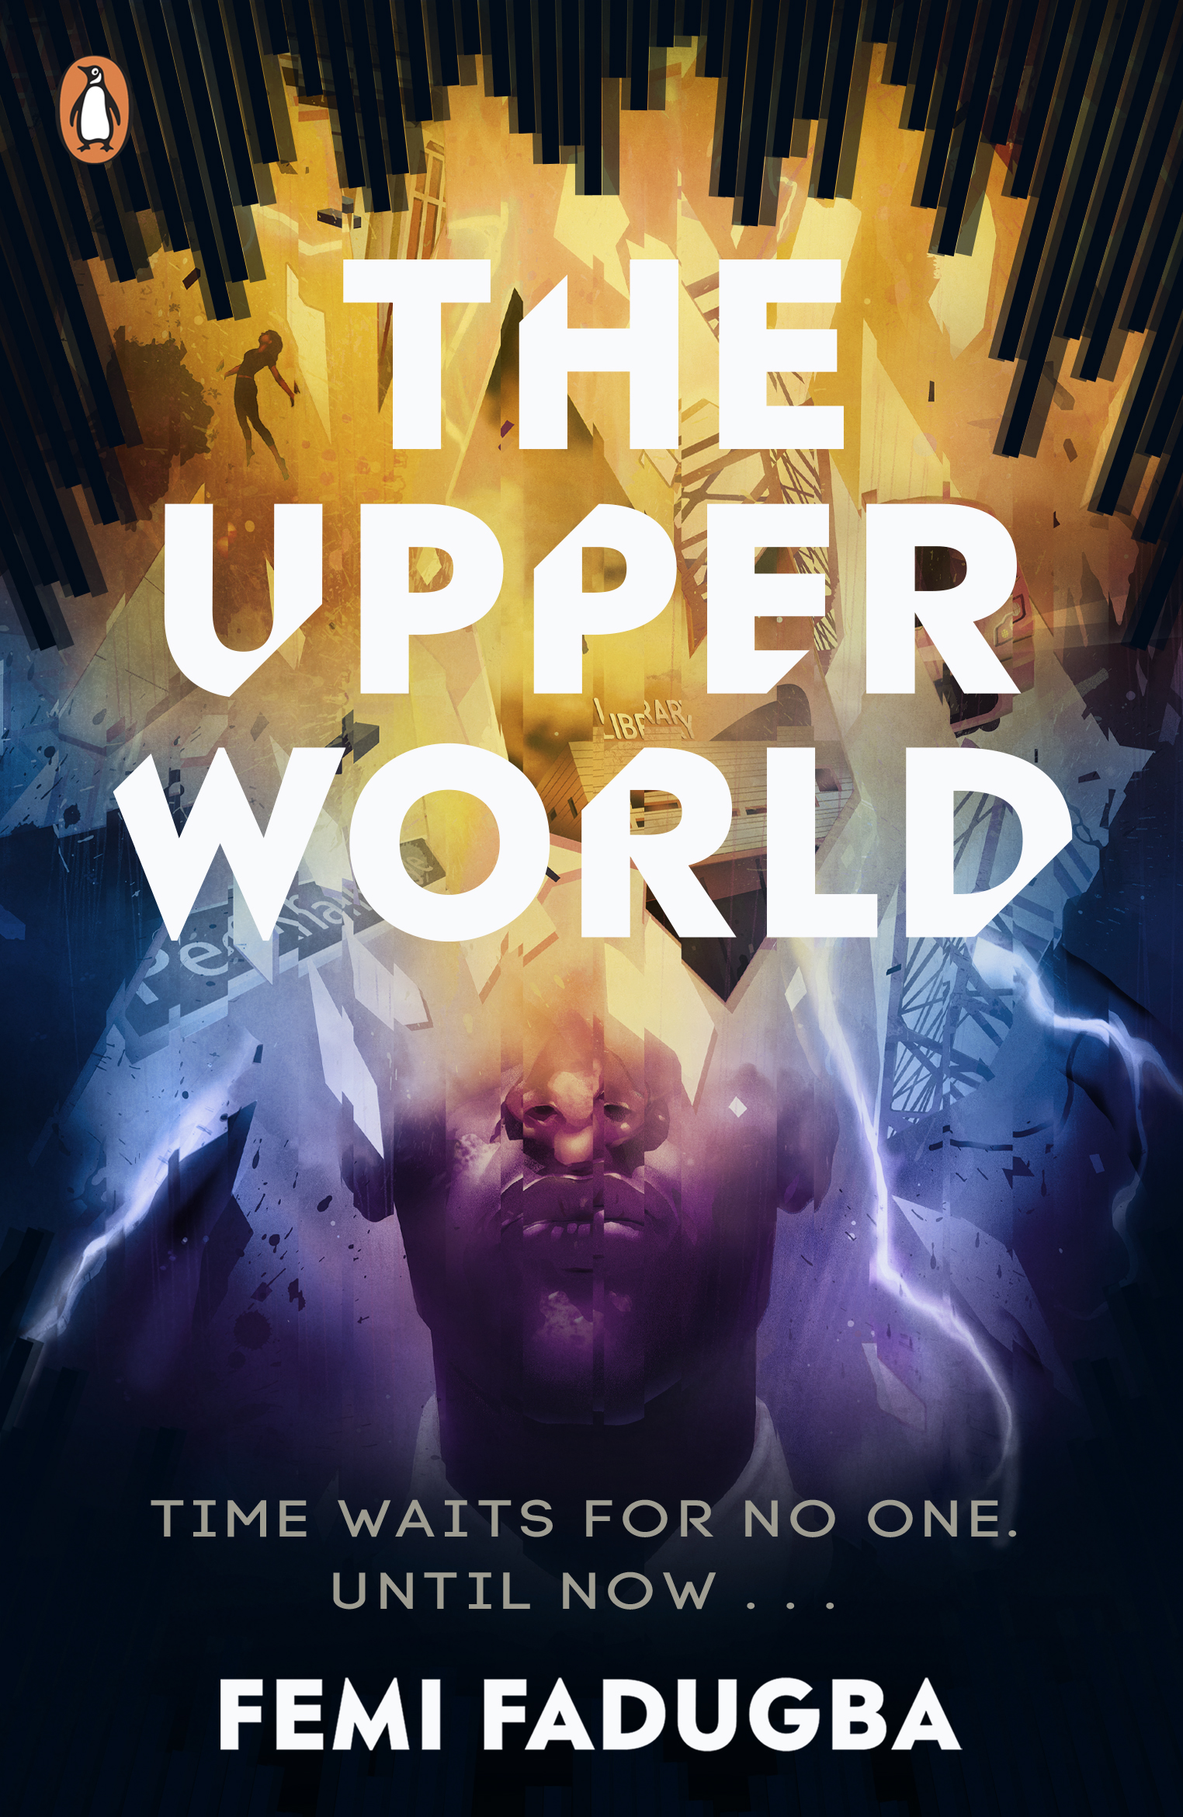
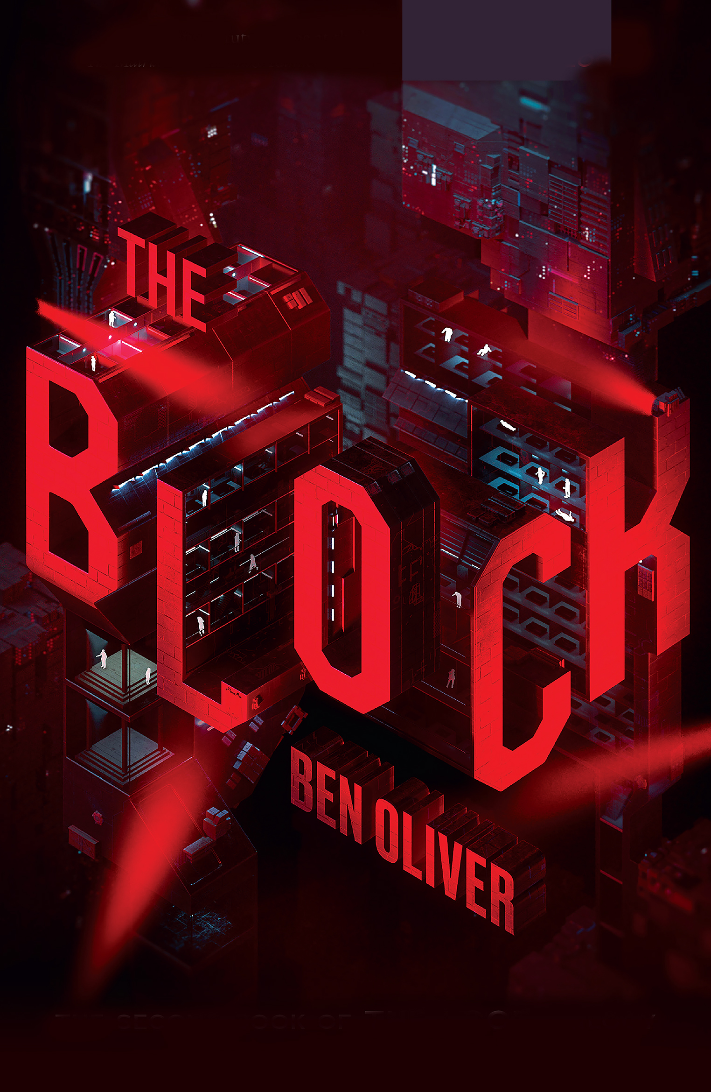
Explore setting, relationships and voice in these three fast-paced,
action-packed novels!
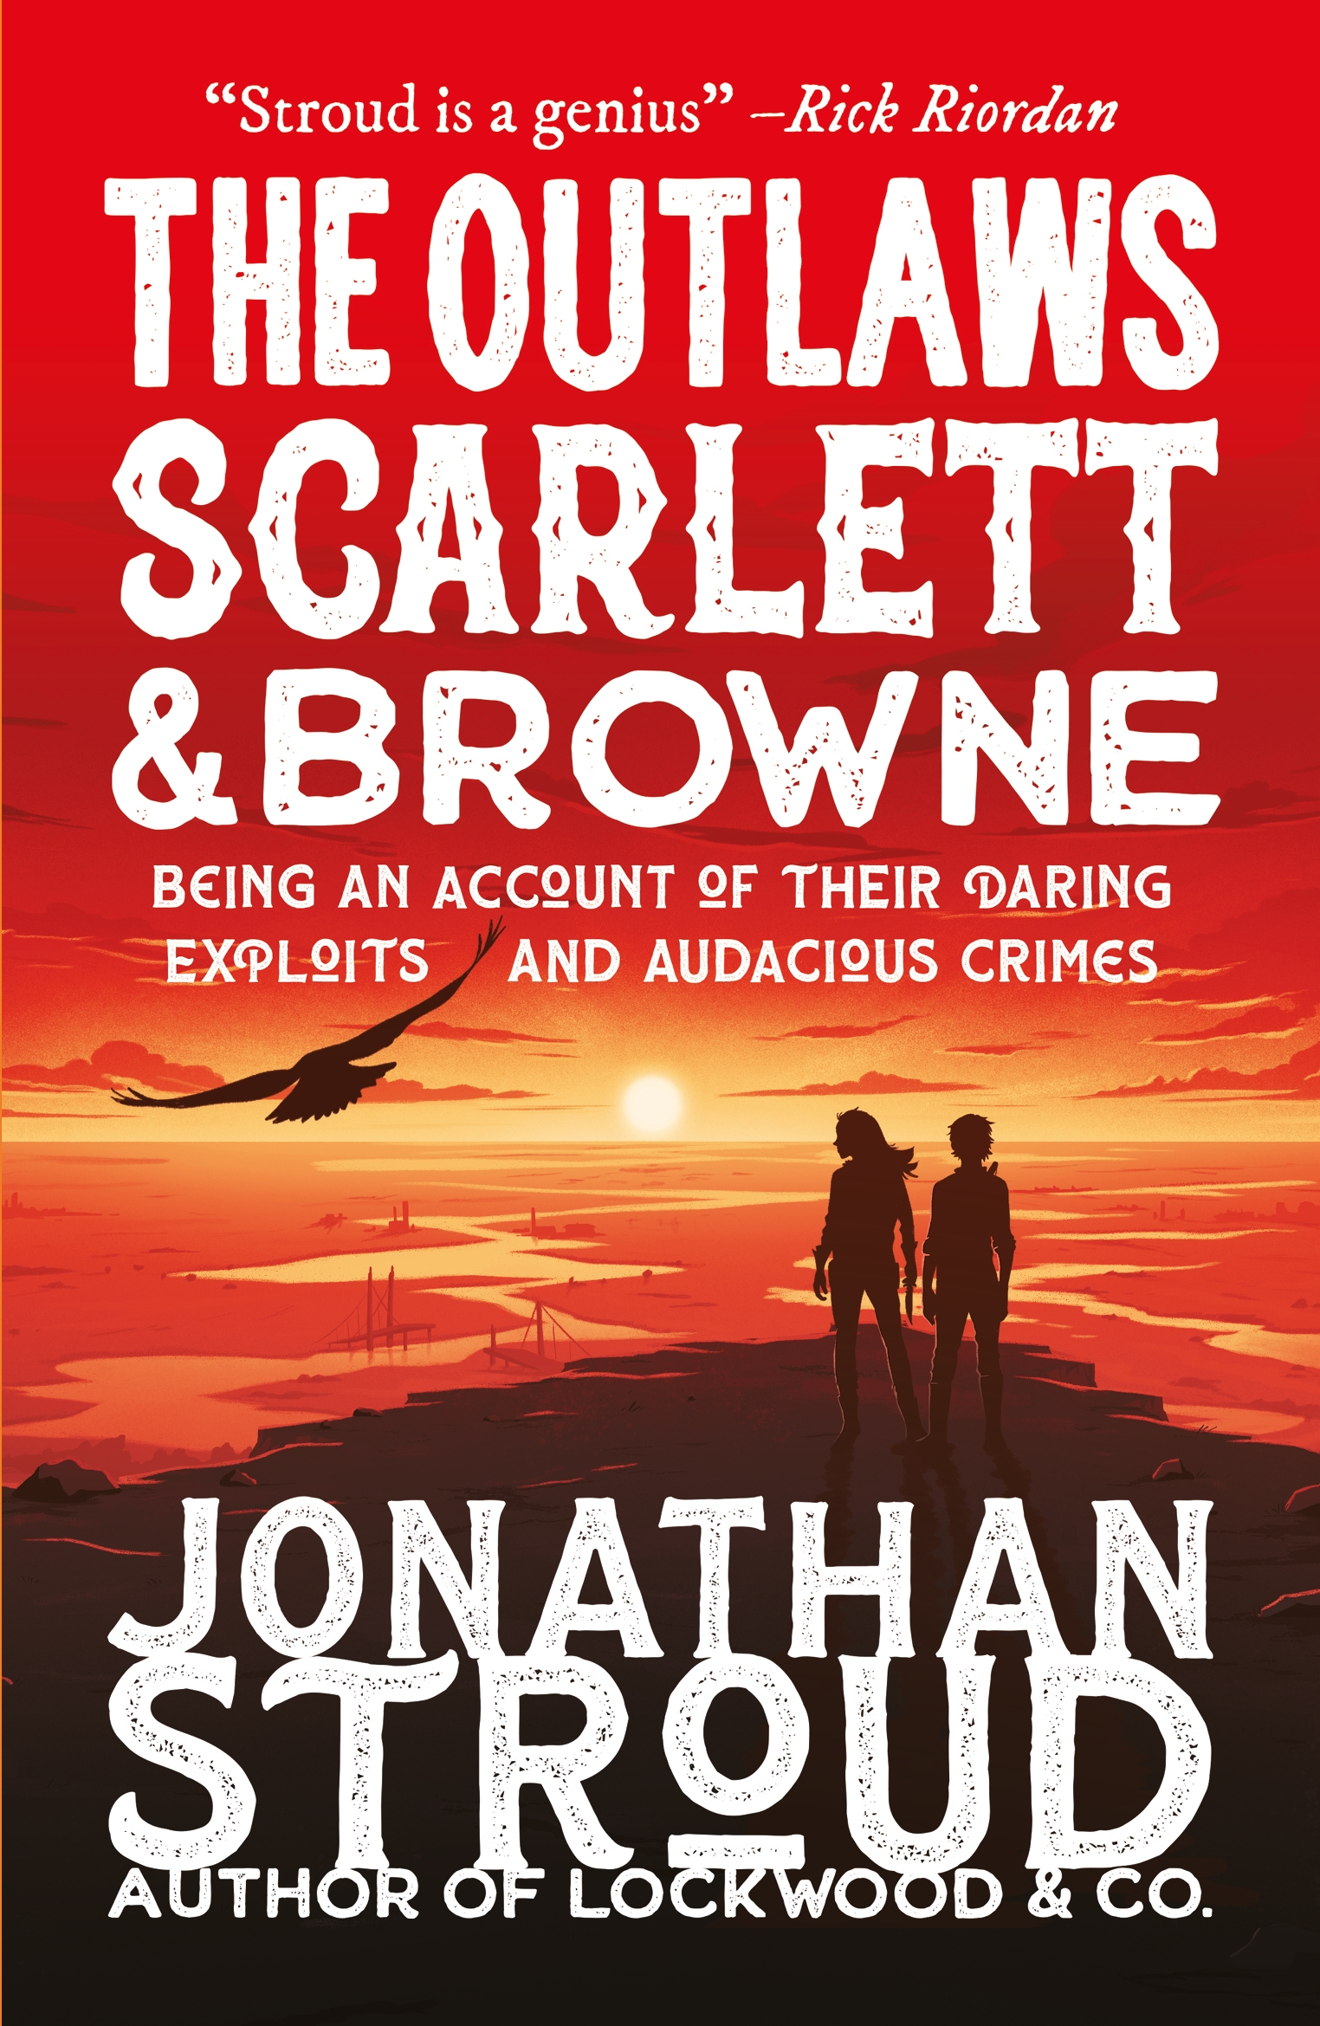

Image of book cover(s)
Level:
Third/Fourth Level
Explore themes of:
√ Science and Technology √ Time Travel √ Friendship √ Language
Subject Checklist:
√ English Language √ Social Studies √ Expressive Arts √ Sciences √ Technology

At a Glance
Before watching the event or reading the extracts!
- Can you see any similarities between these three covers? What might they have in common?
- Based on the covers and the titles when do you think the novels are set?
- Whose ‘voices’ or ‘perspectives’ do you think you will hear in these stories?

Read the Extracts
Taken from chapter 1 of The Upper World by Femi Fadugba
Discussion Questions
1. What do you think is the meaning behind the story of the prisoner in the cave?
2. How does the first chapter let you know that something incredible is going to happen to Esso?
3. Page 6 what does Esso mean by his different voices? Do you use any different voices?
4. What examples of slang can you find in the text. Do you know their meanings?
5. What does Esso tell us about gangs in Peckham? Is Esso in a gang? Are D and Bloodshed?
6. What effect does the last line in this extract have?

Taken from chapter 3 of The Block by Ben Oliver
1. Why is the opening of Rat impactful? ‘When the harvest begins, all that exists is fear.’
2. How does the author build excitement and tension in this extract?
3. What do you learn about Luka and his situation in this chapter? How does he feel about his situation?
4. Where and when do you think the novel is set? What clues are there?
5. What do you think is going to happen next?

Taken from chapter 1 of The Scarlett & Browne by Jonathan Stroud
1. What do we learn about Scarlett in this extract?
2. How does the author build excitement and tension?
3. Where and when do you think the novel is set? What clues are there?
4. What effect does describing Scarlett as “the girl” have?
5. Is Scarlett our hero or a villain? Why do you think this?

Think about what you’ve read in all three extracts
- Can you see any similarities the extracts and between the 3 main characters described in them?
- Which genres are the three books?
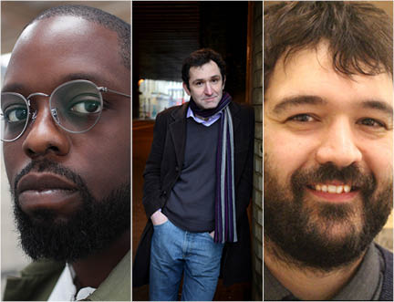

Get to Know the Authors and the Books!
Activity 1: Exploring Time
All three of these books are set in time periods different to our own.
- For each book which clues can you find to give us an idea of when the books are set?
- Which one of the books is set across different time periods?
- In The Outlaws Scarlett and Browne there are aspects of society which remind us of another time period. When and where is this?
- Write a list for each book of clues we are given as to which time period the book is set in. Are any of them misleading?

The Loop The Upper World The Outlaws Scarlett and Browne

- Do you think the books are set in a different time period, or would you say they’re set in an alternative world?

Activity 2: Friendship and Families
In The Loop and The Block Luka forms close relationships with his fellow former inmates, who are willing to make massive sacrifices for each other, while The Upper World explores Peckham gang culture and Rhia’s feelings about her family. In The Outlaws Scarlett and Browne, Scarlett is a lone wolf, until she meets Albert.
- Talk about the different relationships in the three novels, whether friendships, family or love. Do you find them convincing and powerful?
- What sacrifices are the different characters willing to make for those they care about.
- Do their relationships make the characters stronger, or make them more vulnerable?
- Imagine that you were making a film of one of the books. Which actors would you cast as each character? Why? (Or alternatively you could choose to cast your friends or other people you know.)

- Make a movie poster for your film.
Think about:
  - What information you need on your poster.
  - Who you will show on your poster. Draw or print/cut and paste images of the actors you chose.
  - What genre is your film? How can you convey on the poster that it’s dramatic/ action-packed/ romantic etc.
  - What wording you need on your poster. Maybe you want to create a tag line or include a quote from the book.

- You could even plan and film a trailer for your movie. Think about which extracts from the book best sum up the story and the themes. Adapt those scenes into short dramatisations and then act them out in front of the camera to create your trailer. Don’t forget your set and costumes!

Your Turn: Writing your own voice
Activity 1
Each of these two books use language in different ways. From the slang of Peckham gangs in The Upper World to the words for new technologies created in The Loop, via Albert’s formal, slightly antiquated speech in The Outlaws Scarlett and Browne.
- Look through each extract or book and find some examples of the different language used. Are there words you don’t understand?
- What effect does the different language in each book? How does it root them to the times and places in which they’re set?
- Do you and your friends use any slang, dialects or different languages? Think about words from where you come from (whether that’s your town, or another country.) When you message each other do you use abbreviations (like text speak)?
- Do you think that from listening to you and outsider would be able to tell when and where you came from? Would there be any words they might not understand?
- Write a short scene featuring either yourself and your friends or fictional characters who live in the same time and place as you. Try to write as you speak, including any dialect or slang.
- When you read the piece does it sound genuine? If not edit it. You might find it easier to speak what you want to say then write it down.
- Act out your scene in front of your class.

Reflection and Further Questions
Reflection Activity
Think over all that you have learned today. What have you discovered about relationships, language and setting?
Act out an important scene from one of these books (you might choose something from the extracts provided). Create a freeze-frame to show the dynamics in the scene and the characters’ feelings. Then, create monologues for all of the characters involved to show their inner thoughts – what is going on inside their heads? Try to speak as you think the characters would speak.
Lastly, do you have any final questions you would like to ask Femi, Ben and Jonathan if you got the chance? Try to think of at least two and make a note of them.
Keep your eye out for more awesome books from Femi Fadugba, Ben Oliver and Jonathan Stroud, as well as the other authors from the Edinburgh International Book Festival!

