Happy Here with Dean Atta, Patrice Lawrence and Yomi Sode
Listen to/read some stories and get ready to be inspired to write!
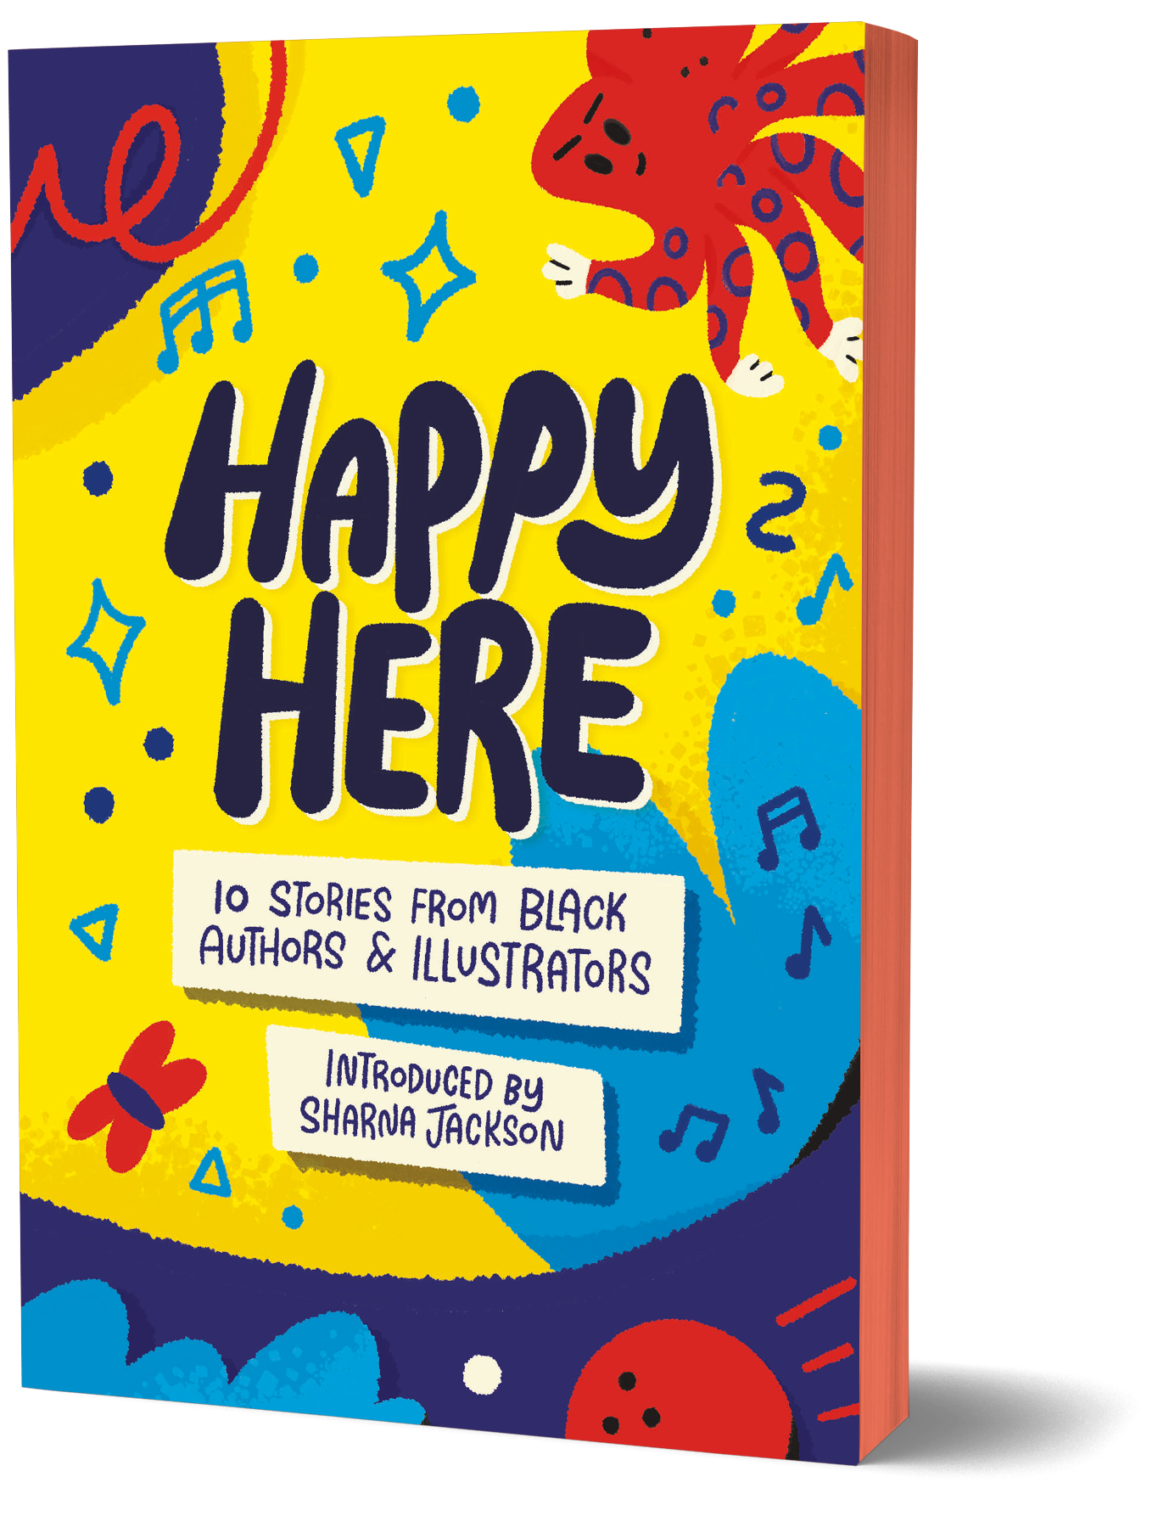

Image of book cover(s)
Level:
Second Level / Third/Fourth Level – KS2/3
Explore themes of:
√ Community √ Different Perspectives √ Friendship √ Identity √ Family
Subject Checklist:
√ English Language √ Social Studies √ Expressive Arts √ Well-being and Health

At a Glance
Before watching the event or reading the extracts!
- Why do you think the artist has chosen to use bright colours on the cover of this book?
- Why do you think it is important to listen/read stories told from different perspectives?
- What do you think of the title, ‘Happy Here’? Why do you think this was chosen?
Discussion Questions:
Asher is a Rockstar! By Dean Atta
1. Who is Asher and why does Josh think she is a rock star? List three reasons he gives.
2. Where do Asher, Josh and Ruben live?
3. Why does Josh sometimes have to tell people Asher’s correct pronouns? How do you think it might feel if someone were to call you the wrong pronouns?
4. Why are Josh and his mum helping to organise a fundraiser at the church hall?
5. What does Asher say being a rock star is about? Do you think this is true?
6. Do you think community is important? Can you think of an example to support this claim in the text?
Tomorrow, As in, By Yomi Sode
1. What are the narrator and their Dad doing?
2. Why does the narrator feel like today is different? Why are they nervous?
3. Give two examples of how they describe their emotions about their crush.
The After Ever After Bureau by Patrice Lawrence
1. What is a soucouyant?
2.What happens if somebody rubs salt on a soucouyants skin when they’re not around?
3. What does the After Ever After Bureau do?
4. Who is Grandma Suki? Where does she live?
5. Why can bad reviews be harmful to small businesses?
6. Who is Sisyphus and what does he do?

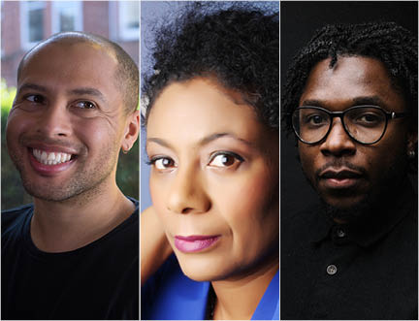

Get to Know the Authors and the Books!
Dean Atta, Patrice Lawrence and Yomi Sode.
Activity 1: Exploring Black British identity
All three stories look at different aspects of Black British identity and how people with mixed heritages can embrace elements of their culture through self-expression and family.
- Have a think about some of the characters we have just met. How do they express pride in where they come from? Why do you think this is important?
- For each character, make a list of some of the facts they have chosen to share about their lives and that of their friends and family.
- Think about what makes a community. Why are communities meaningful? Which communities do you belong to? Are communities good or bad?
- Write a short paragraph about a community that you belong to. Use a few of the writing prompts below to get you going!
  - How long have you been a part of this community?
  - What makes it special?
  - Who else do you know in your community?
  - Do you think you will always be a part of this community? If so, why?
Activity 2: Support systems
These stories look at three people who come from different backgrounds and the different challenges they face. How do the people in their lives support and encourage them to do their best?

- What challenges do the characters we have just met experience? How do they overcome these?
- Consider the themes below, how are they explored in Asher is a Rockstar!, Tomorrow, as in and The After Ever After Bureau. Why do you think these are they important to the authors?
  - Identity
  - Culture
  - Family
  - Bullying
- Do you know of anyone who has faced difficulties in their life, or can you think of a difficult circumstance that you have experienced or encountered? Make some notes about it or discuss it with someone nearby.
- Think about Josh and Grandma Suki. How do they help make their friends and family feel better?
- What do you do when you feel sad or upset? Are there people who you feel you can talk to your problems about or ask for help? Why do you think it is important to help each other with these things?

Your Turn: Pick up your pens!
Activity 1: Superheroes as friends
In The After Ever After Bureau, Marla and her mum know a lot of people. Some of them are princesses, villains, and some of them are superheroes. However, in Asher is a Rockstar! Josh and Asher are both superheroes! They helped raise money for Ruben with their church concert and helped each other overcome their nerves. And in Tomorrow, as in, the narrator talks about how their Dad supports them when feeling nervous about their crush.
- Think about what makes a superhero or rockstar. Asher says, “Its not about clothes or instruments// its about attitude and confidence.” Do you think this is true?
- Think about a close friend or loved one. List FIVE qualities that you think makes a good friend.
- With a person near you, try and find THREE things you have in common. If possible, try and find someone you don’t already know much about and try getting to know them. These things can be as simple as having the same colour hair, liking the same type of ice cream or having the same type of shoes.
- In pairs, get two pieces of blank A4 paper. Take one each them fold it in half, top to bottom. Do this again so you’re left with a narrow piece of paper. Now unfold it. You should have four different sections of paper. Start by drawing a head in the top section, then fold the piece of paper over so the person can’t see what you’ve drawn. Superheroes come in all shapes and sizes so draw whatever you feel like! Just make sure you leave marks on the paper for neck for the next person to start from! Swap pieces of paper and draw a torso doing the same when you’re done. Swap again to draw the legs and feet. Finally, choose a name for your superhero.
- Discuss with your partner what characteristics your superhero has – what communities do they belong to? Where did they grow up? What do their parents do?
- Together, write a short story about your superhero. Use the writing prompts below to help you get started.

  - What makes a superhero?
  - Who do they help?
  - What are their special powers?
  - Who is their arch nemesis?
Activity 2: Roots
Father Francis is from Nigeria, Josh’s mum is from Ghana and Asher’s parents are from Zimbabwe. Neither Josh or Asher have ever been back to their parent’s countries. They live in Peckham. Think about what it means to have family in different parts of the world and why it is important that we listen/read stories by people with different backgrounds.
- What do you think culture means? Why might it be important to someone with heritage from a different part of the world to introduce elements of their culture into their everyday life?
- Can you think of two examples in EACH of the texts of the characters celebrating their culture?
- Why is it important that we have role models within our communities? What can they teach us? Think of an example of a role model within each of the texts.
- Write about a role model in your life. Use the writing prompts below to help get you started.
  - What makes them a role model?
  - How have they inspired you?
  - What makes them special?

Reflection and Further Questions
Reflection Activity
Think about today’s activities. What have you learned? Have they made you think about community and family in a different light? Why are friends and family so important?
Think about a time that a friend or a loved one helped you feel better when you were feeling down. What did they do to help? Was it something they did or said that stands out to you? How did it make you feel?
Lastly, do you have any final questions you would like to ask Dean, Patrice and Yomi if you got the chance? Try to think of at least two and make a note of them.
Keep your eye out for more awesome books from Dean, Patrice and Yomi as well as the other authors from the Edinburgh International Book Festival!

