Maisie Chan Does Not Do Maths (But She Does Write Awesome Books!)
Pick up a pen and get inventive with Danny Chung!
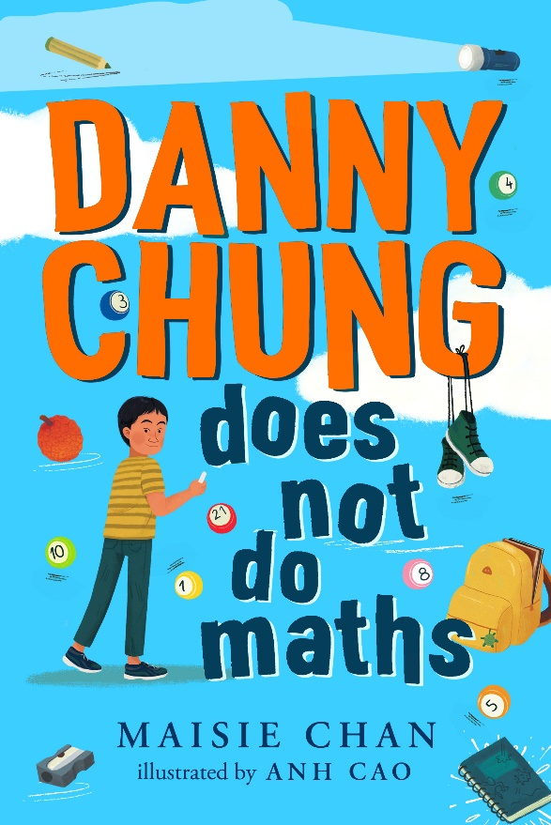

Image of book cover(s)
Level:
First Level / Second Level – KS2
Explore themes of:
√ Identity √ Family √ Imagination √ Creativity √ Humorous writing
Subject Checklist:
√ Drawing √ Expressive Arts √ English Language √ Social Studies √ Creative Writing

At a Glance
Before watching Maisie’s event or reading the extracts!
- What do you think the book is about? Can you see any images on the cover that might be relevant to the story?
- What genre do you think the book might fit into?
- What do you like about the front cover? Does it make you want to read the book?

Read the Extracts
Taken from Chapter One of ‘Danny Chung Does Not Do Maths.
Discussion Questions:

- Why does Danny like drawing?
- Why is Danny proud of his ‘Druckon’? What is the significance of ducks and dragons in Chinese culture?
- What is one of the things Danny drew that he imagined he could have been doing instead of sitting in Mr Heathfield’s maths lesson?
- What do you find out about Danny’s personality in the first chapter? What are his likes and dislikes?
- Who is Ravi and what do we know about him from Chapter One?
- What are Danny’s feelings about the Chinese Way?

- How would you describe to Chinese Way to someone who has never heard of it?

- What do you think Picasso (not Pikachu) meant when he said, ‘Every child is an artist’? Do you think this is true?

- Why do you think Ba wants Danny to focus on subjects like Maths, science, and English instead of drawing? Do you think that some subjects are more important than others?
- What do you think Ma and Ba are hiding from Danny? What do you think Ma means when she says, ‘Not yet’?

Get to Know the Author and the Books!
Activity 1: Real-Life Character
Maisie bases some of her characters on real people in her life! Nai Nai’s character was inspired by a friend’s grandmother who first came to the UK aged 92!

- The world is full of amazing people with exciting stories to tell! Have a think about some of the people in your life and what stories you might tell about them! They don’t have to be extraordinary – heroes come in all shapes and sizes!
- Thinking about somebody you would like to tell a story about, start by thinking what characterises them as a person! Is it the way they dress? Do they have a quirky hairdo? Think about the way that Maisie has brought Danny and his family to life on the page! Use some of the prompts below to get you started:

  - How do you know this person?
  - What makes them special?
  - What can you tell from just looking at them – are they short/tall? Do they wear funny glasses?
  - What are some things about this person that you would not know unless you talked to them? Do they snore loudly? Are they a cat or dog person?
  - Write about a memory you had with this person – where were you? What happened? Why does this memory stand out to you?

- Swap your writing with somebody nearby and talk about them. Was this easy to write? What did you like about the exercise?

Activity 2: Culture
Maisie’s book explores the theme of culture and what that can mean to different groups of people. For example, Ba and Ma talk about the ‘Chinese Way’ of doing things.
- Think about what the word ‘culture’ means. Is it something that people interpret differently? Re-read pages 4 and 5.
- Do different things have different symbolism in different cultures? Ravi says that Chinese dragons are ‘anomalies’ because they don’t try and eat princesses. Why do you think Chinese culture views dragons as ‘lucky’?
- What do you think Ba means when he says, ‘The Chinese Way is hard work.’?
- Think about some of the traditions that you do at home with your family. For example, do you have certain meals in the week that are more special than others? Why do you think this is?

Your Turn: Turn Scribbles into Stories!
Activity 1: Creating a Creature
Drawing is very important to Danny! He draws in the park, in bed and even on the toilet! (But he washes his hands after!)

There are lots of different ways to use your imagination! Look at some of Danny’s drawings and see how he uses his imagination to create fantastical creatures and scenarios with his pencil!

In Chapter One, we learn that Danny has created a creature called a DRUCKON:
‘It was a mutant duck with a dragon’s head. It’s very Chinese, if you ask me. Dragons are the most beloved and lucky creatures in Chinese mythology and ducks are yummy and succulent.’

- Using a scrap piece of paper, draw a line down the middle. On the left-hand side, write down FIVE different animals. On the right-hand side, write down FIVE different objects you can see around the room.

- Cut each of these words up and place in to separate piles face down so you can’t see what each of them are!

- Without peeking, pick one paper from each pile and turn them over.

- Using the animal and object you’ve selected, draw what you think your new creature would look like. Just make sure you leave space for a speech bubble! It doesn’t have to make sense – just have a go at combining your animal and object and give it a name!

- Write down FIVE adjectives about your creature. Is it smelly? Is it fast? What makes it special?

Activity 2: Putting Pen to Paper!
You’ve got your creature! Now what? Danny’s best mate, Ravi likes to help him put speech bubbles on his sketches and turn them into stories.

- Swap your drawing with someone nearby! Add a speech bubble to their creature and try to imagine what they are saying!
- Write a short story about the creature and how it came to be! Use some of the writing prompts below to help get you started.

  - What is the creature feeling? Are they happy? Nervous? Why?
  - What makes them special?
  - What are some things about this creature that you would not know unless you talked to them? Do they like chocolate? Are they allergic to anything?

Has a superpower! | Has a tail! | Is scary!
Has teeth! | I would like to keep my creature as a pet! | Can fly!
Is furry! | Is happy! | Is hungry!

Danny’s Nai Nai loves bingo! See if you can get a full line (a bit like noughts and crosses!) with the creature you’ve created! Cross off each square if it applies to the creature you’ve made.

Reflection and Further Questions
Reflection Activity
Think over all that you have learned today. Perhaps you have been inspired to create some wacky creatures on paper? Or maybe you’ve thought about what culture means to you?
On the picture attached below, use a pen or pencil to write down FIVE things that people can tell just by looking at you outside of the outline. This could be hair colour, height or if you wear glasses or not.
Then, using a different colour write down FIVE things that people would only know by talking to you. For example, this could be your favourite food, if you have pets or if you love drawing! Think about the differences between the two lists and why you have chosen to put down certain things.
Lastly, do you have any final questions you would like to ask Maisie if you got the chance? Try to think of at least two and make a note of them.
Keep your eye out for more awesome books from Maisie Chan, as well as the other authors from the Edinburgh International Book Festival!

