Meet the Tindims of Rubbish Island with Sally Gardner
Discover how you can get creative using
recycled materials just like the Tindims!

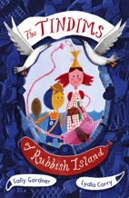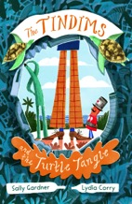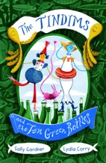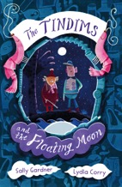
Image of book cover(s)
Level:
Early Level / First Level – KS1/2
Explore themes of:
√ Recycling √ Plastic Pollution √ Conservation √ Looking after the Planet
Subject Checklist:
√ Sciences √ Expressive Arts √ English Language √ Social Studies √ Creative Writing

At a Glance
Before watching the event or reading the extracts!
- How do the book’s titles and illustrations show the themes of protecting the planet and recycling?
- Who do you think the Tindims are? What do you think they will they be like?
- Which is your favourite book cover? Why? Which would you be most excited to read?

Book Cover Activity: Tindims Titles
Look at all of the different titles of the books in The Tindims series and think about the questions below:
- What do the titles have in common?
- Which words stand out to you in the titles?
- Which is your favourite title? Why?
- What can you predict about the themes of the books from these titles?
Come up with a title for a brand new book in The Tindims series! Use the other titles as inspiration. When you’ve come up with your title, draw the book cover too.

Read the Extracts
Taken from Chapters One and Two of ‘The Tindims of Rubbish Island’.
Discussion Questions
- How are Tindims different to humans? What do the Tindims call humans?
- How might life be different for the Tindims? Would you like to be their size?
- What do you like about Skittle’s outfit? Which is your favourite item and why?
- What do you use your toothbrush for? What do Tindims use them for?
- Which other characters have you met so far? Do you have a favourite?
- What is the Tindims’ motto? What does this mean?
- How did the Tindims begin building their island?
- What does ‘recycling’ mean? Do you and your family recycle at home?
- Do you know which materials are hardest to recycle? Give examples.
- How does recycling or re-using materials help to protect the planet?

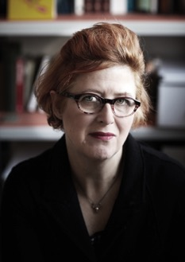

Get to Know the Author and the Books!
Activity 1: Creating a Tindim Character
Sally Gardner’s stories feature characters known as ‘The Tindims’. But who are they – and can you create your own?
- In pairs, discuss Sally’s characters in the stories. What are their personalities? What do they look like? How are they unique? What do you like about them?
- Come up with your own Tindim character! First, talk about ideas for your character’s name and what they look like. Perhaps they are a relative of Skittle or her friend?
- Plan ideas for your character using the questions below. Then, draw them on an A4 sheet of paper including lots of colour! Write a speech bubble next to them so that your character can introduce themselves.
- Share your new characters together and talk about the adventures they might have!
Plan for my Tindim character:
  - What is the name and age of my character?
  - What does my character look like?
  - What outfit is my character wearing?
  - What accessories does my character have? E.G. Skittle has her toothbrush
  - How might my character introduce himself/herself?
Activity 2: Protecting the Planet
The Tindims are ‘Sea-Borrowers’ who are always recycling. How does recycling help to protect the planet? Why is this an important message?
- With a partner, consider the effects of litter. Can you name three negative impacts on the environment? Why is it important to recycle our rubbish to prevent these negative effects on the environment?
- In pairs, sort the different types of rubbish below into the correct bins – ‘Cans’, ‘Plastic’, ‘Glass’, ‘Compost’, or ‘Paper and Card’.
  - Tin of beans
  - Apple
  - Sainsbury’s Bag
  - Magazine
  - Jam Jar
  - Newspaper
- With permission, sort through the litter in your classroom bin. Make sure that you wear gloves or wash your hands after touching anything in the bin. Alternatively, observe what is in the bin just by taking off the lid and inspecting what you see. Record what you find in the bin.
- Which is the most / least common material? Which materials could be recycled? Does everything that you found need to be thrown away? Could it be reused? How?
- Create a persuasive poster to put up around school or in your classroom, encouraging other pupils to check whether they are throwing their rubbish in the right bin, or whether they can recycle it for something else to protect the planet!

Your Turn: Develop Your Inner Recycler!
Activity 1: Turning Rubbish into Treasure
Learn how to be resourceful, just like the Tindims, and turn everyday rubbish into treasure!
- The Tindims use items the Long Legs throw away to create things for the island and their homes! Create a Rubbish Diary of your own to make a note of what you throw away each day. At the end of the week, consider the questions below:
  - Are you surprised at how much you throw away?
  - Could any of your ‘rubbish’ be recycled or used for something else?
- Then, on a large sheet of A3 paper, draw a Treasure Chest. Inside your Treasure Chest, note down or draw some of the items of rubbish that you could keep and use to create something else. For example, a top tip from the back of the book is: You can make pencil holders, or a plant holder from the bottom of cut off plastic bottles!
- Get creative and think about how you can turn ‘rubbish into treasure’ just like the Tindims! Over the next few days, collect the items from your chest and keep them safe instead of throwing them away. Maybe they will come in handy....
Activity 2: Building My Own Rubbish Island!
It’s time to dig out the recyclable and re-usable items from your treasure chest so that you can build your own Rubbish Island!
- Take a close look over the map of Rubbish Island from the books. How has Sally Gardner used her imagination to create this world? Can you spot all the different parts of the island?
- Then, using a large piece of card, start by drawing the outline of your island. Perhaps some of it will be underwater? Maybe there will be creatures and animals around the island you would like to draw or paint on too?
- Next, plan what you will use each item from your Treasure Chest for. For example, on Rubbish Island there is a Fish Hospital and an Engine Room amongst other things. Here are some other ideas you might like to include:
  - A school
  - Houses
  - A port or harbour
  - Mountains, hills, forests, fields
  - A lake
  - Modes of transport (eco-friendly of course!)
- Use your imagination to be creative and to make your Rubbish Island unique. When you have completed your islands, show each other how you have turned rubbish into treasure! Remember all that you have learned from the Tindims to continue to protect our wonderful planet in the future!

Reflection and Further Questions
Reflection Activity
Think over all that you have learned today. Perhaps you have been inspired by Sally Gardner and The Tindims? Or you’ve thought of a new way to use your rubbish? What changes will you make in the future to help protect the planet?
Create a five-step action plan showing five simple steps you can take to help protect the planet – just like the Tindims!
Lastly, do you have any final questions you would like to ask Sally if you got the chance? Try to think of at least two and make a note of them.
Keep your eye out for more awesome books from Sally Gardner, as well as the other authors from the Edinburgh International Book Festival!

