Whose Side Are You On?
Historical Fiction with Liz Kessler and Alex Wheatle
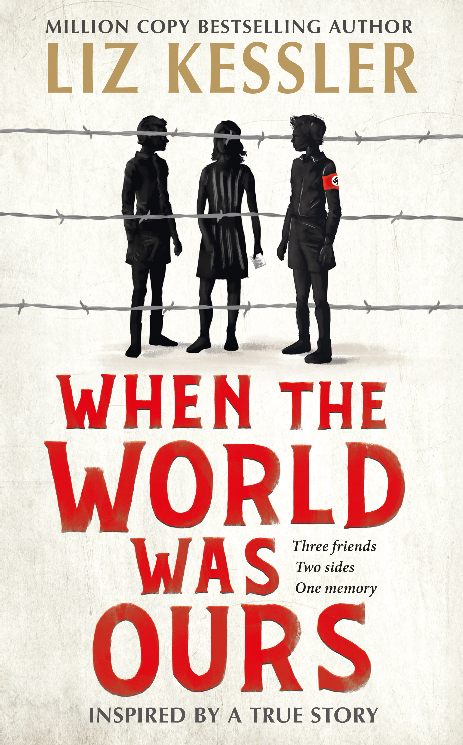
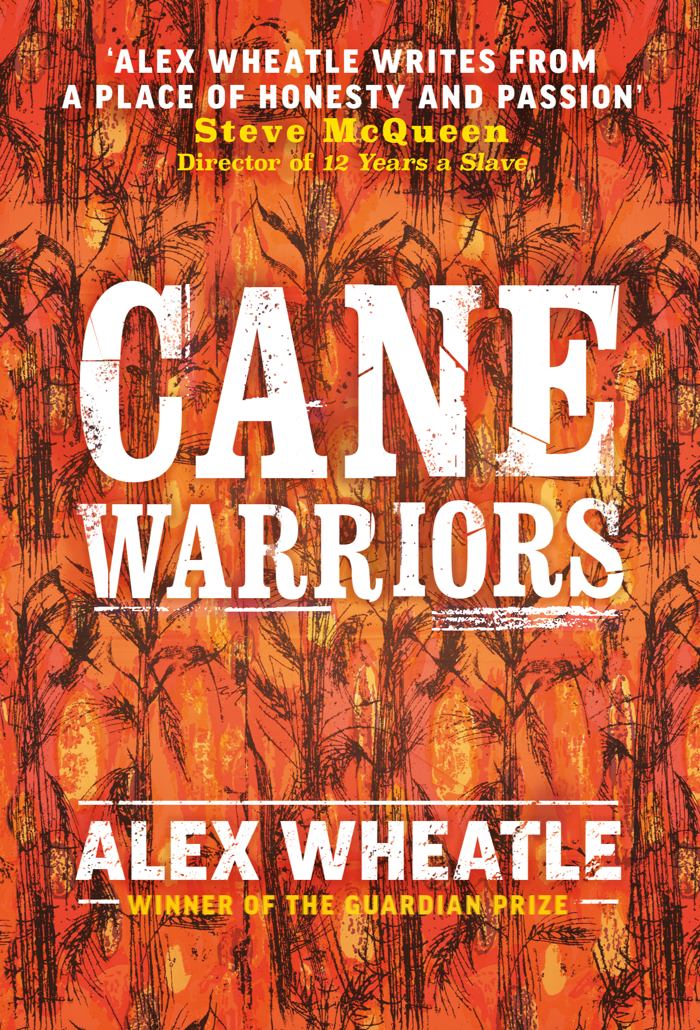
Tackle two troubling times in history with
When the World Was Ours and Cane Warriors.

Level:
Third/Fourth Level – KS3
Explore themes of:
√ Different Sides and Perspectives √ History √ WWII √ Slavery √ Diverse Voices
Subject Checklist:
√ English Language √ Social Studies √ Expressive Arts

At a Glance
Before watching the event or reading the extracts!
- Which key words stand out to you on these book covers? What do they tell you?
- What is ‘historical fiction’? What do you think the challenges might be for writers of historical fiction?
- What sorts of challenges and struggles do you think the characters in these books might need to overcome? Why?
Book Cover Activity: Step Back in Time
These books are set in two vastly different time periods: WWII in Europe; and a slave rebellion in 18th century Jamaica. Imagine you have stumbled upon a time machine that takes you back to the scenes represented by the two front covers pictured above. Where are you? What is happening? What challenges do you face? How do you feel?
Write a brief report on your adventure back in time. Swap your time machine with a partner and discuss your experiences together.
Read the Extracts
Taken from pages 132–133 and 135–136 of ‘When the World Was Ours’ and pages 1–2 of ‘Cane Warriors’
Discussion Questions
1. Why do you think Liz Kessler has chosen to write When the World Was Ours from the perspectives of different children? What is the effect of this?
2. What is happening to Elsa on pages 132–133?
3. How does Elsa feel about her parents’ decision?
4. On page 135: what is Leo’s ‘place’ in ‘Nazi-run society’?
5. What do Elsa and Leo have in common based on your reading of the two extracts taken from When the World Was Ours?
6. How is the character of Louis described at the beginning of Cane Warriors? How does the author, Alex Wheatle, create a vivid picture of him?
7. Who are the men sleeping in the small room? What do they do every day?
8. What are the conditions for Moa and the other men? Find at least three words or phrases to describe them.
9. Can you find examples of Jamaican dialect in the passage? Why do you think the author has chosen to use Jamaican dialect in his writing?
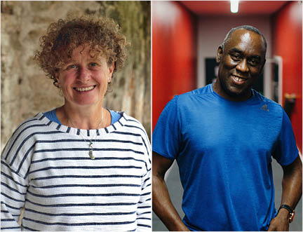
10. What does Louis tell Moa? How does Moa feel about it?

Get to Know the Authors and the Books!
Activity 1: Researching Two Periods of History
These stories are set in very different periods of time. Why is it important to research historical settings and events before writing historical fiction?
- Cane Warriors follows the true-life slave rebellion known as Tacky's War in 18th century Jamaica through the eyes of one boy. When the World Was Ours follows three friends living in Europe during the Second World War.
- These are very different historical periods, events and settings – but, with a partner, consider what the stories might have in common – especially considering these two authors’ interest in ‘perspectives’ and ‘sides’.
- Choose one of these historical periods to find out more about. Make notes as you read the books or carry out research in your school library or online.
- Create two chronological timelines to help you get a better understanding of these two periods. Put key events for ‘Tacky’s War’ or ‘1936 Vienna’ in chronological order. This should help you get a better picture of what life was like for the characters in these books.
- Is there anything that you learn about the authors that helps you understand why they have chosen to write these books? Why are they interested in these historical periods? What are they passionate about?
- Which historical period would you like to write about? Why?
Activity 2: Important Ideas and Themes for the Authors
These two authors share similar interests in ideas and themes; what are they?
- Look at the taglines for each book below. Can you match the correct tagline to the correct book? Give reasons for your choices.
- Nobody free till everybody free.
- Three friends. Two sides. One memory.
- What do you like about these taglines? Which one draws you in the most? Why? What can you tell about the themes of these books from the taglines?
- Below are nine suggestions for the prominent themes and ideas in When the World Was Ours and Cane Warriors. Can you add any more of your own?
- Working on your own, in a pair, or in a small group, rearrange them into a ‘Themes Diamond’. Create a Themes Diamond for each book.
- The formation of the diamond should flow as follows: x1 suggestion at the top, x2 suggestions below, x3 across the middle, x2 underneath, and x1 suggestion at the bottom – forming the shape of a diamond. The suggestions placed towards the top of the diamond would be the more important themes in the books, in your opinion.
- If possible, compare your ideas with other readers and discuss any differences.
- Perspective
- Friendship
- Racism and Prejudice
- Bravery
- Home
- Hope
- Freedom
- Violence
- Rebellion

Your Turn: Think Like a Historian!
Activity 1: A Jigsaw of Perspectives
Create a jigsaw representation of all the different perspectives that you see around you; how will they help people in the future get a picture of what life is like in 2021?
- Historians piece together clues to form a picture about what life was like in the past, taking into different perspectives and ‘sides’ of the same story.
- Imagine your classroom or local community (or even the global community) is a jigsaw. Each piece of the jigsaw represents a different voice or perspective in the community. Remember: even though we are all living at the same moment, our experiences and viewpoints are very different. How will these different perspectives help people in the future form a picture of what life was like today?
- Create a jigsaw-image to represent the community you have chosen, whether it’s your classroom, local community, or the global community. On each piece of the jigsaw write down a unique perspective of the current moment. For example: you might include a person who has suffered financial hardship during COVID-19, or a young person who has encountered racism. What are the important issues of today? How many different perspectives can you include to represent the year 2021?
- Choose some of the different pieces of your jigsaw and write down what a person in the future might learn from them.
- Who might tell the story of 2021 in another hundred years? Which side of the story will they choose to tell?

Activity 2: Different Accounts of Historical Events
Sometimes one event can be made up of multiple different experiences and perspectives. Consider how this happens on a daily basis.
- As a class, discuss the following:
Who writes History, and why is this an important question to ask?
- History is often about power and perspective, or bias. Those with the strongest or most powerful voices are the loudest.
- Explore this idea by researching at least two accounts based on a single event. The event can either be something you’ve seen in the news, something you’ve learned about at school, or something you’ve witnessed in your local community.
- Consider the different perspectives of those involved in the event that you’ve chosen. How might their accounts be different?
- Write two accounts of the event you have chosen from two different perspectives.
- When you’ve written at least two accounts of the same event, reflect on how different they are. Then, imagine that only one of these accounts survives in the future. How would this effect people’s interpretation of what actually happened?

Reflection and Further Questions
Reflection Activity
Think over all that you have learned today. What have you realised about History? Why is it sometimes a matter of ‘perspective’? Whose perspective in history would you like to know more about? Whose story do you want to hear?
Carry out your own research into a forgotten or unusual historical period or perspective.
How can you help to tell this story? Carry out some initial research and create a collage of your findings to present your ideas.
Lastly, do you have any final questions you would like to ask Liz or Alex if you got the chance? Try to think of at least two and make a note of them.
Keep your eye out for more awesome books from Liz Kessler and Alex Wheatle, as well as the other authors from the Edinburgh International Book Festival!

