Yapping About Poetry with Joshua Seigal
Discover hilarious and heartfelt poems, and everything in between,
with Joshua’s new poetry collection: Yapping Away
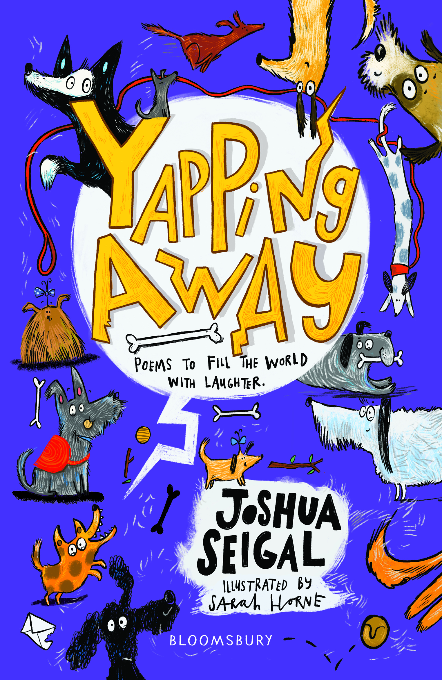

Level:
Early Level and First Level / KS1 and KS2
Explore themes of:
√ Poetry √ Performance √ Reading and Writing Techniques √ Funny Poems
Subject Checklist:
√ Expressive Arts √ English Language √ Well-being and Health √ Creative Writing

At a Glance
Before watching the event or reading the poems!
- What do you guess some of the poems might be about in this collection? Why?
- What is different about reading poems than reading fiction or non-fiction?
- How can you tell from the cover that the poems inside might be funny?
Book Cover Activity: Funny Poem Challenge!
Look closely at the cover of Yapping Away. Which illustrations stand out to you? Can you find examples of the following: Dog; Leash; Bone; Ball; Envelope?
Can you link some of the illustrations together to create your own funny story? Turn your ideas into a short poem! Remember: not all poems need to rhyme . . .
Read the Poems
Taken from ‘Yapping Away’
Discussion Questions
1. What technique does Joshua Seigal use in ‘A Classroom Speaks’, where all of the objects are given human characteristics?
2. Which is your favourite line in ‘A Classroom Speaks’? Why?
3. Can you identify the rhyme scheme in ‘A Classroom Speaks’? How does the rhyme scheme help to give the poem a rhythm or make it easier to read?
4. How does Joshua Seigal use repetition in the poem ‘Magic’? Why do you think he does this?
5. Can you identify a line where Joshua Seigal makes you laugh in ‘Magic’? Why is it funny?
6. Can you find an example of alliteration in ‘I Wanna Be a Bear’?
7. Why do you think it might be better to read ‘I Wanna Be a Bear’ out loud? How can you make it come to life when you read it?
8. In ‘Ooshush Magooshush’ – who is Ooshush? Where does he live? Can you think of your own made-up name for a creature?
9. Why do you think some of the words in ‘Ooshush Magooshush’ are written in a different style or font size? What is the effect of this?
10. Which poem is your favourite? Why?

Get to Know the Author and the Book!
Activity 1: Getting into the Poetry Groove!
Joshua Seigal clearly has a love of poetry. Can you discover your own ‘poetry groove’ to find a passion for rhyme?
- What inspires poets like Joshua Seigal? Judging from some of the poems you have read in his collection, where do you think Joshua looks to find the inspiration?
- What inspires you? Take a moment to reflect on which settings, objects, relationships or places get your creative ideas flowing. Make a list of them! They might come in useful later . . .
- Joshua Seigal uses rhymes in some of his poems. What are rhymes? Can you put together some pairs of rhyming words?
- Get into the poetry groove and test your rhyming skills! Sit or stand in a circle. Start by choosing a word to begin with; it can be anything you like – a colour, for example, or an object.
- “Pass” the word by making eye contact with another person in the circle and throwing the word to them as if it is an imaginary ball. The second person should mime “catching” the word.
- He or she then has three seconds to say a rhyming word and choose another student to “throw” the rhyme to again.
- If you can’t find a rhyming word, you are “out” and must sit down. Play until only two pupils remain – and make sure everybody joins in (teacher included)!
- Record some of your favourite rhymes; they might come in handy when you start writing your own poems!

Activity 2: Performing Funny Poems
Sometimes funny poetry is better when it is read aloud. Explore this idea by performing some of Joshua’s poems!
- In pairs or groups, choose one of Joshua’s poems. Before reading it aloud, mark where you could experiment with the following things:
  - Changing the volume
  - Changing the speed
  - Using actions
  - Emphasising specific sounds or rhymes
- Make a list of any musical instruments that you think would help when reading your chosen poem aloud. Can you identify any specific lines where certain musical instruments would help to convey the meaning of the poem or to create comedy?
- In your pairs or groups, create a performance of your given poem. Use props in the classroom (or even from outside!) to make sounds, as well as musical instruments. Don’t forget to give everyone a part of the poem to read, and to focus on using the overall performance to convey meaning.
- Ask your teacher to record your performances so that you can watch them and decide where you did well and where you could improve next time. Most of all; enjoy reading and spread the love of poetry!

Your Turn: Develop Your Own Poetry Skills
Activity 1: My Speaking Place Poem
Joshua uses the technique ‘personification’ in his poem ‘A Classroom Speaks.’ Can you identify how he does this, and perhaps try using this technique in your own poetry?
- Before you read Joshua’s poem again, look around at your own classroom. What can you see? Make a note of all of the different objects in the room. If they could talk, what would they say?
- Re-read Joshua’s poem ‘A Classroom Speaks’. Can you identify what each of the following objects ‘says’ in the poem? What is the effect of this?
  - THE WHISTLE
  - THE CARPET
  - THE STICKER
  - THE SINK
  - THE BELL
- Now think of a place of your own. It might be the Sports Hall at school, or the Playground – or it might be your own bedroom.
- Make a list of the different objects in your chosen place. Next to each object, write down what that object might ‘say’ if it could talk. In other words, have a go at ‘personifying’ the objects in your chosen place!
- As an extension, think about how your object would speak. For example, in Joshua’s poem, he describes how the carpet is ‘sighing’ and the bell ‘bellows’.
- From all of your notes, write a poem entitled ‘A ...................... Speaks’ – based on your chosen place or setting.
- Try swapping poems and performing them. Give each object in your place or setting a distinctive voice!
Activity 2: Writing Magic!
Poetry is magical because it captures the small, beautiful moments in life. How do Joshua Seigal’s poems do this?
- Re-read Joshua’s poem ‘Magic!’. You might notice that, in each stanza, Joshua includes five images. Find these images or underline them in each stanza.
- Then, choose your favourite stanza. Create five boxes. Inside each box, draw each image that is described in your chosen stanza. Label your illustrations with the lines from the poem.
- Now it’s your turn! Find five images around you that you think are magical. They might be simple things, like a bar of chocolate or a new pair of shoes – or they might be experiences, like going for a walk with your family or reading a book before bed.
- In five boxes, draw your five images: your five magical moments!
- Then, try to write a line for each of your illustrations. When you’ve written a line for each box, put all of your lines together to create a stanza for Joshua’s poem ‘Magic!’.
- As an extension, you might want to try to write your lines in Joshua’s rhyming scheme – and then read them aloud!
- As a class, put all of your stanzas together to create one long, magical poem inspired by Joshua Seigal!
Reflection and Further Questions
Reflection Activity
Think over all that you have learned today. Perhaps you have been inspired to write poetry? Or maybe you’ve thought about the magical and beautiful things around you . . .
Keep a Poetry Diary in which you record all of the funny, strange or magical moments that happen every day – no matter how big or how small. When you see something wonderful, write it down!
Lastly, do you have a question you would like to ask Joshua if you got the chance? Make a note of it and share your questions together. Can you predict what the author might say?
Keep your eye out for more beautiful poems from Joshua Seigal as well as the other authors from the Edinburgh International Book Festival!

