Fighting Food Poverty... and Bank Robbers!
with Onjali Q Raúf
Deal with themes of food poverty and empathy in a light-hearted way
in this resource based on The Great Food Bank Heist.

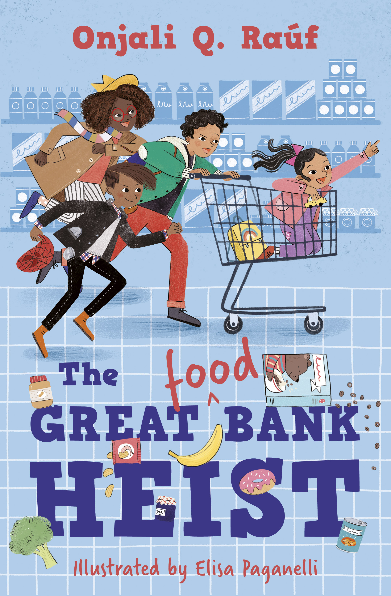
Level:
First (P2–4) and Second (P5–P7) / KS1 and KS2
Explore themes of:
√ Reading and Writing Techniques √ Food Poverty √Charitable Giving √Community √ Empathy
Subject Checklist:
√ Expressive Arts √ Literacy and English √ Health and wellbeing √ Creative Writing √ Social Studies

At a Glance
Before watching the event or reading the book!
- From the cover do you think the book will be funny or serious? Why do you think this?
- Does the title of the book make you think of any other films, books or tv programmes? If so, what does that make you think this book might be about?
- Why is the word “food” written differently in the title? What effect does it have?
Book Cover Activity: Who Am I?
Look at the figures on the cover of The Great Food Bank Heist and answer the following questions. What clues from the illustration make you come to your answers? You can do this alone or with a partner.
- Who are the people on the cover? How do they know each other?
- Where are they and what are they doing?
- How do you think they feel?
- As you read the book see how correct your answers above are!
Read the Extract
Taken from pages 1-9 of The Great Food Bank Heist.
Discussion Questions
1. Why do Nelson and his family have to play “the pretend game”?
2. Why do you think Nelson and Ashley don’t have enough to eat?
3. What age do you think Nelson and his sister are? What clues are in the passage?
4. On page 7 why does Nelson’s mum give him “a sad smile”?
5. Nelson’s mum works really hard as a nurse. Why do you think being a nurse is a hard job?
6. If Nelson’s family don’t have enough money, how do you think they’ll get the things they need from “The Bank”? What kind of bank do you think it might be?
7. How do you think Nelson feels about going to the bank and breakfast club?
Get to Know the Book!
Activity 1: The Great Bank Heist
On the cover of the book the word “Food” is written differently to the rest of the title. Why do you think this is and what effect does it have?
What would you expect a book called The Great Bank Heist to be about? What kind of book would it be?
What would you expect a book called The Great Food Bank Heist to be about? What kind of book would it be?
We’ve made some changes to some famous stories:
The Great Train Robbery becomes The Great <Toy> Train Robbery
The Godfather becomes The <Fairy> Godfather
The Great Detective becomes The Great <Mouse> Detective
Use one of our examples or make up your own and write the outline of the story. Think about:
Who your characters would be?
What genre your story is (is it serious or funny, a detective film or a western, realistic or magical?)
Activity 2: Master Chef
In The Great Food Bank Heist Nelson and his family play a game called Master Chef where they have to make a meal out of the weirdest ingredients which the food bank has given them.
- In your class ask each person to think of an item of food and write it on a piece of paper. (or you can each write several if you have a small class.) Put them all into a bowl or other container.
- Split your class into small groups. Each group should close their eyes and pick 4 or 5 ingredients.
- In your group try to think of a meal that you could make with the ingredients.
- In your class or group talk about:
Do you think your meal would be tasty… or disgusting? Would you eat it?
Would your meal be for breakfast, lunch or dinner?
- Using your knowledge, or searching online find out how much each of the ingredients in your meal costs, and so how much the meal would cost in total.
Do you think the meal is expensive or good value for money?
Is your meal healthy or unhealthy?
Would it fill you up or not?
Share your meal and what you think about the questions above with the rest of your class.
Your Turn: Become a Social Justice Warrior!
Activity 1:
Why not organise your own collection to help your local foodbank (without getting involved in a stake-out at a supermarket!) or another charity.
Research food banks in your local area. Collection points can be found at most supermarkets.
Make sure you know which kinds of foods your food banks collects. They often need dried and tinned foods as these last longer.
Put posters up around your school asking other pupils to bring in the items you want to collect.
Make sure you have somewhere to store the food, and a way of transporting it to the foodbank when you’ve collected it!
There are more ideas of ways to help foodbanks and other charities tackling food poverty on pages 101-103 of The Great Food Bank Heist.
Activity 4: Do the Write Thing!
At the end of The Great Food Bank Heist Nelson and his friends are invited to Parliament, alongside a famous footballer called Noah Equiano a.k.a. The Equaliser, to help make sure that every child in the country gets the food they need.
Either:
Write the speech that Nelson or Noah Equiano make at the Houses of Parliament.
Think about:
what they’re asking for or trying to do.
Who they need to help them.
For bonus points you can deliver your speech in front of your class!
Or write the newspaper article which is published after Nelson and his friends catch the Food Bank robbers. (See p85.)
We’re given the title:
SUPERMARKET TROLLEY GANG BUSTED IN FOOD BANK HEIST!
Noah Equiano takes action after children stop donation thieves.

Think about:
- What style are newspaper articles normally written in.
- How to describe the robbery and catching the thieves. What information is most important.
- How is Noah Equiano taking action.

Just for Fun!
The Animal Spirit Game
In the book Nelson, Ashley and their mum play The Animal Spirit Game
“We had to look at the people walking past and imagine what animal spirits they might be.”
For example Ashley thinks anyone wearing something glittery or shiny is a unicorn, and someone wearing a yellow and black striped jumper is a bumble bee.
Why not play the animal Spirit Game in class and decide which animal spirits you would be (or which you would like to be?) Explain why you chose each animal.
Why do you think Nelson’s mum plays so many games with them? Might there be various reasons?

If you, or someone you know, are affected by food poverty then please tell a teacher or another trusted adult.
Some useful organisations, who can direct to food banks and other help are:
The Citizens’ Advice Bureau
The Trussell Trust
Keep your eye out for more stories from Onjali Q Raúf as well as the other authors from Edinburgh International Book Festival!

