Hey You!
A sensory story version of the wonderful book by Dapo Adeola to make the story accessible to people with complex additional needs.
Resource created by Ailie Findlay.

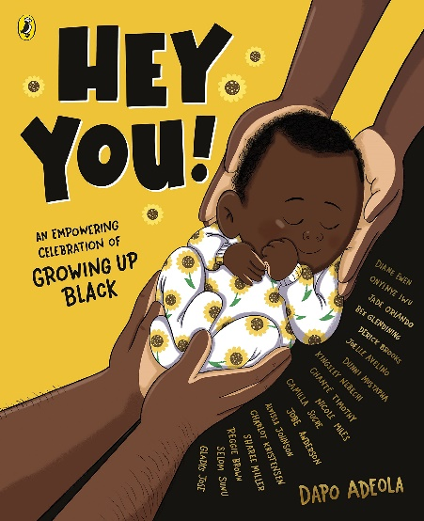

Level:
Suitable for all ages!
Explore themes of:
√ Self-worth √ Touch √ Positivity √ Affirmation √ Exploring senses
Subject Checklist:
√ Expressive Arts √ Health and Wellbeing

Summary:
This resource focuses on using sensory stimuli to re-create the atmosphere and emotions in this wonderful story. The participants can relax as the story washes over them, although there are also plenty of opportunities for active participation.

This resource is great for:

- Giving people with complex additional needs access to this important book.
- Relaxing, taking a break from daily life and feeling surrounded by positivity.

Introduction
After watching the event Dapo Adeola: Love the Skin You're In use this resource to help you create a gentle sensory version of the story suitable for people with additional needs, including those with profound and multiple learning disabilities.
If the person you are reading to enjoys shorter stories better then you could try mainly reading the text in the larger font and omitting some of the pieces of text in the smaller font. I think this story works best if read at a slow pace; you could also repeat the phrases of the story several times over.

This book transforms beautifully into a peaceful sensory story where most of the actions/stimuli carry over a few pages. This list of ideas indicates where I would start the action or stimuli; you could carry on with these actions until the next prompt so that the story feels smooth and seamless. (This may be easier if there are two of you working together, one to read the story and one in charge of the props.) You can really take your time with this – if the participant is enjoying a particular part of the sensory story linger there for a while.

Hey you… Look at your participant take their hands in yours.

I hope that you know you are loved…You are wonderful… Sprinkle some confetti gently over your participant. You can make your own confetti by cutting up tissue paper very small. Alternatively, you could give your child a short hand massage or back rub.

Love your beautiful skin… Rub your participant gently on the back of their hand or arm.

You stand on the shoulder’s of greatness… Pat your participant gently but firmly on both shoulders a few times over.

You always have a choice…be curious… Hold a small toy or object in each of your hands with fingers tight so they are roughly hidden. Offer the child both hands and let them choose which to open. Or you could put the toys/objects in boxes or bags.

Keep Searching… You could use a pile of books or photo albums as a sensory prop for this.

Happiness, love and laughter… As you read this spread out a large scarf, or if in a classroom get out a large piece of Lycra or a parachute. Stretch this out between you in a circle or hold the scarf between you in a pair if you are at home. Work together to bounce the fabric up and down slowly as you read the next pages.

An alternative if there are just two of you would be to drape a large scarf over both of you so you are both ‘inside’.

You are a hero… If you are in a classroom keep the large piece of fabric or parachute stretched out and bounce a superhero soft toy on it (make sure the toy has no hard bits that could hurt someone). You could simply take a soft toy your already have and give it a little superhero cape made from a scrap of fabric or scarf.

Add in lots of colourful scarves for the ‘dreams’ and bounce them all around using the parachute or Lycra. At this point you could return to some of the key phrases from the story and chant these in a call and response fashion in time to the bounding of the fabric. (E.g The narrator says ‘You are wonderful’ and everyone repeats.)

Alternatively put a super-hero cape round the shoulders of your participant. (You can improvise with any larger piece of fabric.) and finish with some gentle music and more confetti.

Further information
Keep your eye out for more books by Dapo Adeola as well as the other authors from the Edinburgh International Book Festival!

