Pirate Stew
Make a Sensory Pirate Stew in this fun activity created by Ailie Findlay,
based on the book by Neil Gaiman and Chris Riddell!

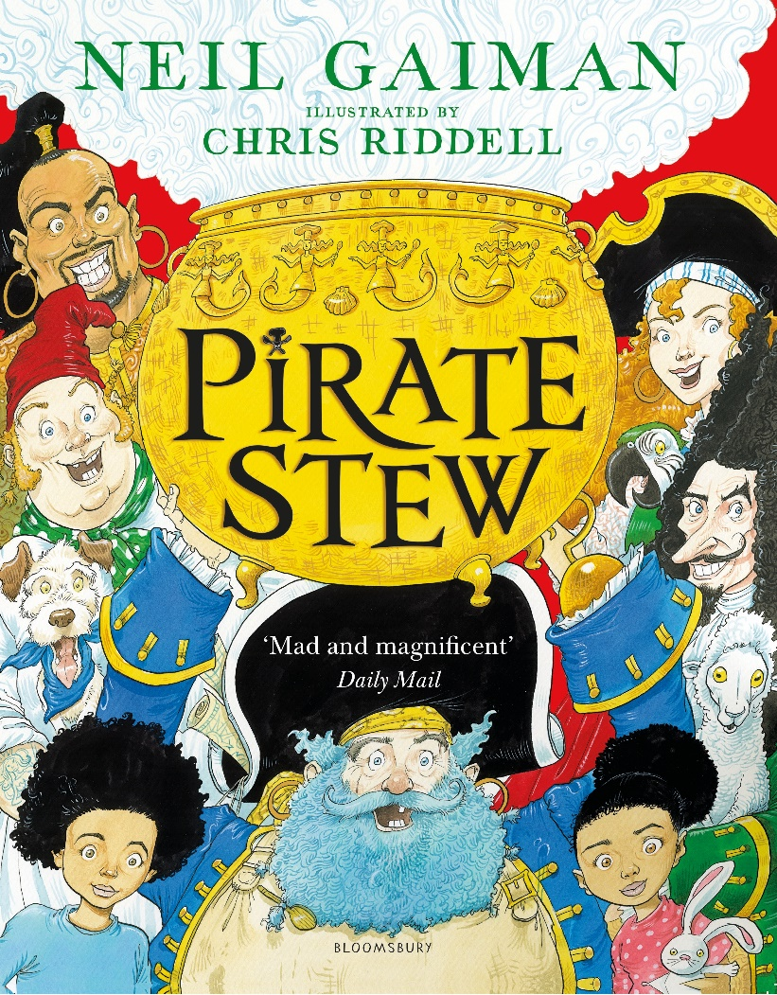
Level:
Suitable for all ages including those with additional support needs.
Explore themes of:
√ Pirates √ Touch √ Dressing up √ Movement and dancing √ Exploring senses
Subject Checklist:
√ Expressive Arts √ Health and Wellbeing

Summary:
The rollicking rhyming language of Pirate Stew makes it a great online event (and book) to share with participants with additional needs. And the section where the Pirate Stew is made is perfect for turning into a sensory story suitable for those with complex additional needs.
This resource is great for:
Helping us all to get in touch with our inner pirate and sharing some rambunctious fun!
Encouraging participation and turn taking. Everyone can have a turn to add things to the stew.
Sensory exploration: there are lots of different props you could choose to include in the sensory adventure with interesting smells, textures and sounds.
Adapting to suit the needs of particular participants. It is simple to vary the length of the sensory adventure to suit your participantsby taking out or adding in props. You could also choose to concentrate on exploring just one or two of the senses if that would suit your participantsbetter.
Introduction
Watch the event Neil Gaiman & Chris Riddell: Pirate Stew! And enjoy Neil’s reading of Pirate Stew. This starts at 15 minutes and 50 seconds into the online event. The stew making starts at 18 minutes and 50 seconds into the video. The pace of the story in the video is quite fast; if you stop and start the video as you introduce the props and actions this will mean you can tell the story at a slower pace. Or you may prefer to paraphrase this section while you make your own stew. (Or read along with a copy of the book.) If you keep repeating the Pirate Stew chant this will hold things together even if you are paraphrasing the rest of the words.

Get ready for the stew-making by looking through the list of Pirate Stew ingredients. It is probably not a good idea to try to include props for all the ingredients – this would be a sensory overload and involve an awful lot of preparation! Pick and choose according to what will appeal to your participants and what you have to hand.

Creating Your Sensory Stew
We start our sensory adventure with the pirates chanting:
Pirate Stew! Pirate Stew!
Pirate Stew for me and You!

If you are telling this story at home you can clap or stamp this chant out. In a classroom you might want to record it on to BIGmack (or similar) recording devices so that all your pupils can join in. Encourage everyone to repeat this chant at any time during the making of the stew! And repeat it often yourself, with a good deal of thigh slapping!

Here are a few suggestions for props and actions to include in your sensory story:

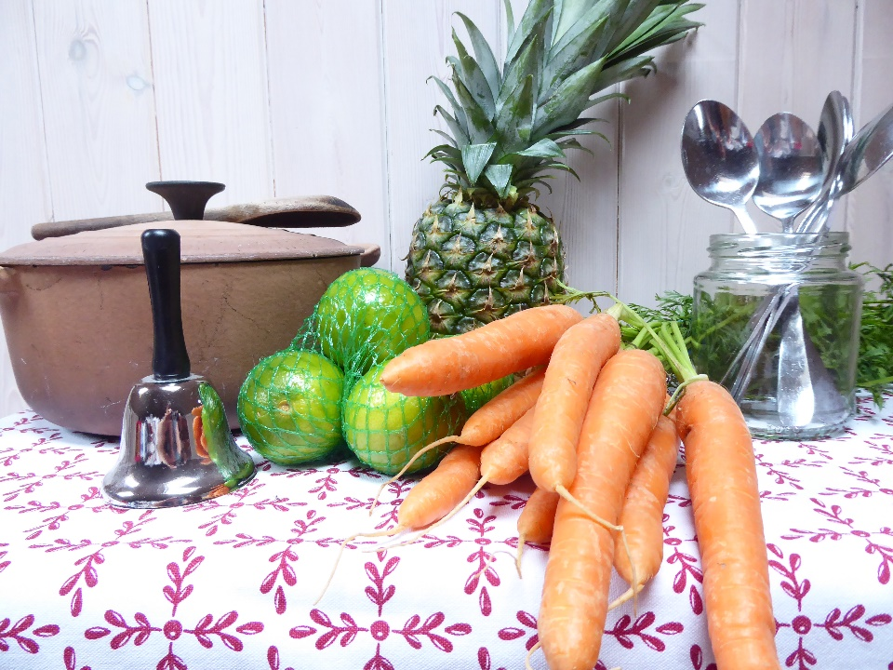

Props

Carrots – preferably with their leafy tops.

Onions – but be careful around eyes!

Seeds – a small fabric bag tied tight shut with lentils or beans inside will be satisfying to handle.

A pestle and a bowl for the participants to try.

Limes – but careful of those eyes if you cut them open.

Silver spoons – but they do not have to be silver! If you put them in a jar they will make a satisfying noise.

Dubloons – two pence pieces in a small fabric bag will be satisfying to feel. But make sure the bag is very securely sewn or tied shut to avoid a choking hazard.

Haddock – cut out a fish shape and tape it to a stick for an instant puppet. Or if you search online for ‘sensory squidgy fish’ you will find some fun tactile toy fish.

Pirate sword – perhaps you have one in your dressing up box or cut one out of cardboard. Cover it with foil for the full effect!

Mermaid’s tears – the internet has lots of information about how to make glitter sensory bottles, sometimes called Calm Down Jars. I think these would make excellent mermaid’s tears. Or perhaps you have a glitter wand that you could use.

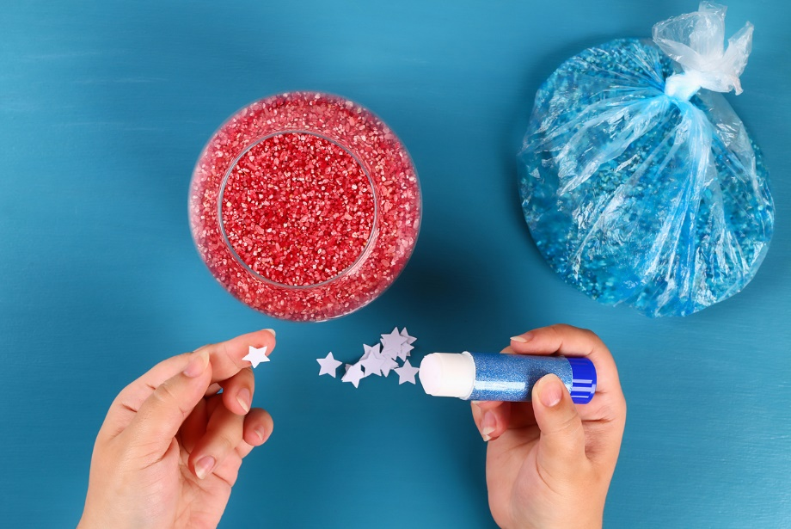

Red bandana – bandana or any red scarf.

Locks from Davy Jones locker – a big chunky padlock if you happen to have one.

Pineapples – a bit spiky but interesting from a tactile point of view!

Shilling shockers – I think the modern equivalent would be Hello magazine of something similar. Use old copies in case they get ripped!

Seashells – if you have some large ones they will be less of a choking hazard.

Any pan with a lid will do for your stew pot but the bigger the better.

Jolly Roger – any piece of fabric would do for this – preferably black if possible.

Dinner bell – any kind of bell would be fine – even a bicycle bell!

Actions

‘Drop it in’ – let the participants add the objects to the pot.

‘Here they dance around the kitchen’ – put on some pirate jig type music and clap, stamp and dance!

‘Some extra Arrs for talking’ – Practise your ‘arrs’ and encourage your child to copy you. Or these could also be recorded on to a BIGmack and the participants could join in at any point during the story with an extra ‘arr’ or two…

‘Pop the lid on most securely’ – let the participants do this.

‘Cook it in a treasure chest’ - Let the participants ‘stir the stew’ with a wooden spoon.

‘Serve it, eat it, then digest’ – mime eating the stew, rub your tummy and encourage everyone to copy you.

The Finale

Our sensory adventure finishes at 20 minutes and 46 seconds into the video of the event or on the page that ends:

You’ll become a pirate too!

Time to turn into a pirate! Have a look online for instructions on how to make pirate hats from newspaper or use brightly coloured scarves wrapped around the participants’s heads or draped round necks. Pass out treasure maps (paper rolled up and tied with a ribbon) or any kind of ‘treasure’! Practise saying ‘Arr arr!’! You could finish by chanting and clapping the Pirate Stew chant together several times over or put on some more jig music and dance around the room.

If you are telling the story in a classroom and you have a parachute you could get this out at the end of the activity and hold it stretched out in the group, saying: ‘And here is our pirate sail, and here comes the wind…whoosh…’ Finish with a storm at sea as your ‘sail’ flaps and billows.

Follow On Activities

It is fun to repeat the Pirate Stew sensory adventure but substitute some different props each time. These could be pirate or sea related, or they could be random objects. Choose objects that are interesting from a sensory point of view (things with an

intriguing texture or smell etc.) or objects that the participants might recognise (teacher’s shoe, Granny’s handbag etc.)

You could also start with the new object already hidden in the stew pan with the lid on: ‘I wonder what is in our stew today.’ Give the pan a shake – what noise does the object make?

Or if you are repeating the activity at different times of the week or term you could add a topical object to the stew: ‘Today there’s a drum in the stew – that’s because today is music day!’ or ‘Look a Halloween pumpkin for our stew!’

This activity also provides a good opportunity for making choices. Present your participants with two different objects and let them choose what to add to the stew!

Further information
Keep your eye out for more books by Neil Gaiman as well as the other authors from the Edinburgh International Book Festival!
