There’s a Storm Ahead, Me Hearties!
An art project exploring mark making
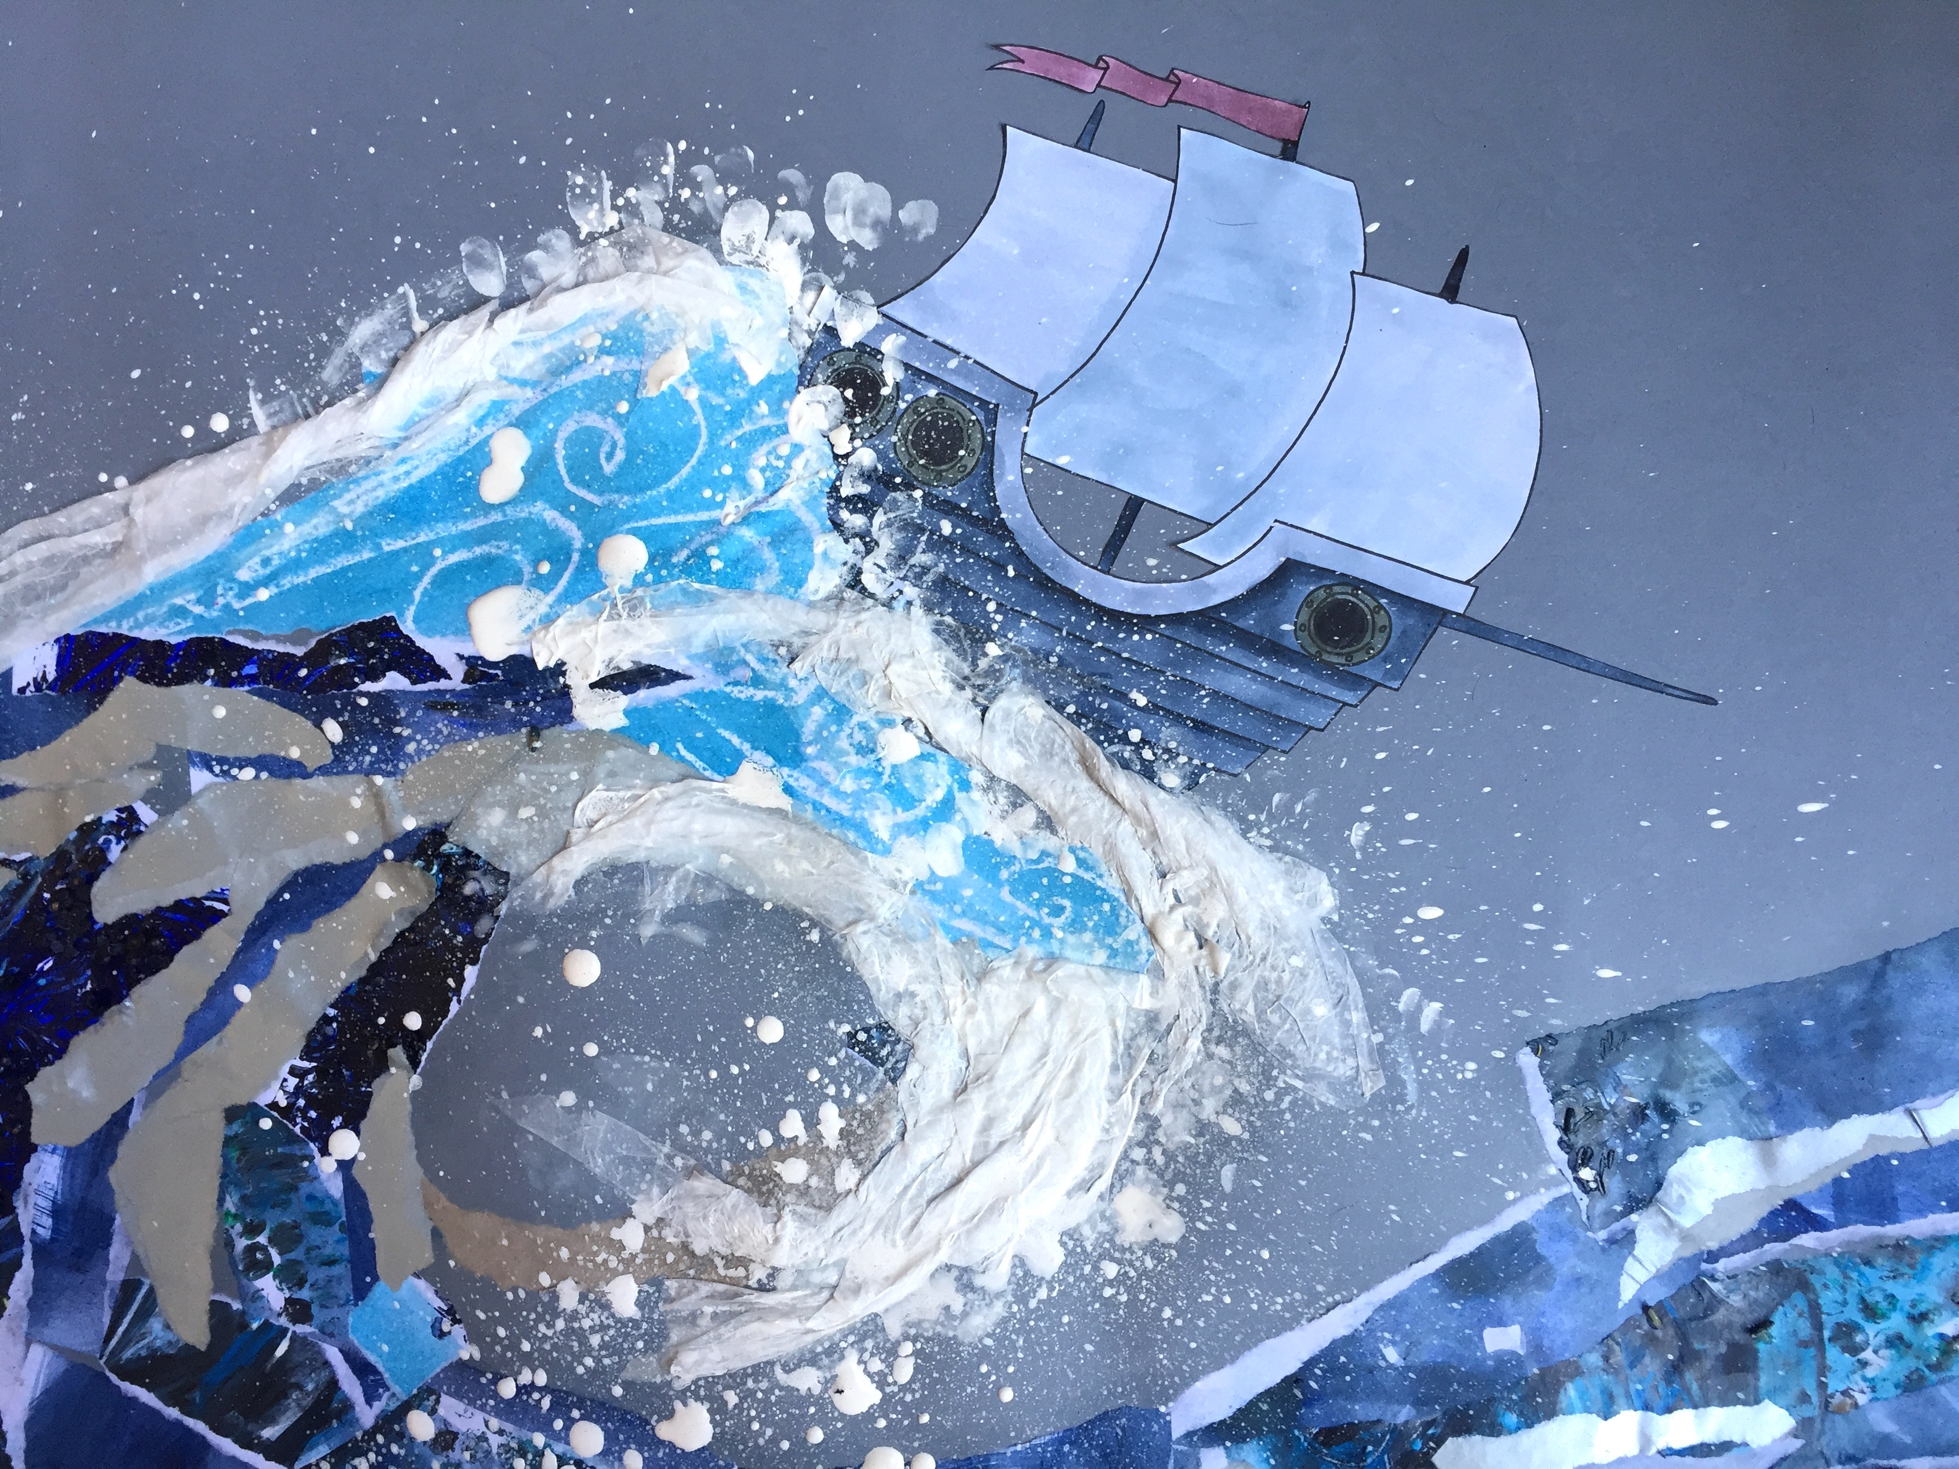

Level:
Early (pre-school to P1)
First (P2-4)
Second (P5-7)
Third and fourth (S1-3)
Senior Phase (S4-6)

Summary:
In ‘Prirate Stew’, by Neil Gaimon and Chris Riddell, Long John McRon and his pirate crew live on a pirate ship. In this ship they are able to sail all over the world. Have you ever wondered what it would be like to live on a pirate ship? It must be rather pleasant when the sun is out and the sea is calm….but what’s it like when there is a big, ugly storm?
The project uses expressive mark making to recreate the feelings of being in a pirate ship during a storm. After the children have experimented with stormy themed mark making, they will work together, using their mark making samples, to create a big, stormy, collaged wave, complete with pirate boat.

This resource is great for:
- Exploring mark making through experimenting with paints, a variety of tools and other materials
- Developing manual dexterity skills through the mark making activity
- Stimulating the imagination by using sensory play to recreate being on a ship on a stormy sea and translating this experience into the artwork
- Working as a team and building communication skills as the children work together to create the collaged wave
- Having a legitimate excuse to get messy!

Introduction
Introduce the children to what happens during a storm and what it might feel like using sensory aids.

- At the start, the sea is calm - Get the children to notice the silence.
- It starts to get bit windy - Use fans to create a bit of a draft on hands or cheeks.
- The wind gets stronger - Use a large piece of fabric to flap above the children’s heads.
- Encourage the children to join in and make ‘whhhiiissshhhing’ noises to represent the wind.
- It may start to rain - Use a diffuser to gently spray some water.
- The rain gets heavier and heavier - Use rain makers or containers filled with rice or lentils to get a storm going. Invite the children to shake these.
- Remind the children that they’re in a boat and that the sea now has big waves - invite the children to sway around as their pirate ship is tossed about on the waves.
- Then the thunder begins to boom - Use drums or repeat ‘BOOOOMMMM’ a few times, in a deep voice and encourage the children to join in.
- By now the ships bell will be frantically clanging - Ring a bell.

Keep this going for as long or little as you like, or until the children are suitably inspired to move onto the stormy sea-themed art activity.

Step 1
This will be a messy activity, so it is strongly advised that participants wear some kind of overall to protect their clothing. You also may want to cover tables with a wipeable cloth.

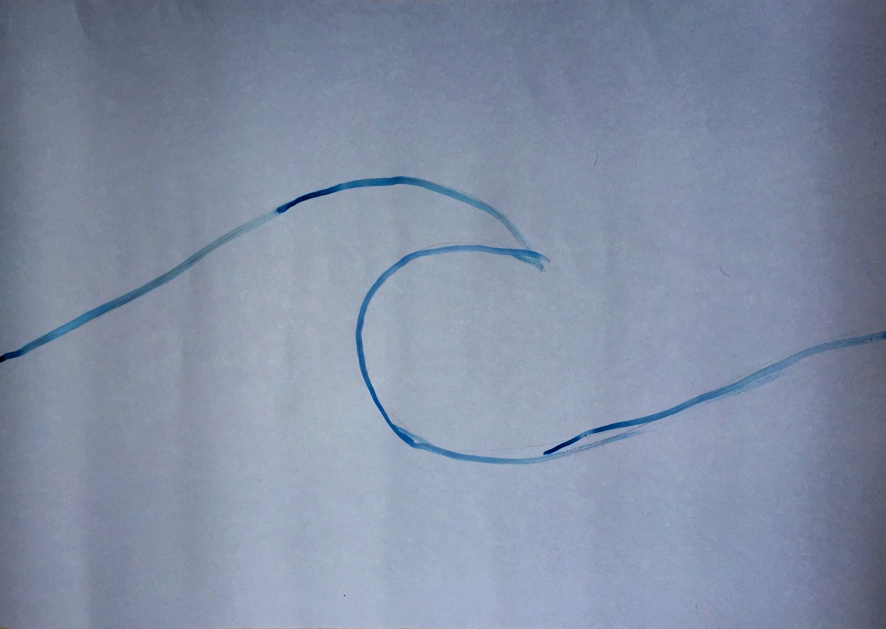
First of all, get a large piece of blue/grey/storm coloured stiff paper or card and roughly trace out a wave shape. Make sure that the paper/card is not too thin as it will need to support the final collage which will be glued onto it. The paper/card can be as big as you like. You may want to consider the number of children that you’re working with and how many could fit comfortably around the sheet while still having room to work. You could always make a few waves if you think that working around one sheet of paper would be too crowded. These waves could be hung together and would make a lovely frieze for the wall.

Step 2
This is the messy part in which the children are going to experiment and play with mark making.

You will need (probably in plentiful supply)-
- Stiff paper and/or card - It’s probably best that the children work on A4 as this is easier to handle and probably easier to store while the pieces are drying. Make sure the paper isn’t too thin as it may tear with vigorous mark making activity.
- Paints - Poster paint, acrylic paint and anything water-based (ink, food colouring, watercolour) will work well. Perhaps use a limited colour palette so that you’ll achieve the storm sea colour - blue, black, grey, white, green, turquoise, brown. Be aware that once dry, acrylic paint and ink won’t wash out!
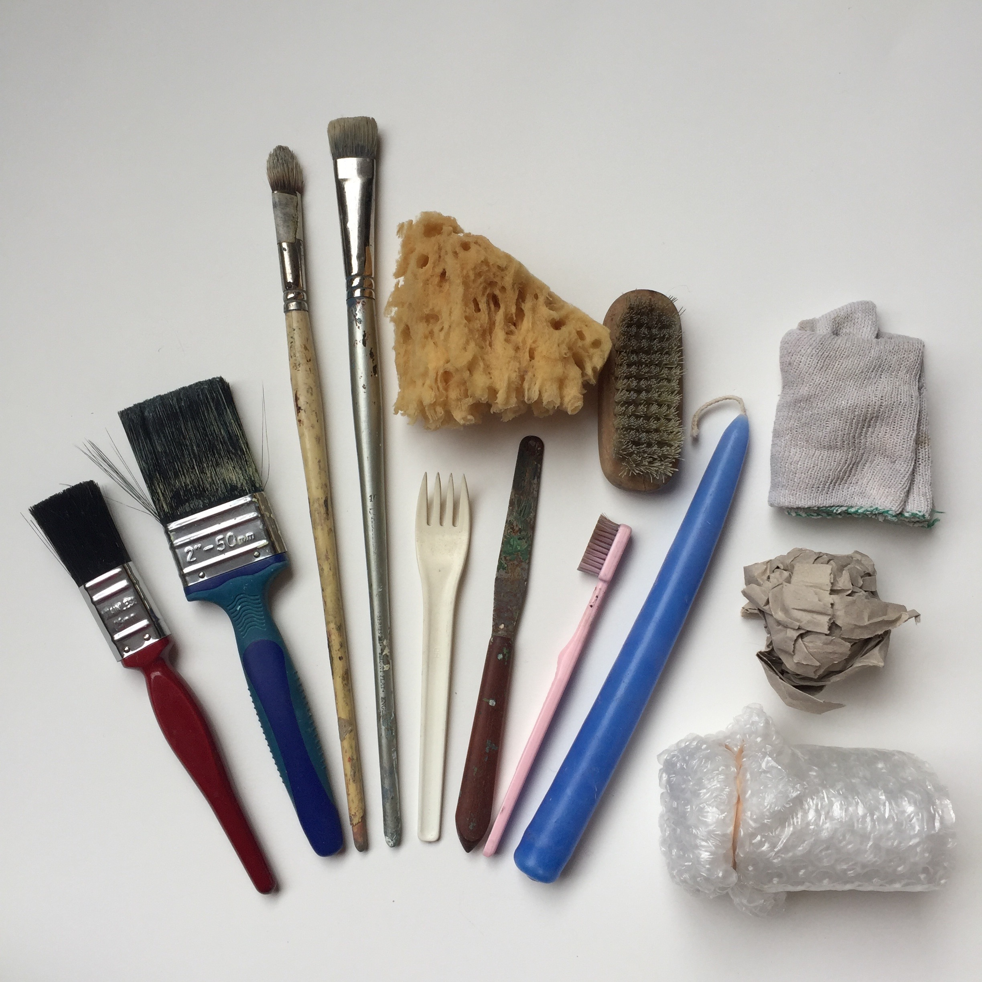
- Gather together tools and objects which will create interesting marks when used with paint. For example, paint brushes, nail brushes, bubble pack, toothbrush, fork, sponge, scrunched up paper, feather (attached to peg or tied to a stick so that it’s easier to hold), glue spreader, cotton wool, dish cloth and of course, don’t forget that fingers and hands are also great for applying paint.

- Gather materials that can be mixed into the paint which will alter the texture and consistency. Here are a few suggestions - sand, shaving foam, PVA glue. oats, flour, white candle, sawdust, rice, lentils, rock salt.

Now the fun begins! Encourage the children to really experiment with colour, the objects they use to apply the paint and mixing the paint with other materials. Show them that as well as painting with a brush, they can dribble, flick, scratch, scrub, rub, wipe and print with the paint.

- In order to keep the sea storm atmosphere in the art room, you could play some storm inspiring music while the children work. Try ‘The Sorcerer’s Apprentice’ by P. Dukas (remember Mickey Mouse in Walt Disney’s ‘Fantasia’?) or ‘In the Hall of the Mountain King’ by E. Greig. I think that a lot of Russian composers would also fit this bill!

Once the children have created all their mark making samples, allow the pieces to dry thoroughly before moving onto the next stage.

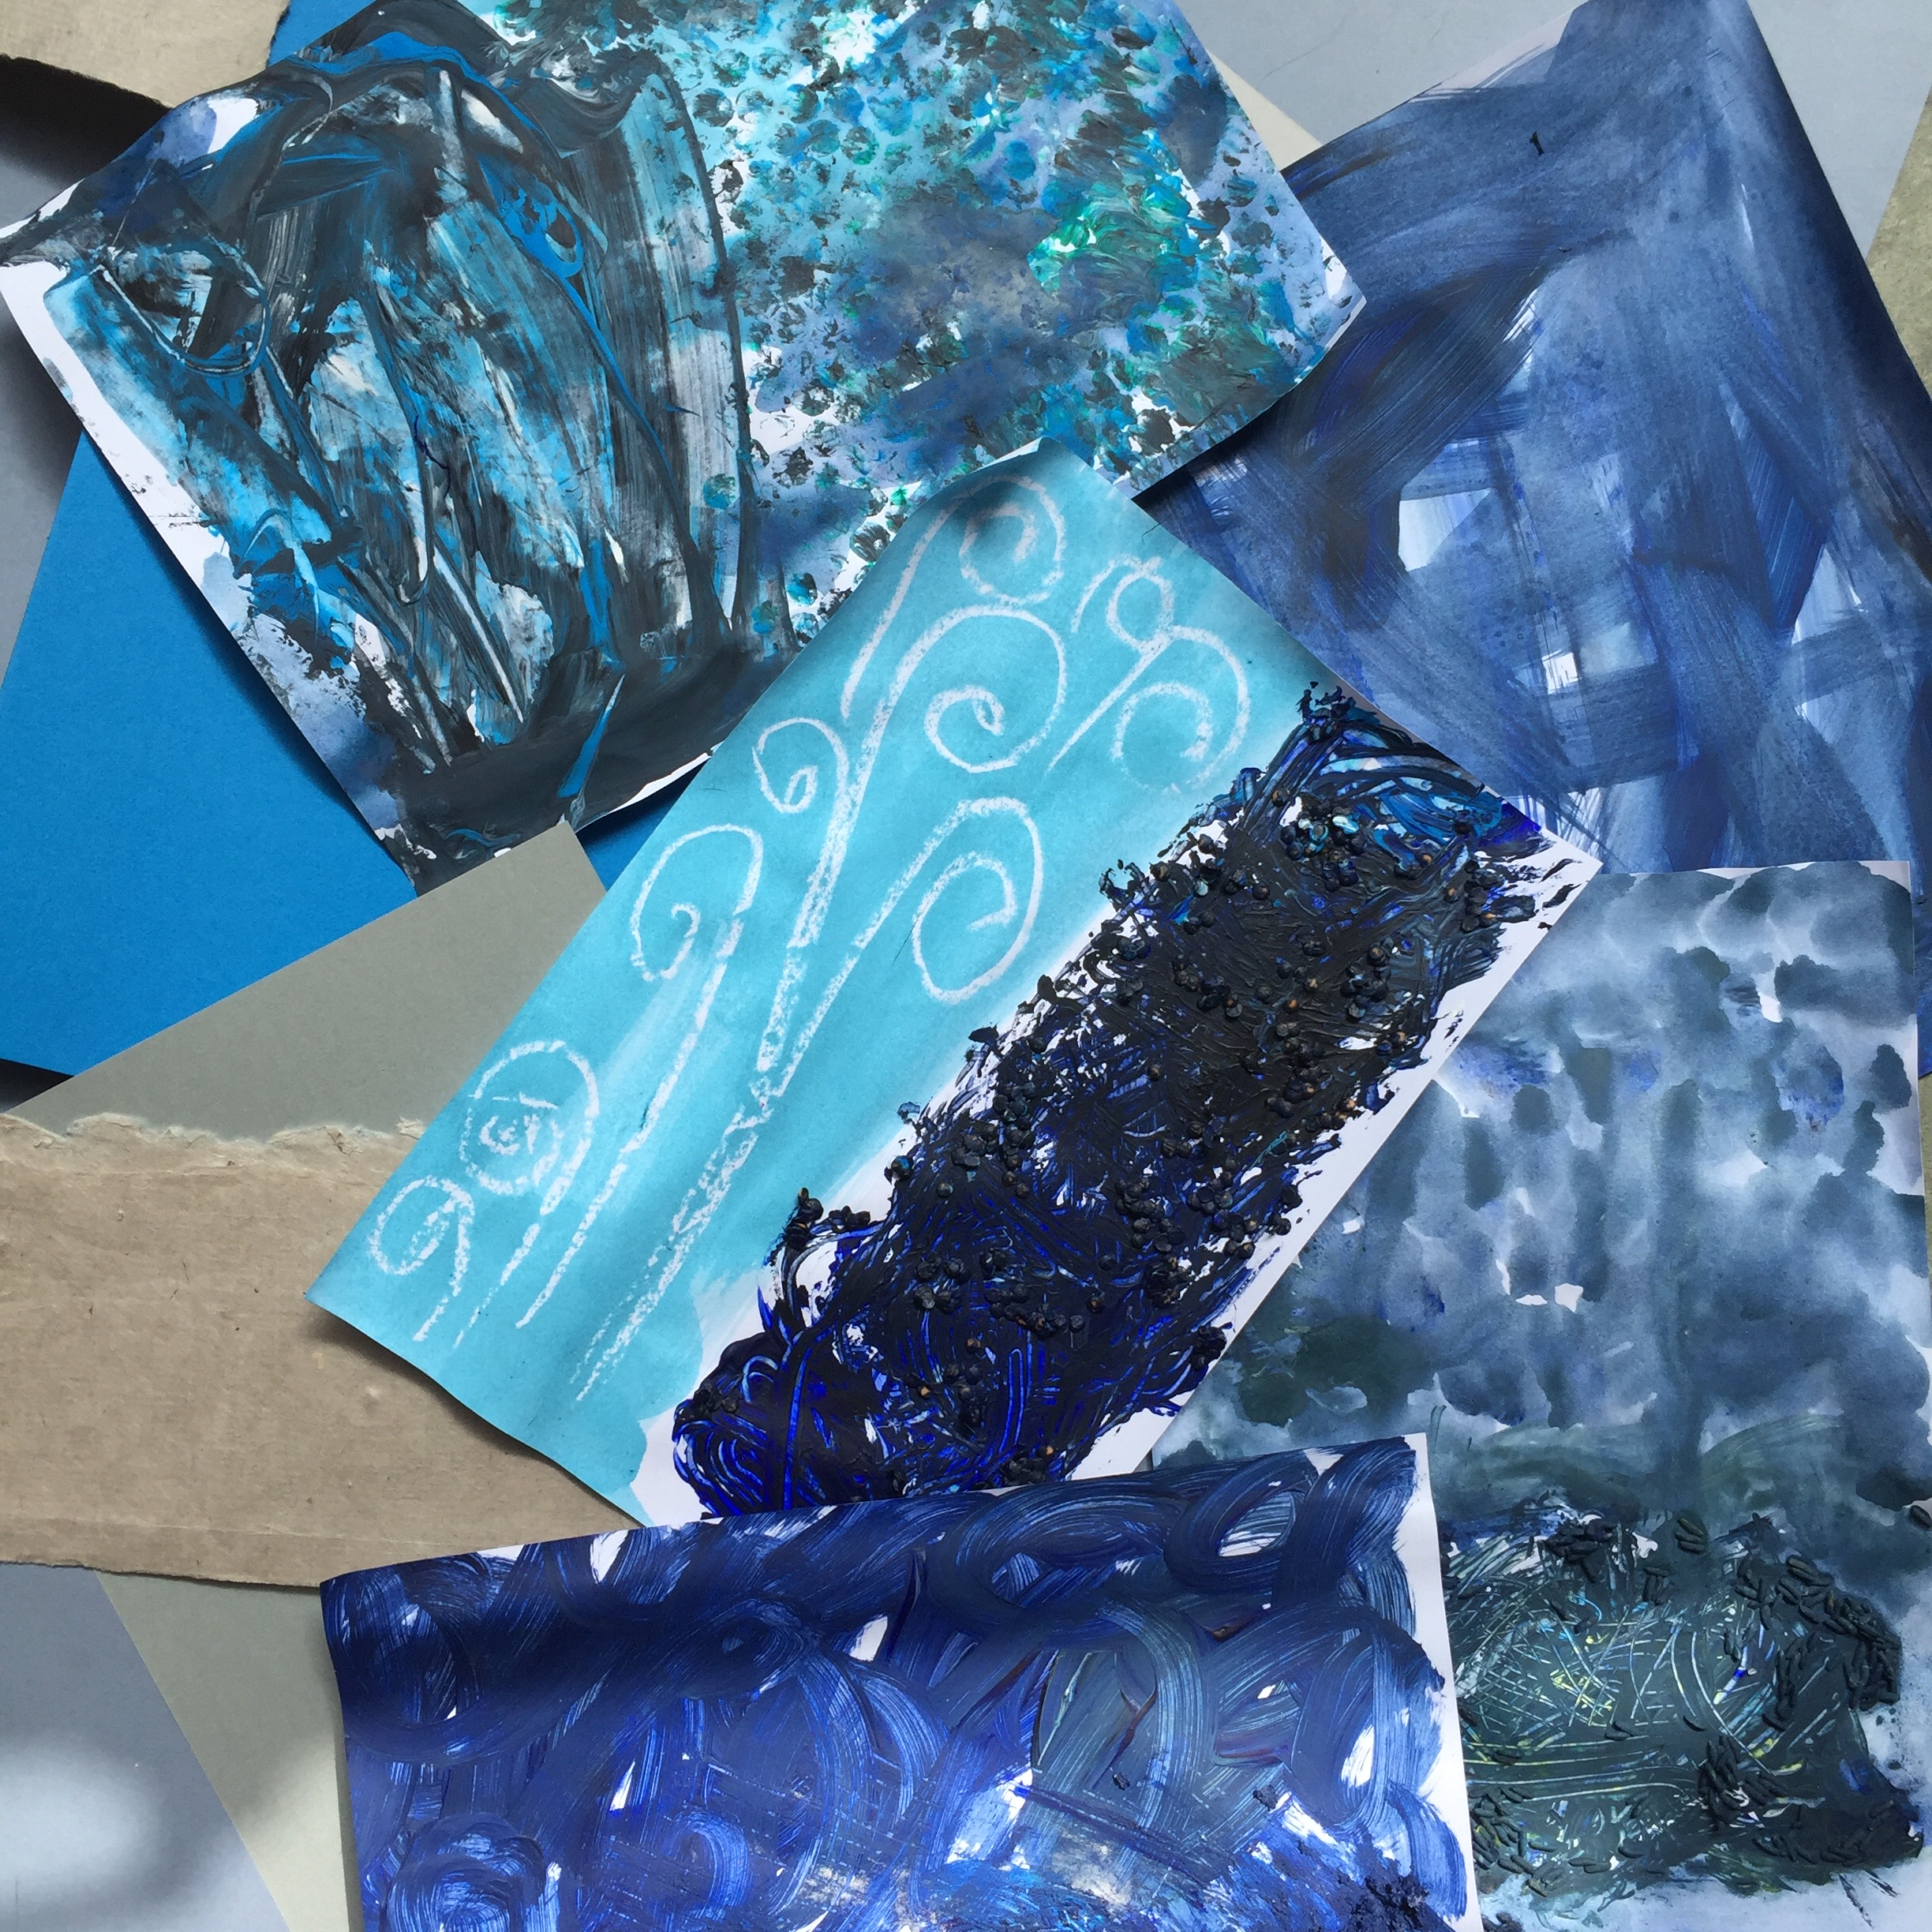
Samples of painted mark making

Note: The turquoise sample with the white swirls in the photo above was made by drawing onto the paper with a candle, then painting very watered down paint over the top. The wax from the candle resists the water-based paint and will highlight any marks that have been made with the candle.

Step 3
The next step is to collage the big stormy wave.

- First, get the children to tear up their mark making samples. Put all the torn pieces into a pile so that they are all mixed up together.
- Lay out the large piece of stiff paper or card with the wave design roughly traced out.
- Invite the children to randomly choose pieces from the pile to stick down onto the large piece of stiff paper/card. Encourage the children to work within the traced-out wave however if some pieces stray, it doesn’t matter at all. It just adds to the stormy sea effect!
- I recommend that you use a glue that needs to be applied with a brush - something like PVA glue or similar. Be very liberal with the glue and don’t worry if it gets all over the collaged pieces. It will dry clear and it will help to reinforce and stabilise any paint that’s been mixed with rice or lentils, which tend to be loose and may fall off when dry.
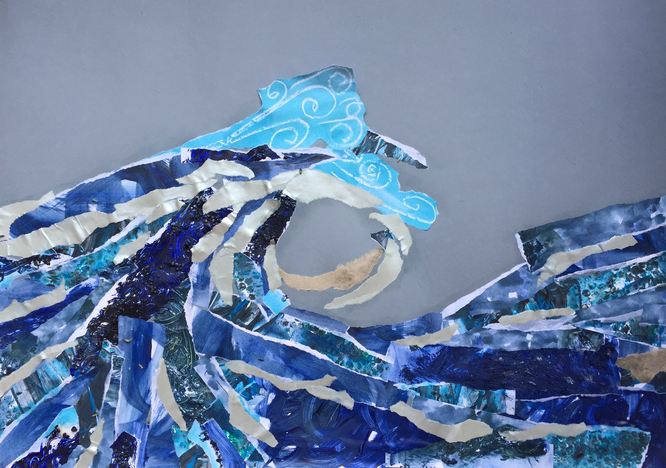
- Allow the glue to dry thoroughly.

Step 4
- While the stormy wave is being collaged, invite someone in the class to work on the pirate boat. This could be a child who has a particular passion for pirates or someone who likes to be focused and working with detail.
- Their task will be to draw and colour in a pirate ship. For ideas and inspiration, you could look at the drawings Chris Riddell did for ‘Pirate Stew’ or search for images on the internet.
- If you need a helping hand, there is a free printable download of a pirate ship included with this resource.
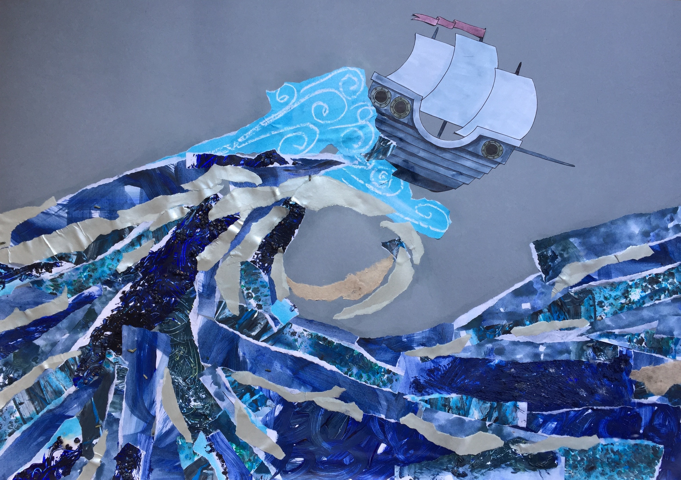
- Cut out the pirate ship and then glue it onto the collaged stormy wave.
Step 5
To finish off the stormy sea effect, add some white frothy wave foam.
- Dab some white paint to the end of the wave with fingers.
- Use an old toothbrush to flick watered down white paint around the pirate ship and the end of the wave.

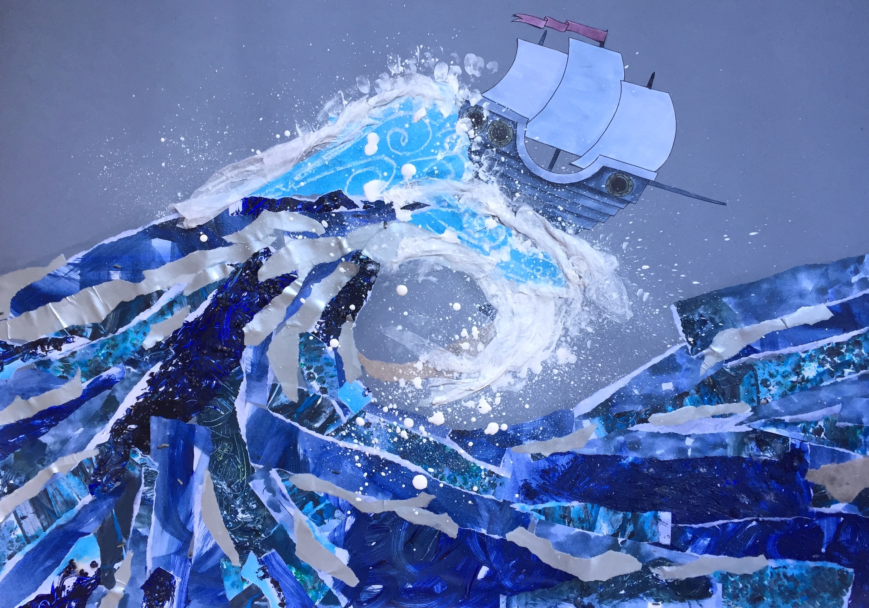
- Tear white tissue paper into strips, twist it and glue it down with generous quantities of PVA glue.

Well done, me Hearties! You now have a very dramatic picture of a pirate ship in a stormy sea!

Further information
- If a child is averse to getting their hands dirty or playing with paint, give them a selection of textured and coloured paper, or old magazines, or even old wallpaper sample books. Encourage them to search out textured papers and samples of colour which they think best represent a storm. Tear the pieces out and add them to the collaged wave.
- To make this project extra sensory, add a few drops of essential oil to the paint. You could give each colour its own smell.

