Velda the Awesomest Viking with David MacPhail
Find out what it was like to go on a Viking quest with Velda,
the tiny warrior with a BIG attitude!
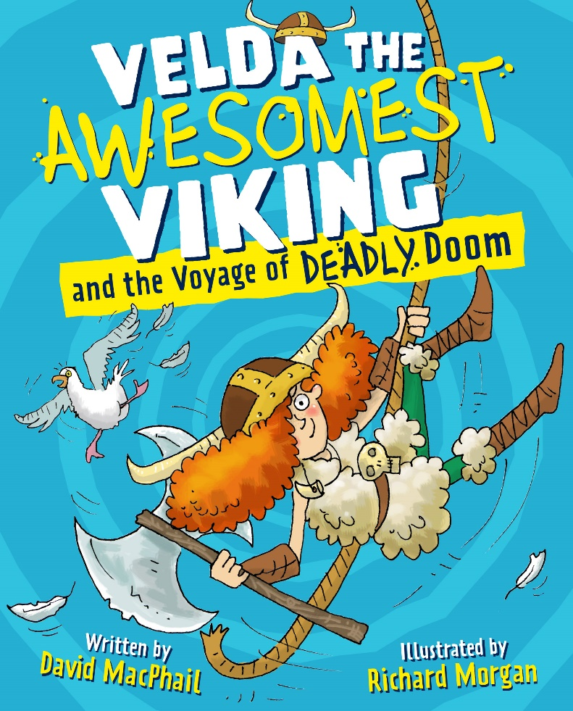

Level:
First Level / Second Level – KS2
Explore themes of:
√ History √ Vikings √ Scots Language √ Humorous writing
Subject Checklist:
√ Languages √ Expressive Arts √ Social Studies √ Creative Writing

At a Glance
Before watching David’s event or reading the extracts!
- Who do you think the character on the cover is? What can you tell about her?
- What do you think her personality is like?
- How would you describe this character? Think about what adjectives you would use.
- What do you like about the front cover? Does it make you want to read the book?

Read the Extracts
Taken from Chapters One and Two of ‘Velda the Awesomest Viking and the Voyage of Deadly Doom.’
Discussion Questions:

- When is Velda the Awesomest Viking set?
- Who is the captain of the Valkyrie?
- Why do you think Velda WANTS to go to the Island of Certain Death?
- How can you tell that the crew of the Valkyrie are “not your average Viking crew”?
- Describe the Island of Certain Death.

- Who is left on the Valkyrie with Velda? What do we find out about them?

- What do you think Velda thinks is happening at the end of Chapter 2?
- Did you find these chapters funny? Explain why.

Get to Know the Author and the Books!
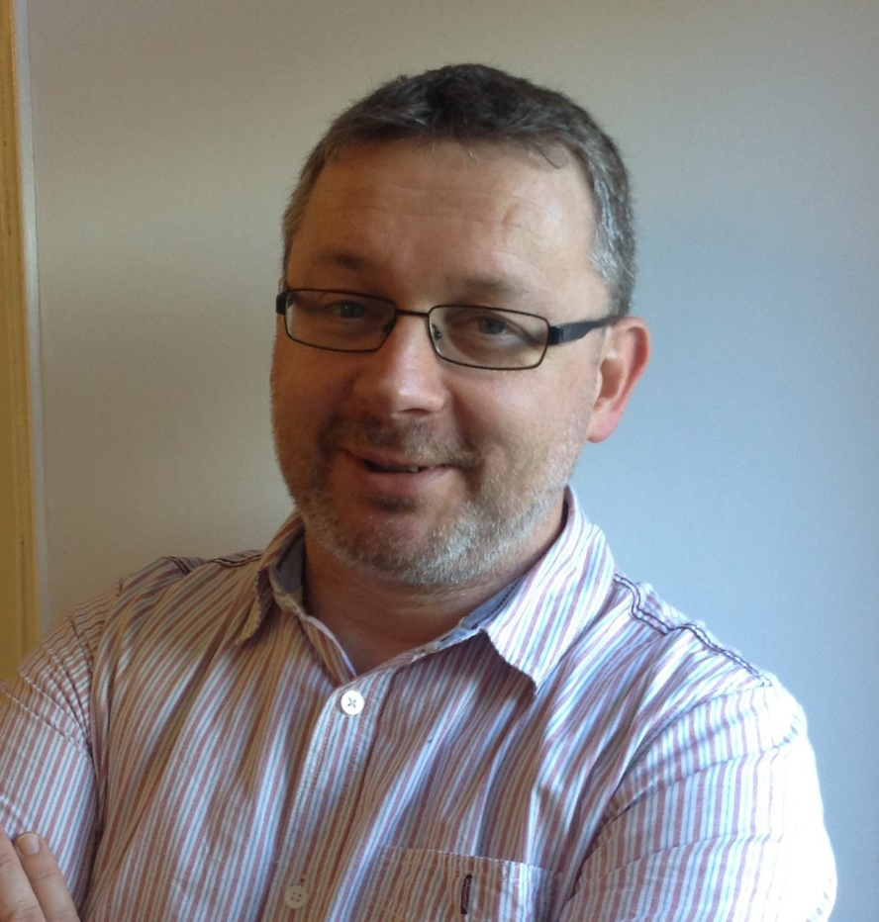

Activity 1: Explore Life as a Viking
In Velda the Awesomest Viking and the Voyage of Deadly Doom, author David MacPhail uses real facts about the Vikings, as well as other peoples such as the Picts and Celts.

- What do you know about the Vikings? Write down what you know about the Vikings and the using the internet or library books add down some other key facts. You could include:

  - Where did they come from?
  - Where did they live?
  - What did they eat and wear?
  - How did they travel?
  - What beliefs did they hold?
  - Why are they well-known today?

- Make another two headings and do the same for the Celts and Picts.

- Several Viking myths or legends are referred to in Velda the Awesomest Viking such as Fenrir the Wolf and Odin’s lightening bolts. Find out about these Viking legends and other ones. There are lots of fascinating ones to discover!

- Velda and her crew travel around on a longship, the Mangy Mutt, with a carving of a dog on its prow (front.) Design and draw your own Viking longship.

  - What colours are its sail.
  - Which animal head is on its prow? (and why?)
  - What is it called?

Activity 2: Scunnered by Scots!
One of Velda’s shipmates, Bridie is a Pict from Pictland who speaks Scots! Practise your Scots words by linking Bridie’s words up with their English meanings.
Hoolie Look
Nae Storm
Shoogled About
Aboot No
Gonnae Wobbled
Ye Going to
Keek You

Your Turn: Design Your Own Viking Island!
Activity 1: The Island of Certain Death
In Velda the Awesomest Viking and the Voyage of Deadly Doom the Island of Certain Death turns out to be something quite unexpected… a Viking holiday resort! It’s called the Island of Certain Death to scare away non-Vikings.

Create your own island (or other place) which has a terrifying name but an altogether innocent reality. For example, The Mountain of Misery could conceal a pirate theme park!

- Think of a terrifying name for your place.
- Decide what pleasant surprise it could conceal. Who would go there?
- Taking inspiration from the map at the start of Velda the Awesomest Viking draw your own map. Make sure you include some dangers which need to be overcome to reach your place.

Activity 2: Rhyming Riddling Runes
As Velda gets closer to finding the Silver Tusks her crew must solve a series of riddles translated from Runes to help them navigate through the Islands of Deadly Doom.

“Beware ye the angered wolf.
To avoid the teeth,
Ye must scratch beneath.”

- Look back at the picture of the island or other place which you created in Activity 1.
- What dangers would characters need to navigate in order to reach your island?
- Write a series of riddles to help characters navigate the dangers and reach your island. You could use the same rhyme scheme as he riddles in Velda the Awesomest Viking, ABB, meaning 3 lines long with the second and third lines rhyming.
- Swap your island pictures and riddles with a friend and try to solve the riddles to reach the end of your quest!

Reflection and Further Questions
Reflection Activity
Come up with a title for the next book in the Velda the Awesomest Viking series (we hope it’s going to be a series anyway!) Follow the format “Velda the Awesomest Viking and the xxxxx of xxxxx.” (and remember that David loves alliteration (when words start with the same letter like Deadly Doom!)
Draw the cover of your book. What would Velda get up to in this adventure. If you’re feeling inspired you can write the first chapter, or even the whole story!
Lastly, do you have any final questions you would like to ask David if you got the chance? Try to think of at least two and make a note of them.
Keep your eye out for more awesome books from David MacPhail, as well as the other authors from the Edinburgh International Book Festival!

